

DEOS Automation



June 30, 2023

L-QuBE Pte ltd

Developed and prepared by: Goh Teng Wei



Table of Contents

1. Installing Google Chrome 2

2. Pre-requisites for installing Chromedriver 4

Setting Chromedriver PATH 4

Installing WinRAR 8

Check for Google Chrome version 10

3. Installing Chromedriver 14

Check for Chromedriver in the system 19

4. Running DEOS user interface application 22

Edit Configuration 24

Test IP 30

Adding a new DEOS device 32

Removing a DEOS device 36

Automate Collation (Repeated) 38

Running application in the background 43

Indication of daily collation running status via System Tray 45

Starting/Stopping daily collation via System Tray 45

Killing the program completely 46

Download all data (Non-repeated) 47

Choose specific slots to download (Non-repeated) 49

PC limitations that will result in errors 55

5. Result of the automated collation 56

6. Error fixing 59

a. Chromedriver not found 59

b. Invalid IP address 60

c. Invalid password 61

d. Invalid slot name 62

# Installing Google Chrome

You may skip this step if your device already has Google Chrome installed.

**Ensure that you are connected to the Internet before proceeding with the next steps!**

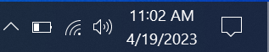

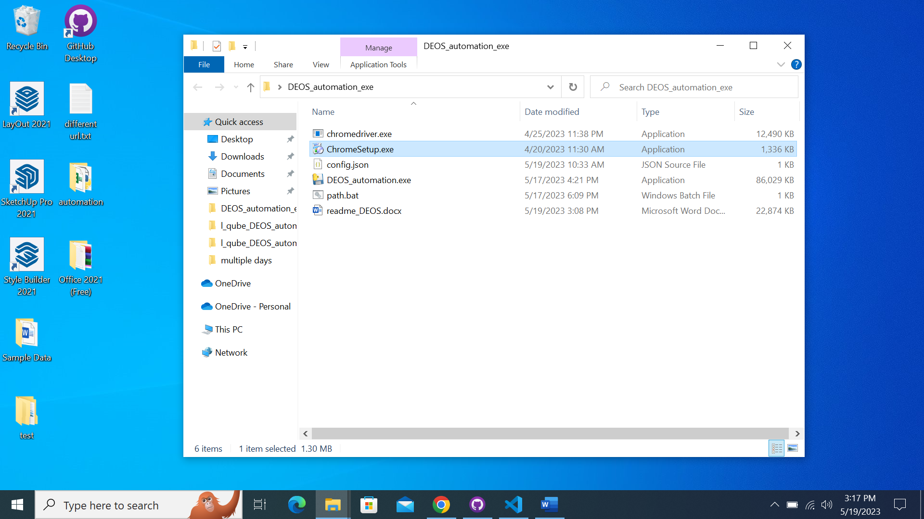

Double click on the file ‘ChromeSetup.exe’

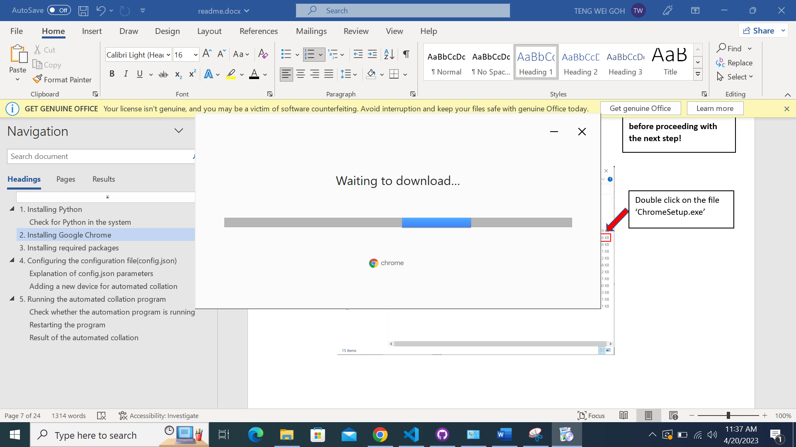

It should lead you to this page.

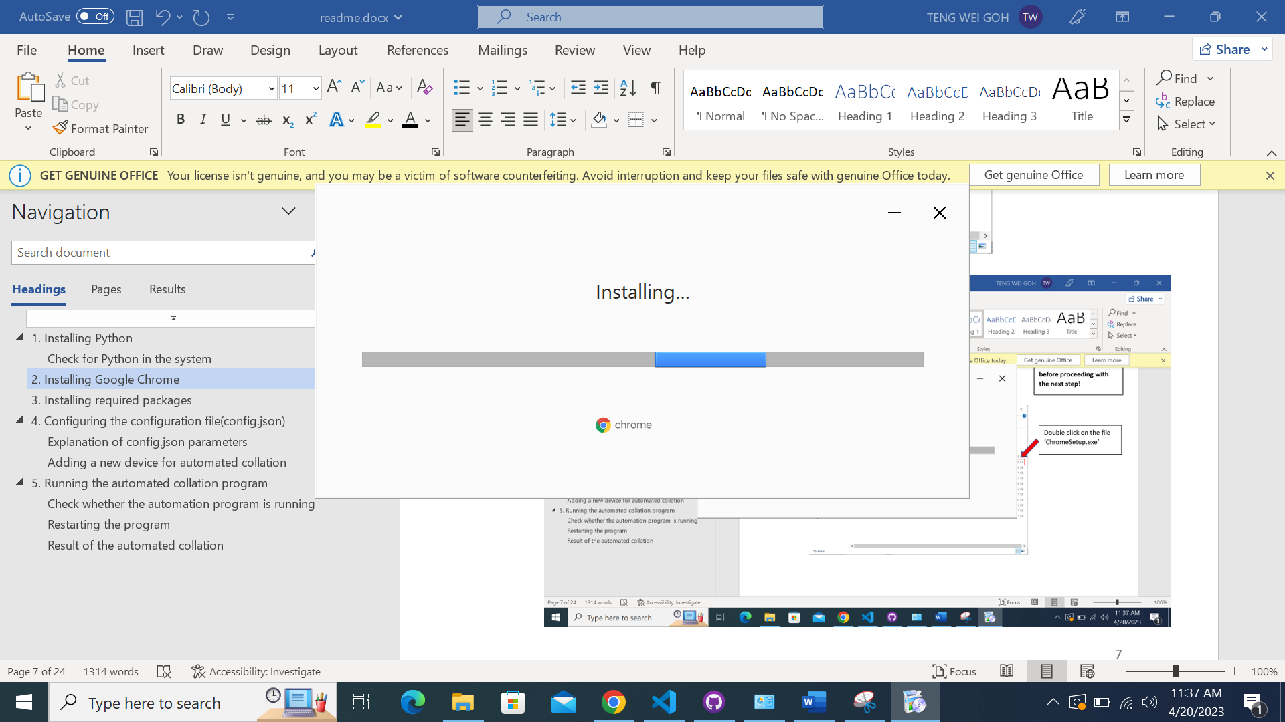

Google Chrome will automatically download if you are connected to the Internet.

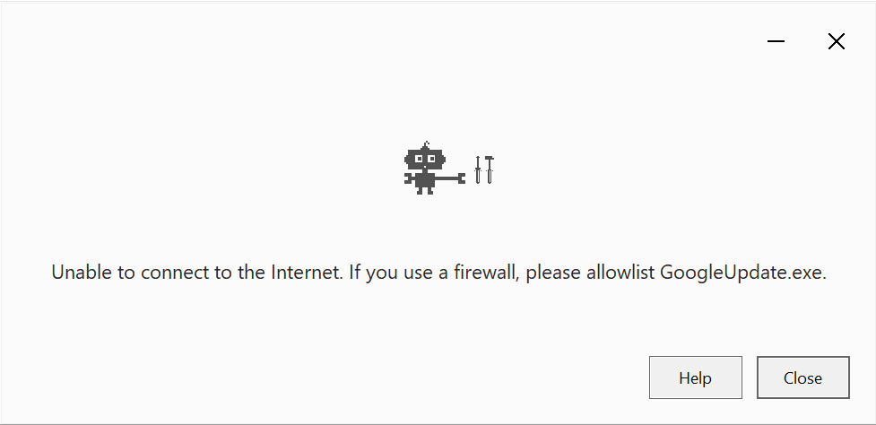

You will see this prompt if you are not connected to the Internet.

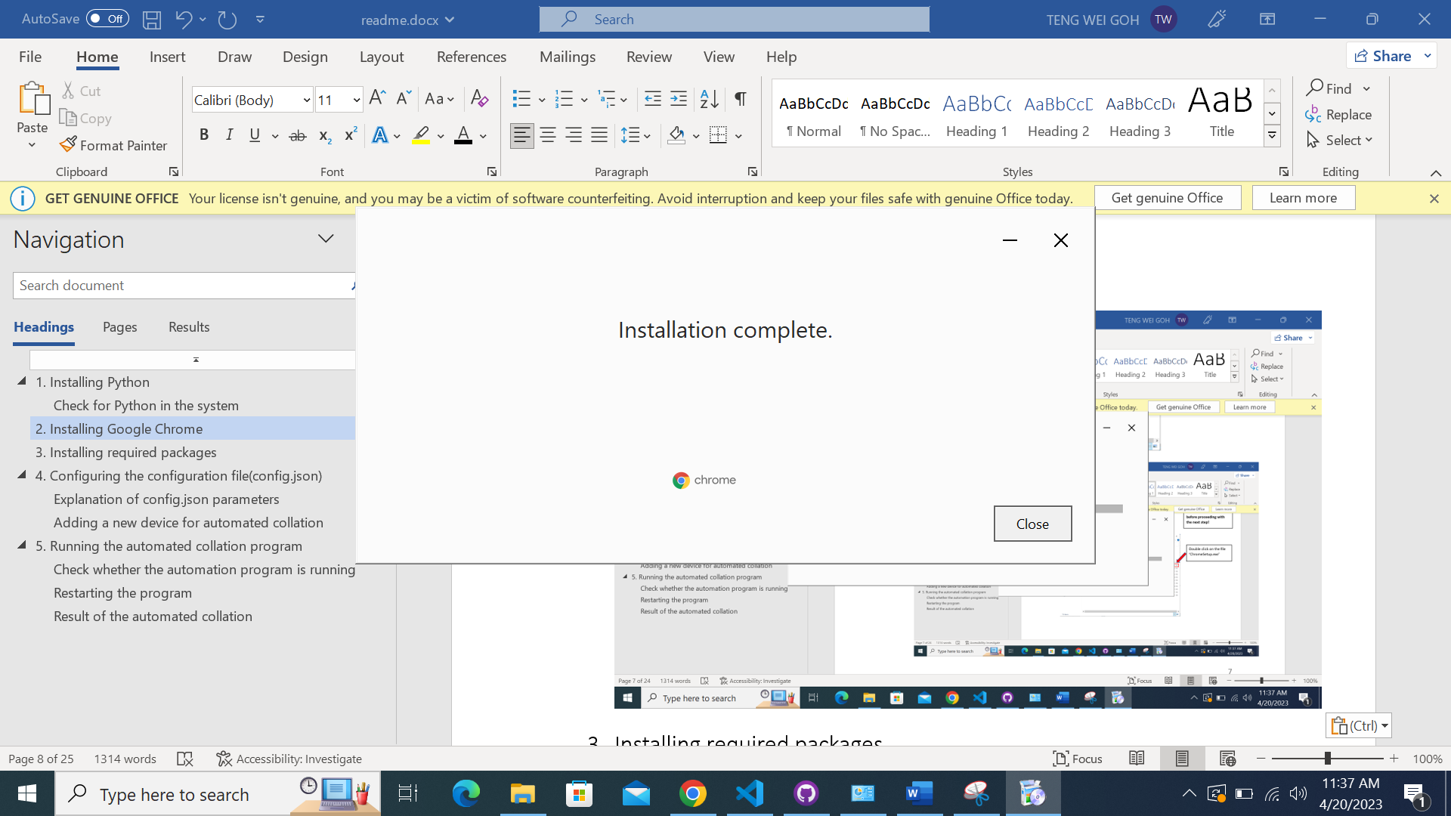

After installation has completed, you will see this prompt and you may close the installer now.

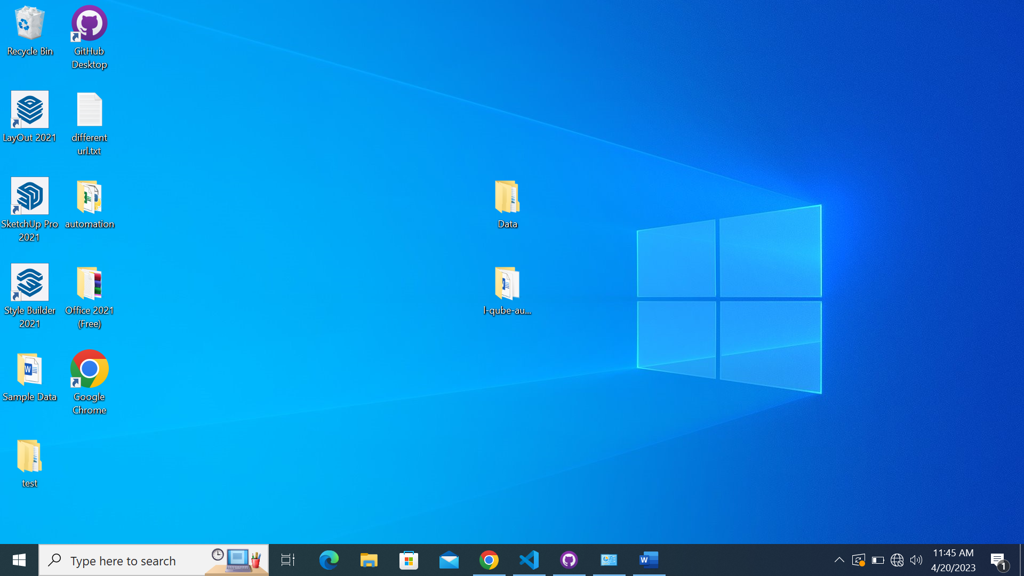

A shortcut of Google Chrome will automatically be created on the Desktop. This verifies that Google Chrome has been successfully installed.

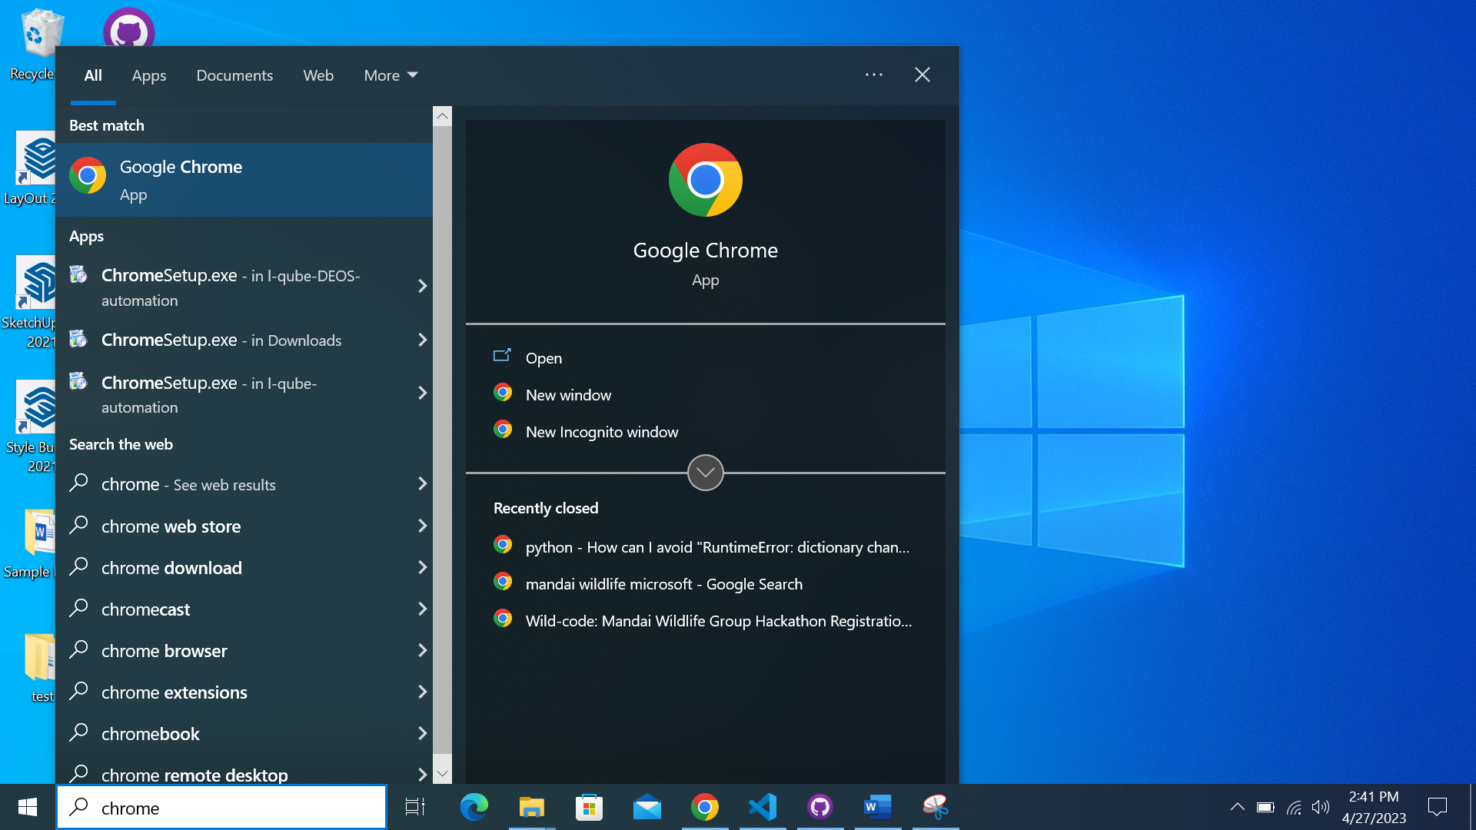

Another way of verification:

Typing ‘chrome’ in the search bar should lead to ‘Google Chrome’ showing up. This verifies that Google Chrome has been successfully installed.

# Pre-requisites for installing Chromedriver

## Setting Chromedriver PATH

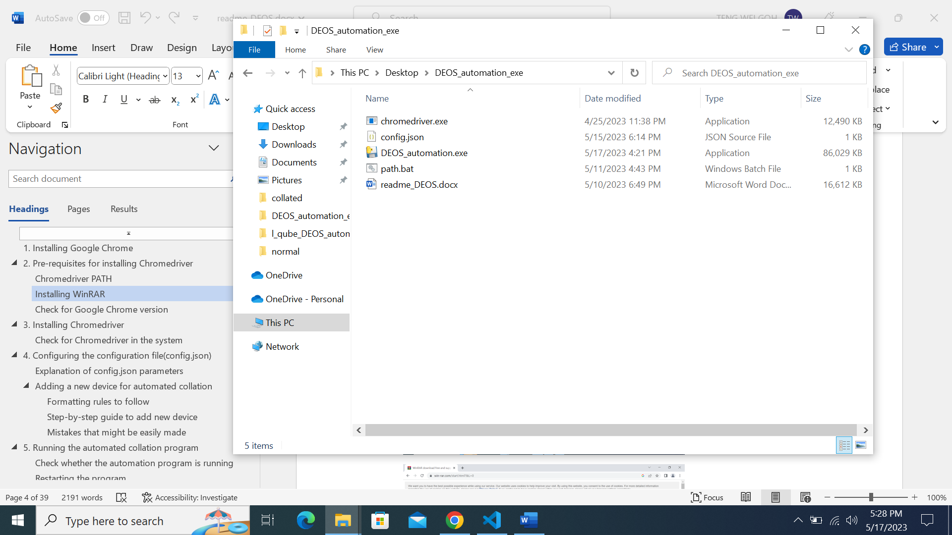

Navigate to the folder where the files are.



Click on the white space on the right of the directory.

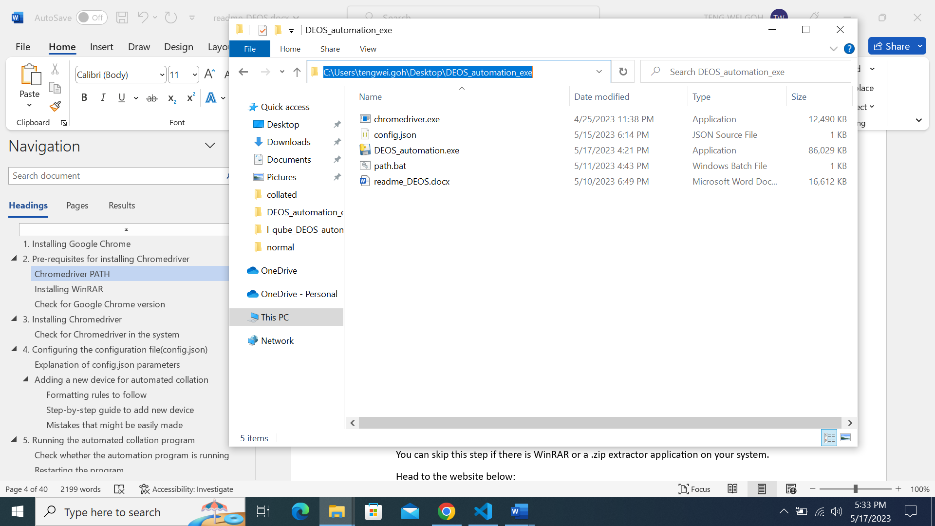

The directory will then be highlighted in blue.

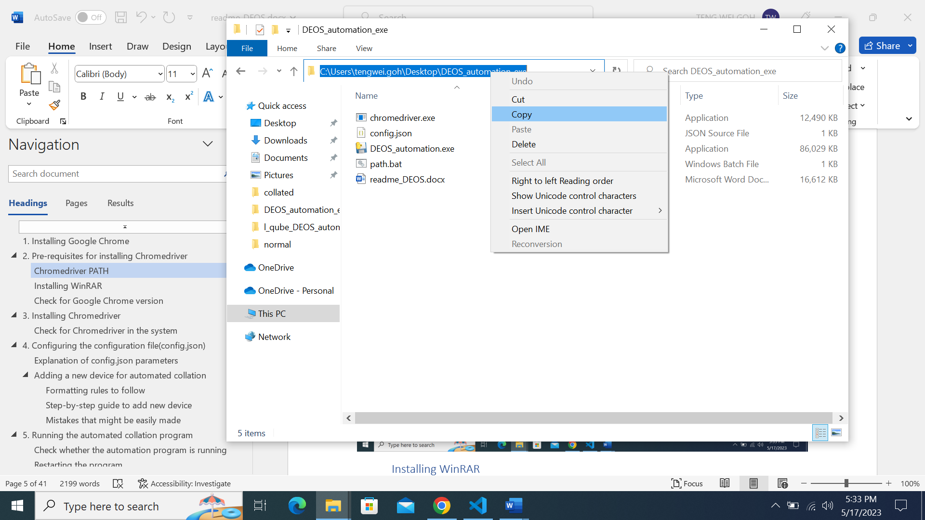

Right-click on the highlighted directory and click on ’Copy’ option.

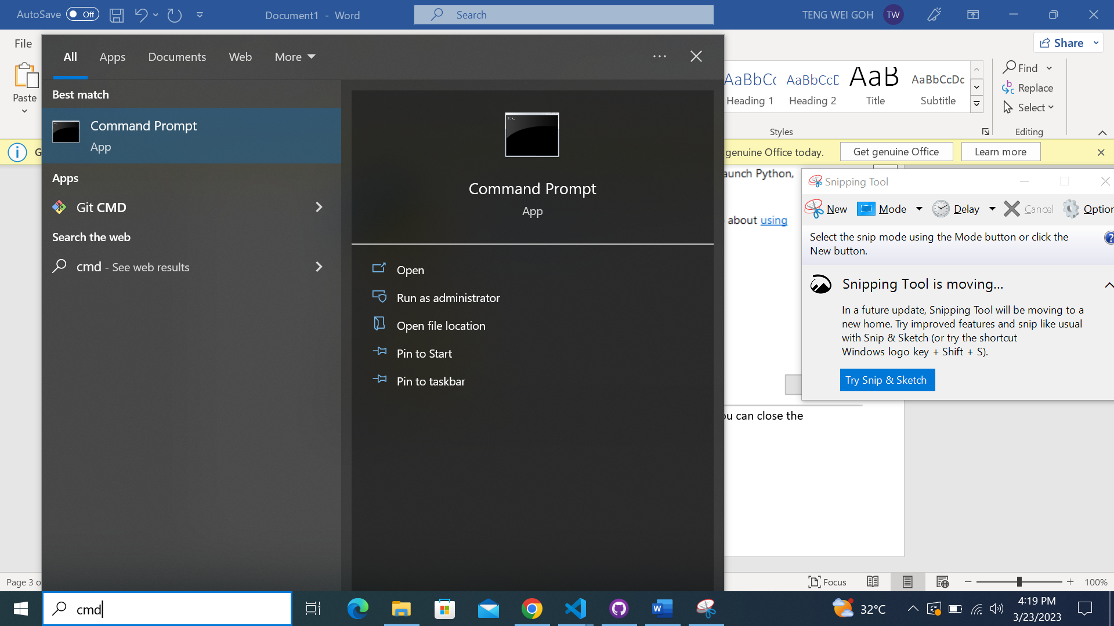

2

1

2. Click the Command Prompt App shown under ‘Best match’.

1. Type in ‘cmd’ into the search bar on Windows

2

1

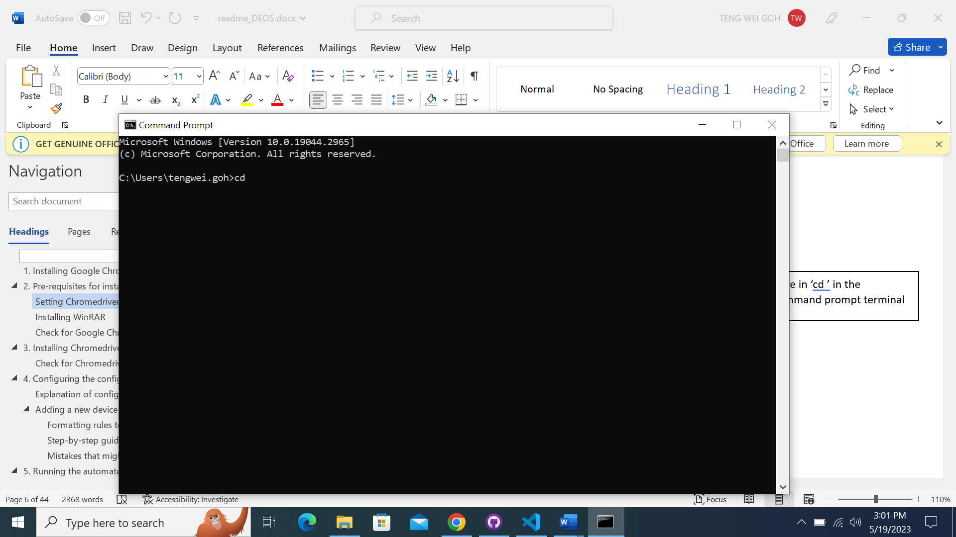

Type in ‘cd ’ in the command prompt terminal.

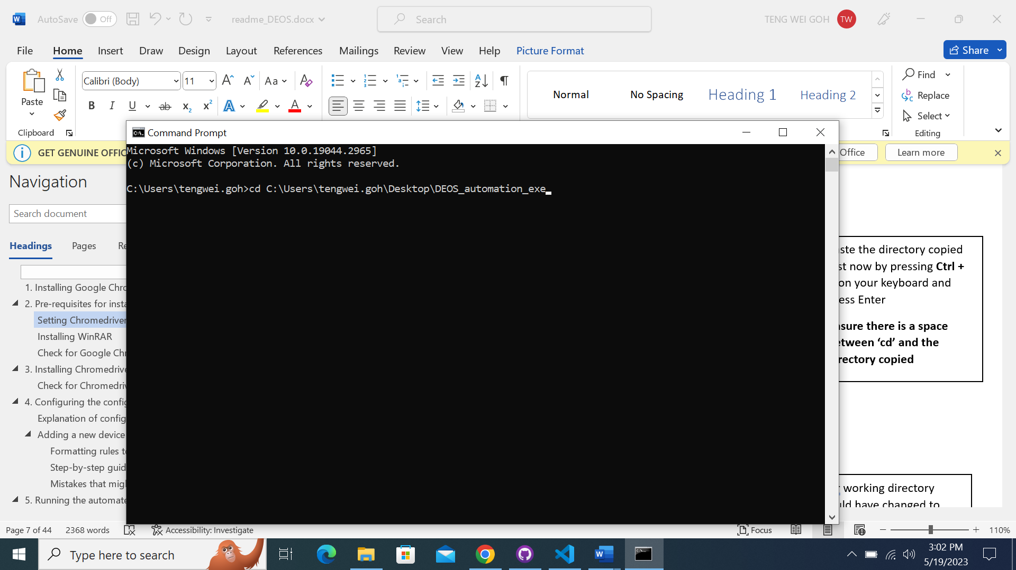

Paste the directory copied just now by pressing **Ctrl + V** on your keyboard and press Enter.

**Ensure there is a space between ‘cd’ and the directory copied.**

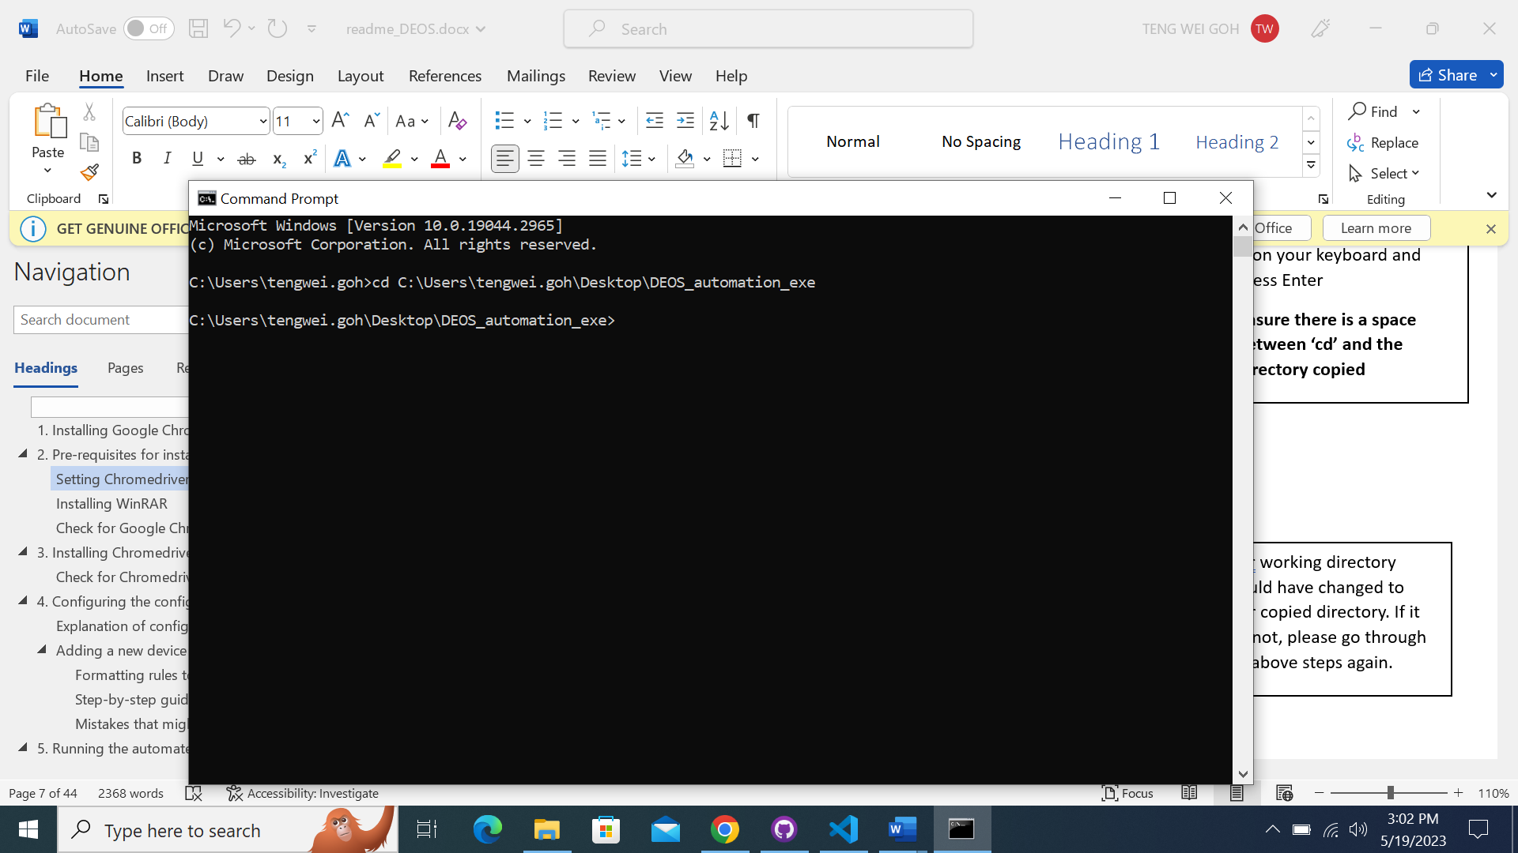

Your working directory should have changed to your copied directory. If it has not, please go through the above steps again.

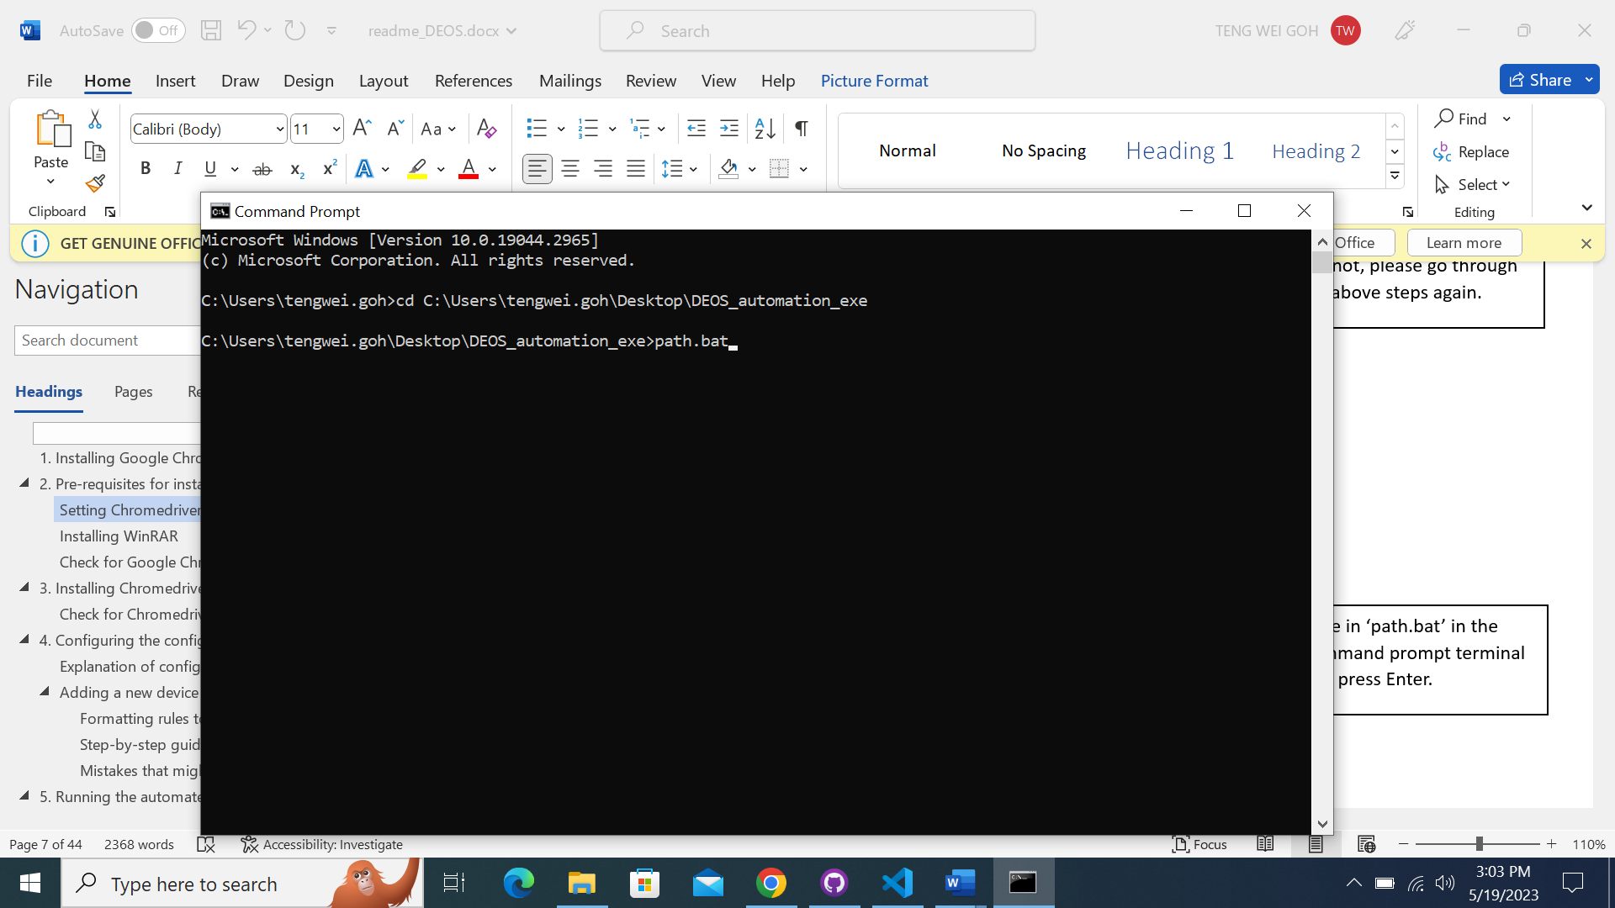

Type in ‘path.bat’ in the command prompt terminal and press Enter.

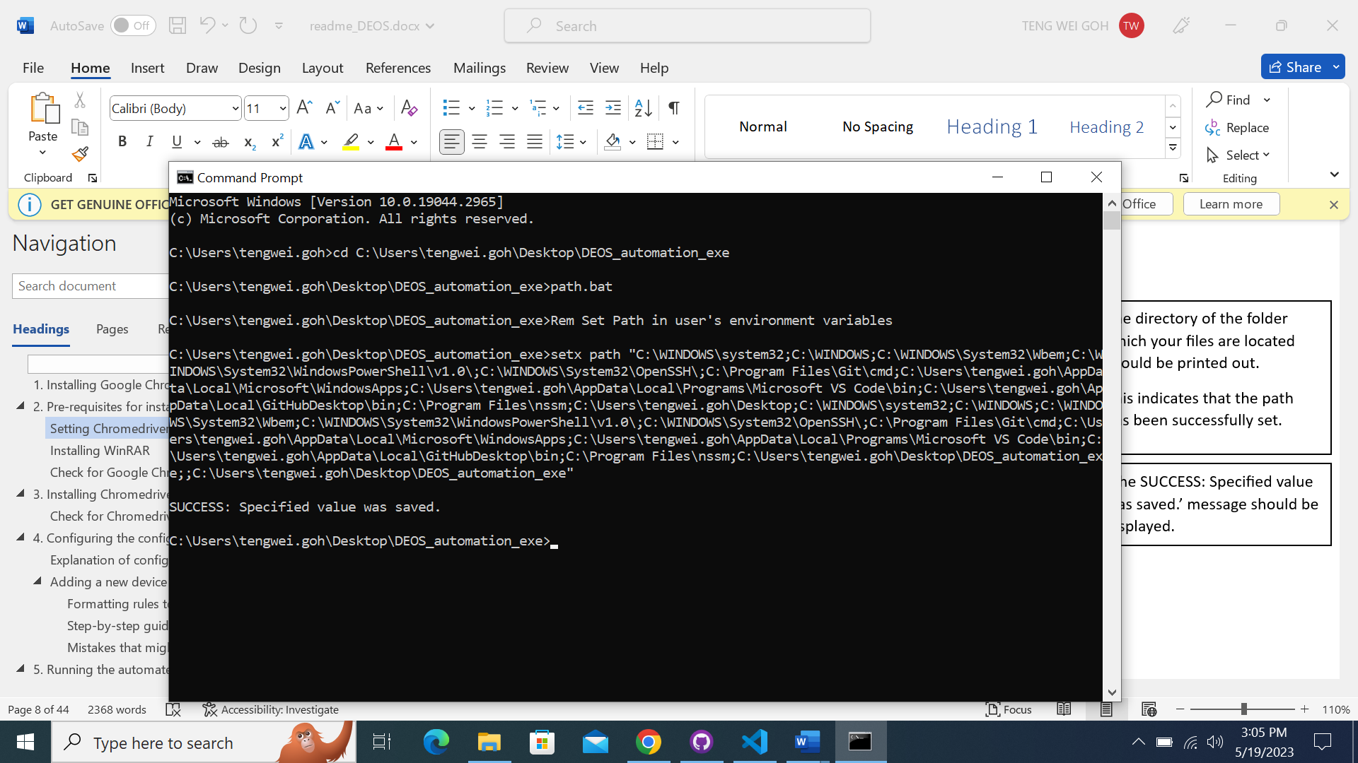

‘The SUCCESS: Specified value was saved.’ message should be displayed.

The directory of the folder which your files are located should be printed out.

This indicates that the path has been successfully set.

You can exit the terminal after ensuring that the directory has been added successfully

## Installing WinRAR

You can skip this step if there is WinRAR or a .zip extractor application on your system.

Head to the website below:

[https:/www.win-rar.com/start.html?&L=0](https://www.win-rar.com/start.html?&L=0)

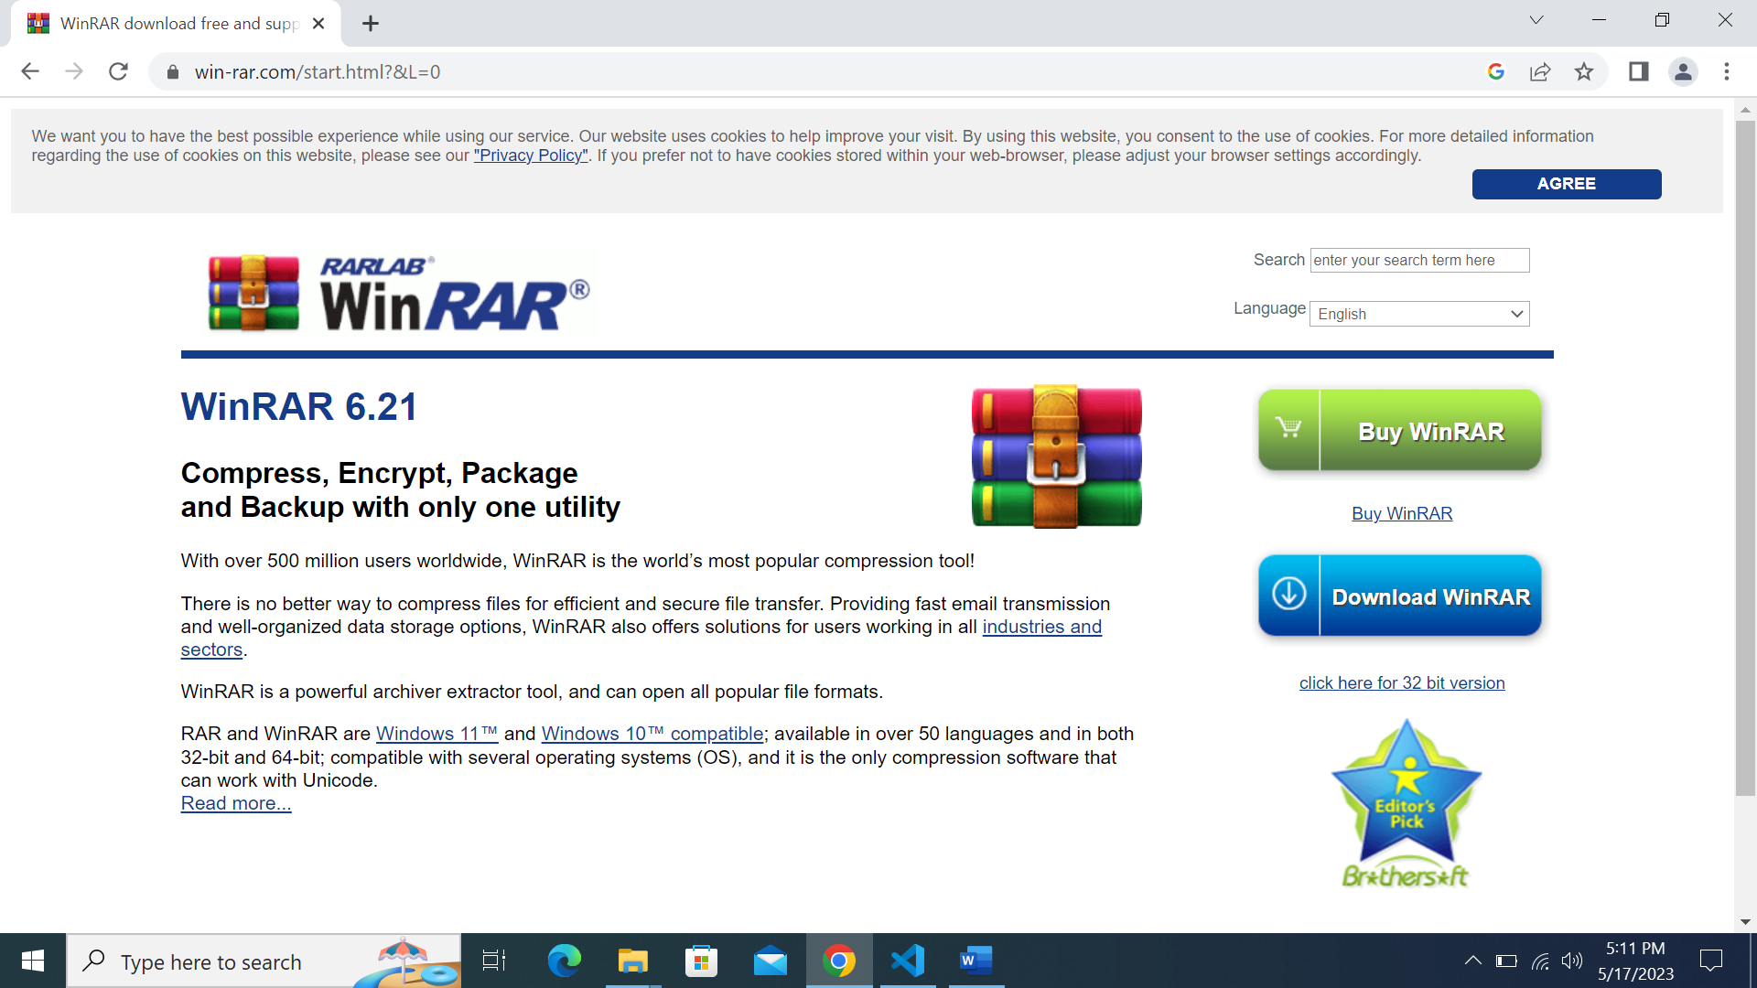

You should be led to this page.

If for some reason the URL has been changed, please Google Search ‘winrar download’. It should be the first result displayed.



Click on ‘Download WinRAR’

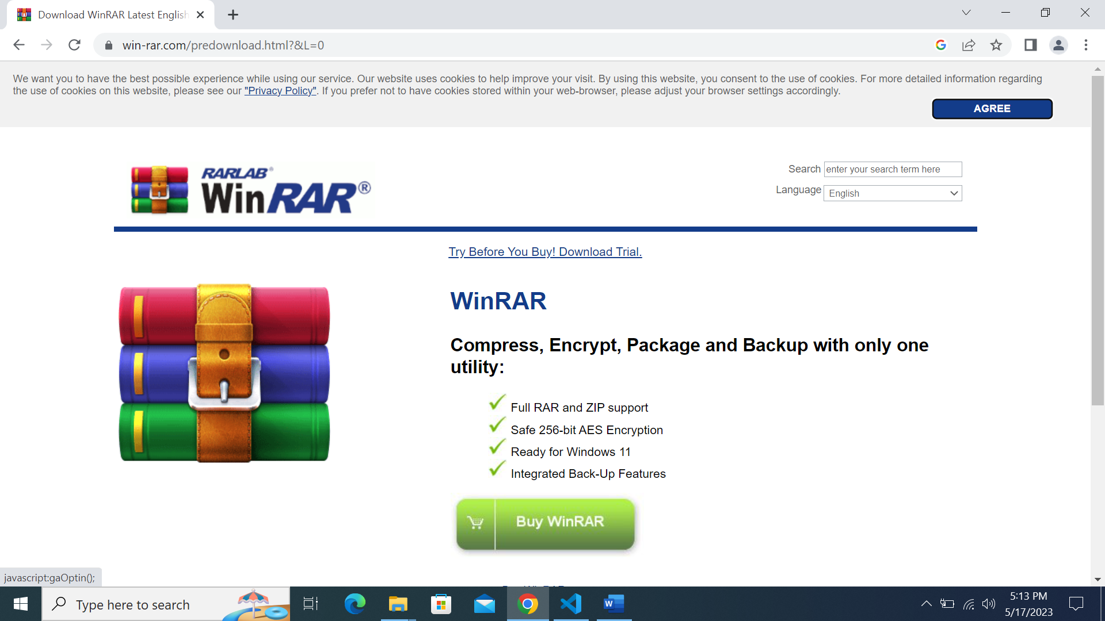

You should be led to this page.

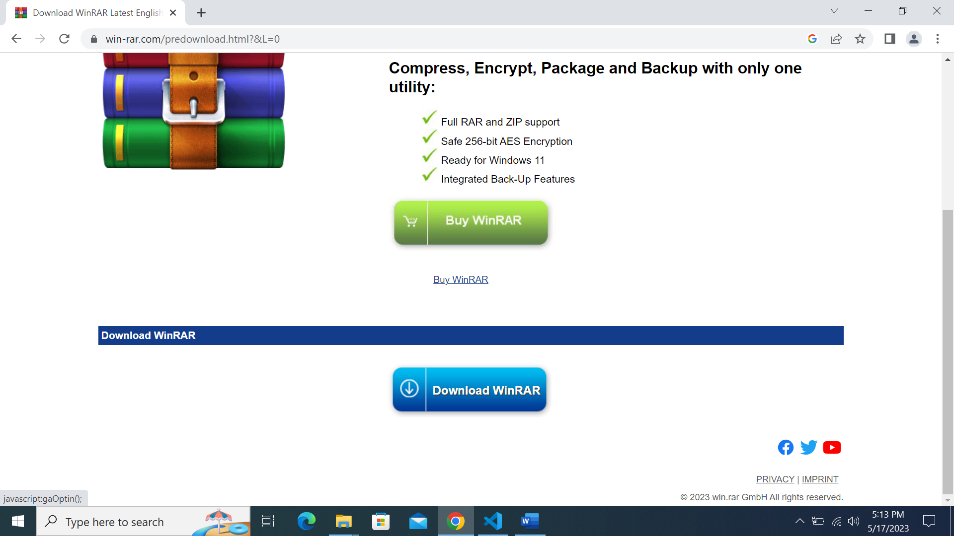

Scroll down and click ‘Download WinRAR’.

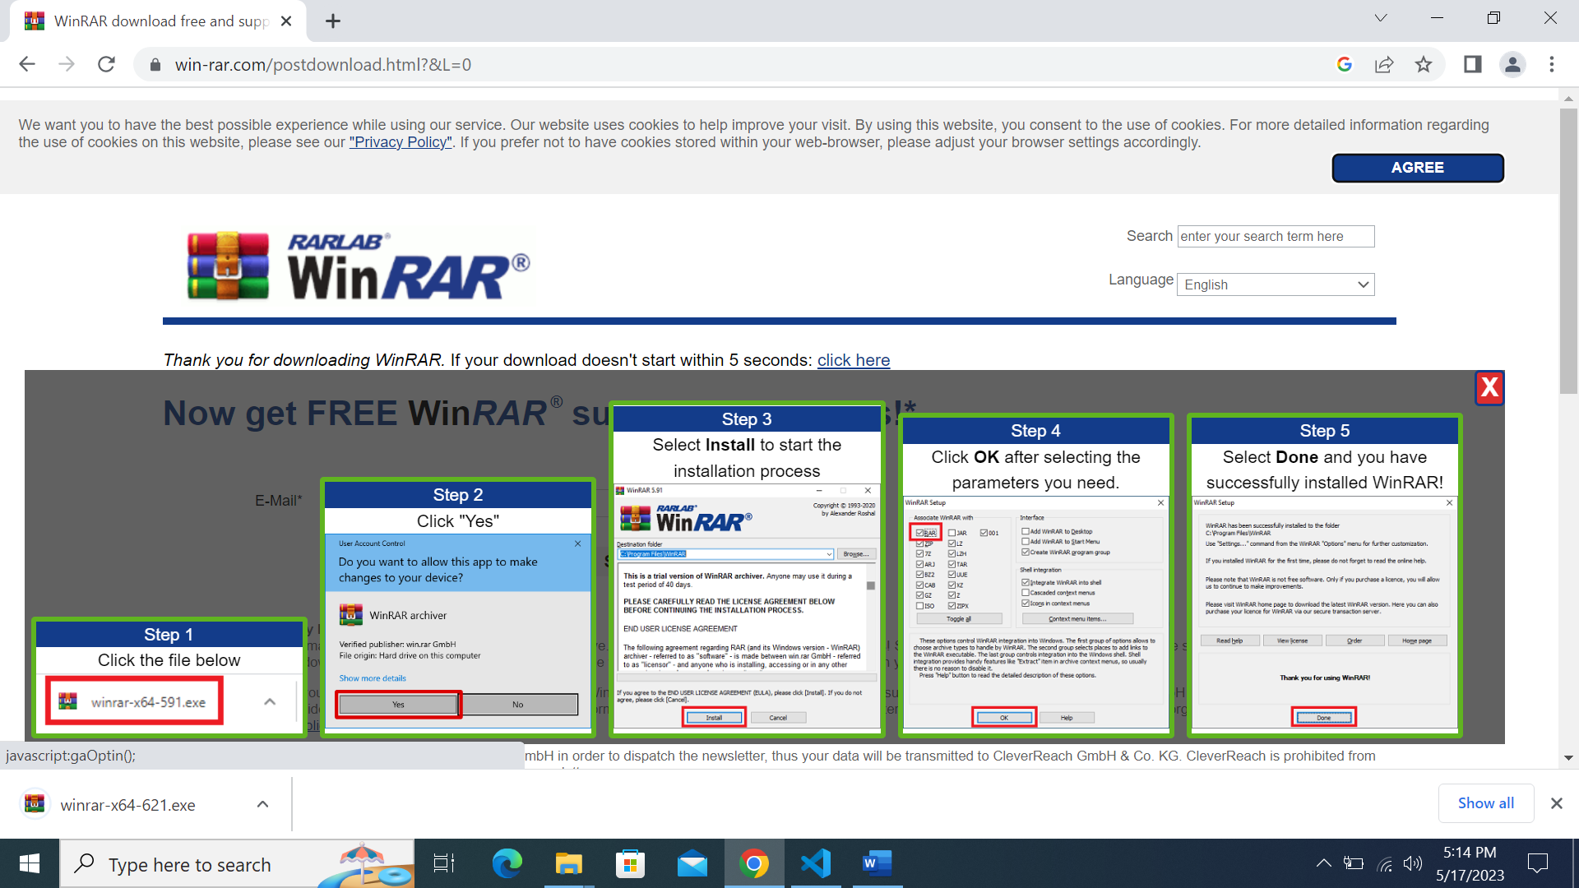

Download will begin automatically, and you can follow the instructions provided by the WinRAR website.

## Check for Google Chrome version

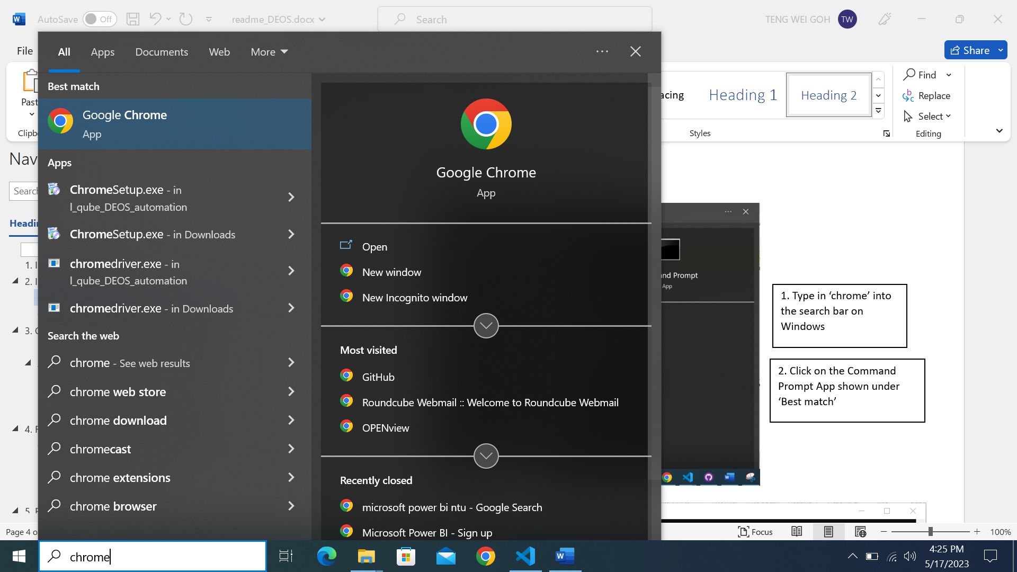

2. Click on the Google Chrome App shown under ‘Best match’.

1. Type in ‘chrome’ into the search bar on Windows.

1

2

1

2

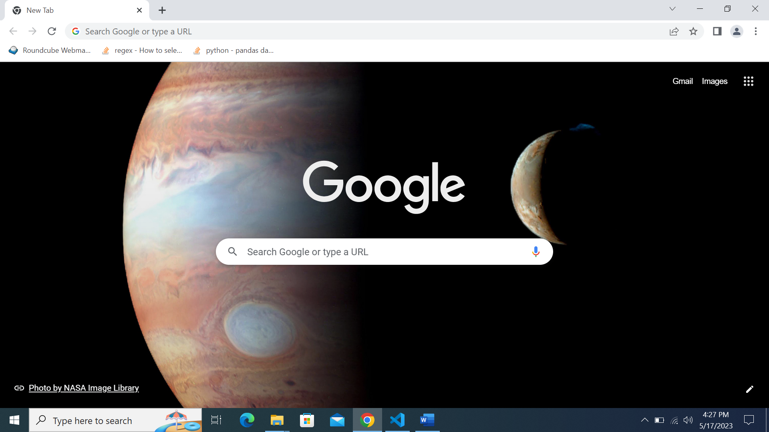

A similar display will be shown once the Google Chrome browser is launched.



At the top right, click More 

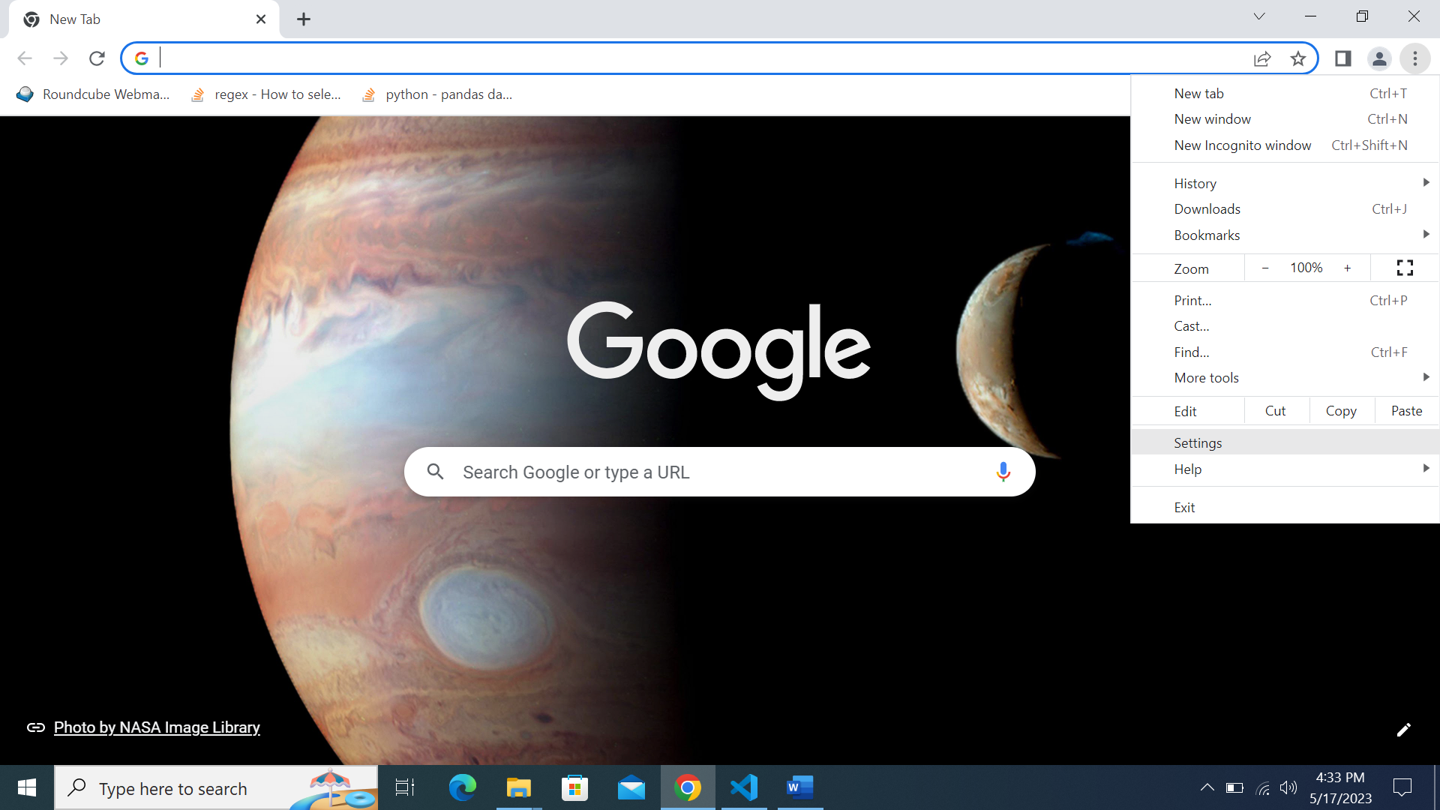

Click Settings

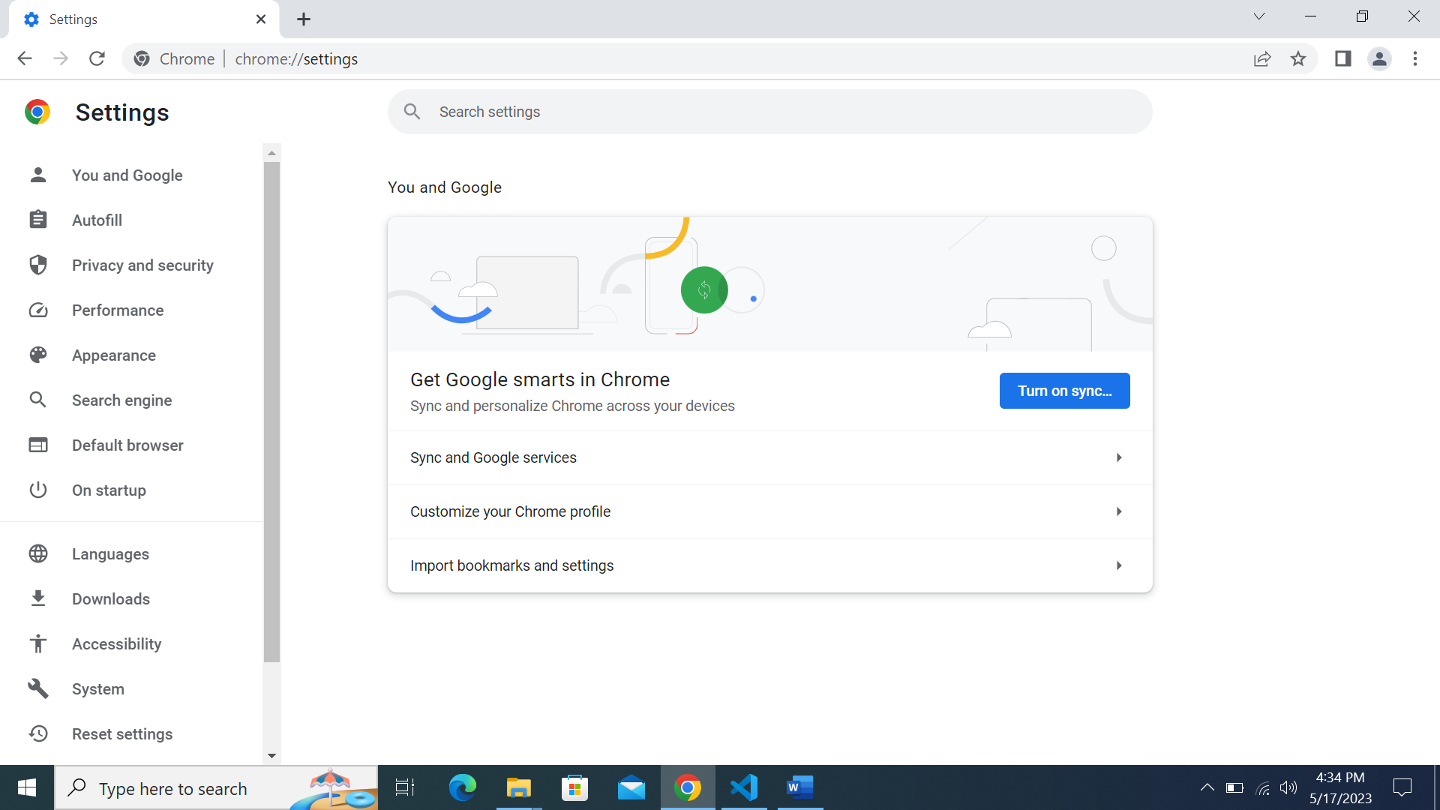

You should be directed to this page.

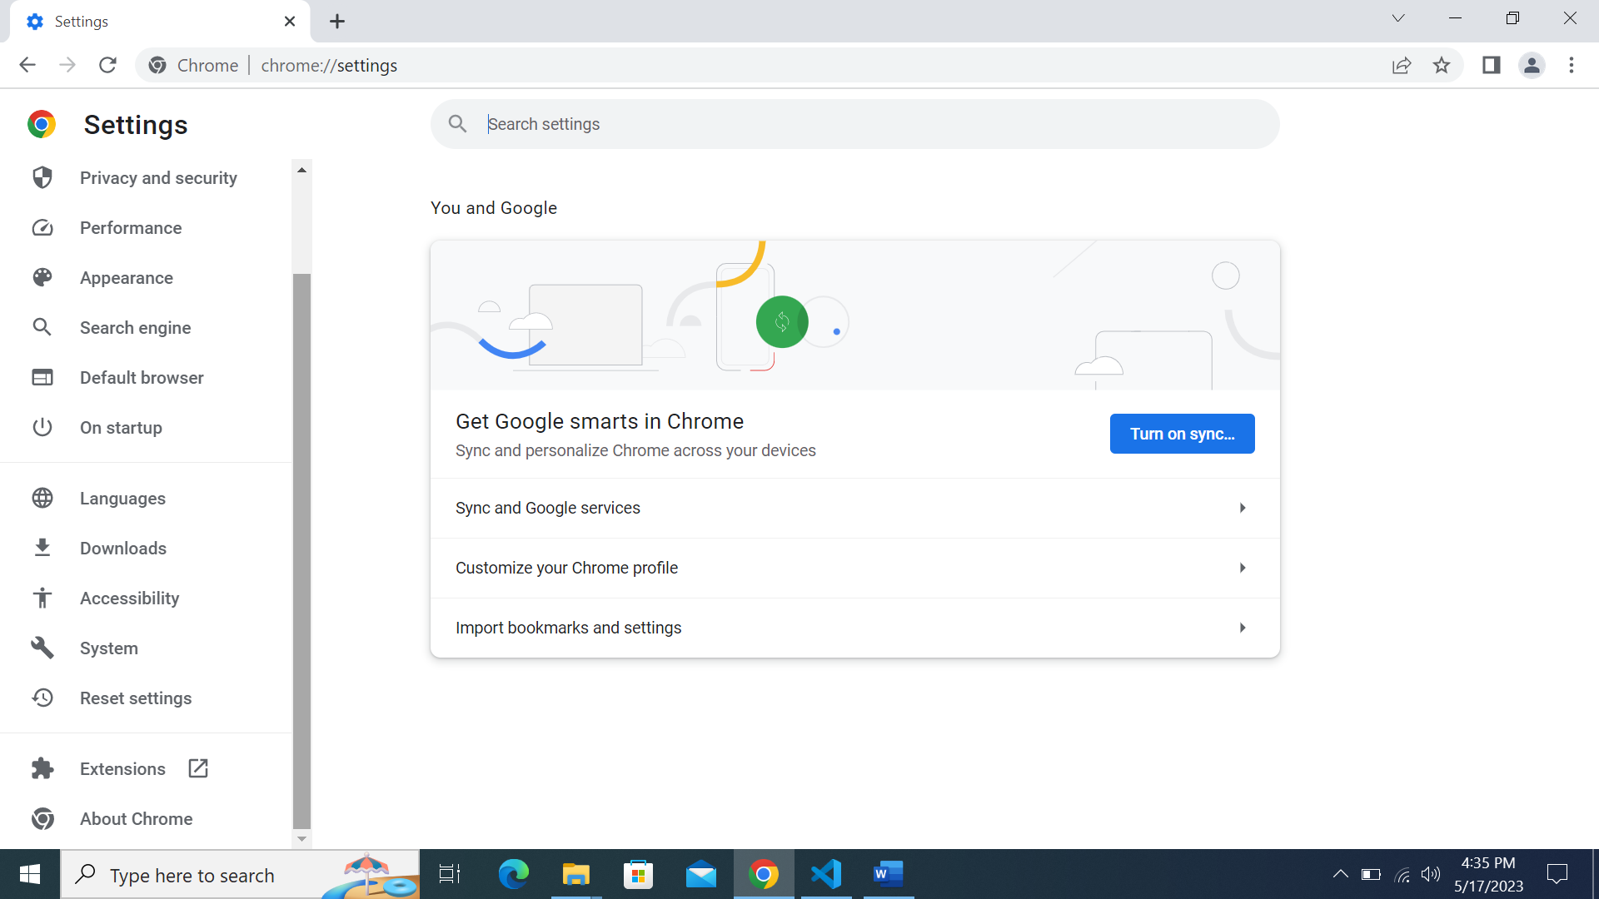

Scroll down using the scroll bar on the left.

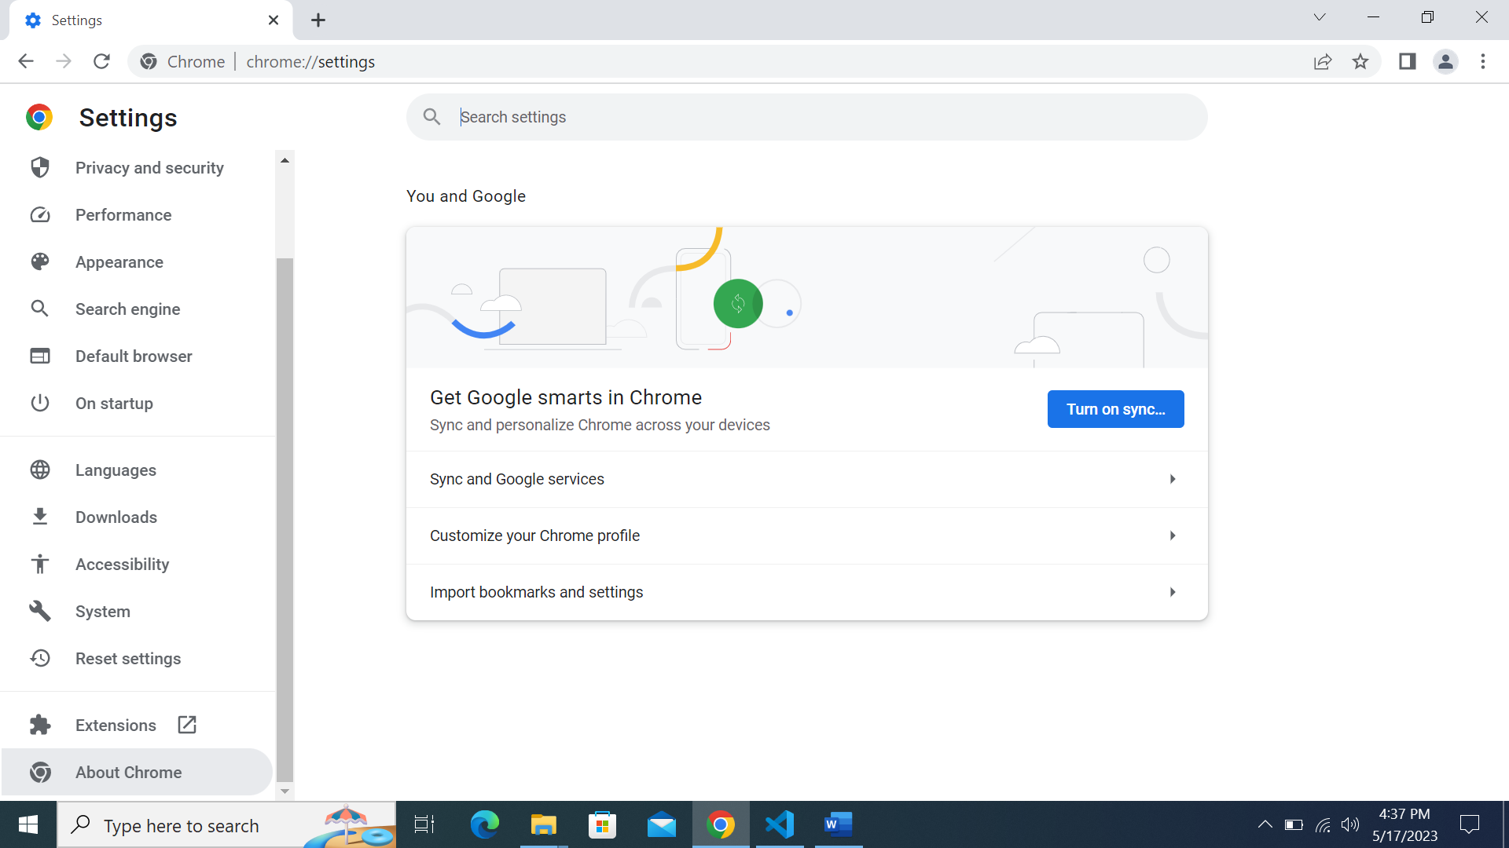

Click on ‘About Chrome’.

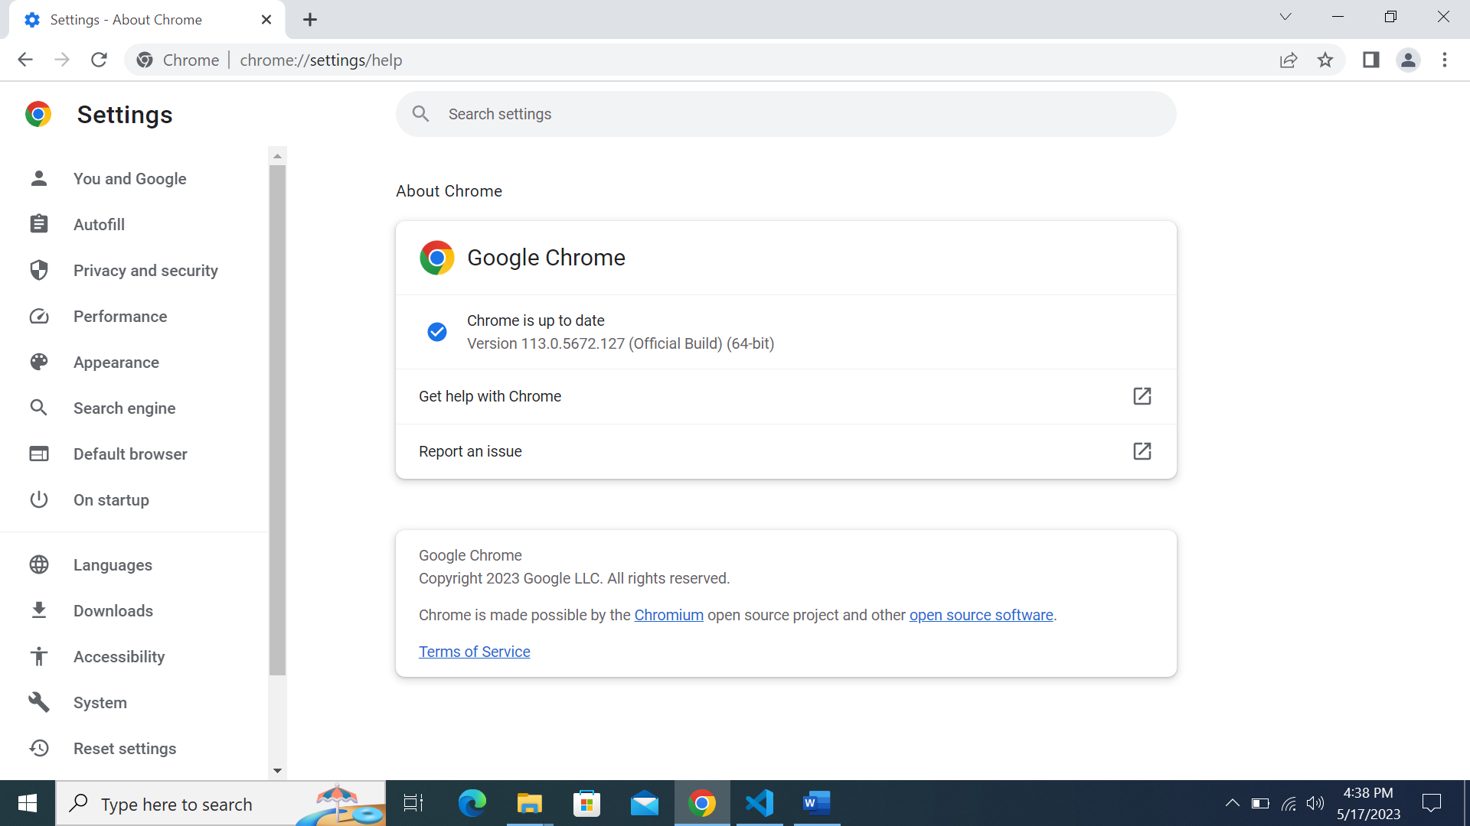

You should be brought to this page.



Take note of the version of Google Chrome, which will be used later.

Only the major version number is required.

I.e., In this case, the version of Chrome we are using is 113.

# Installing Chromedriver

Head to the website below:

[https:/chromedriver.chromium.org/downloads](https://chromedriver.chromium.org/downloads)

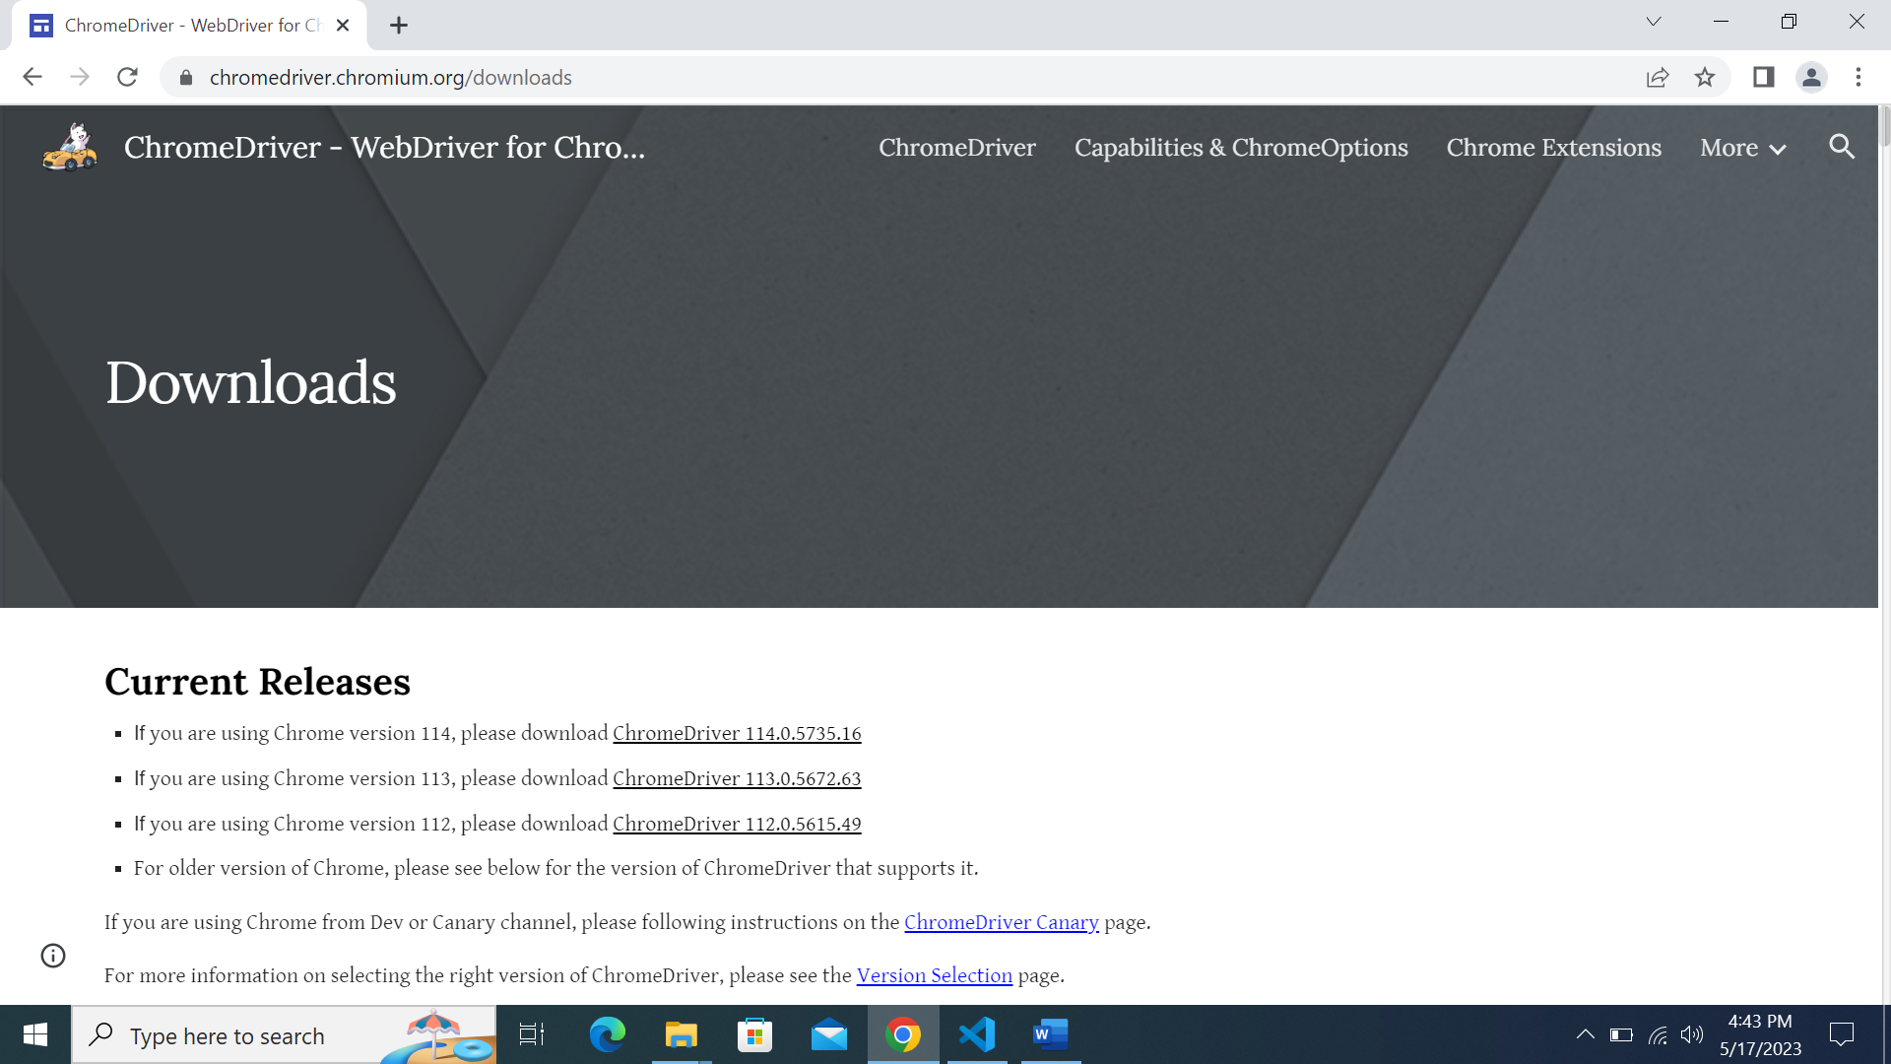

You should be led to this page.

If for some reason the URL has been changed, please Google Search ‘Chromedriver download’. It should be the first result displayed.



Remember the version of Google Chrome we checked earlier?

The version of Google Chrome will be used to download the corresponding version of Chromedriver.



In my example, I am using Chrome version 113. Hence, I will click on the Chromedriver for Chrome version 113.

Please download the corresponding Chromedriver w.r.t your Chrome version.

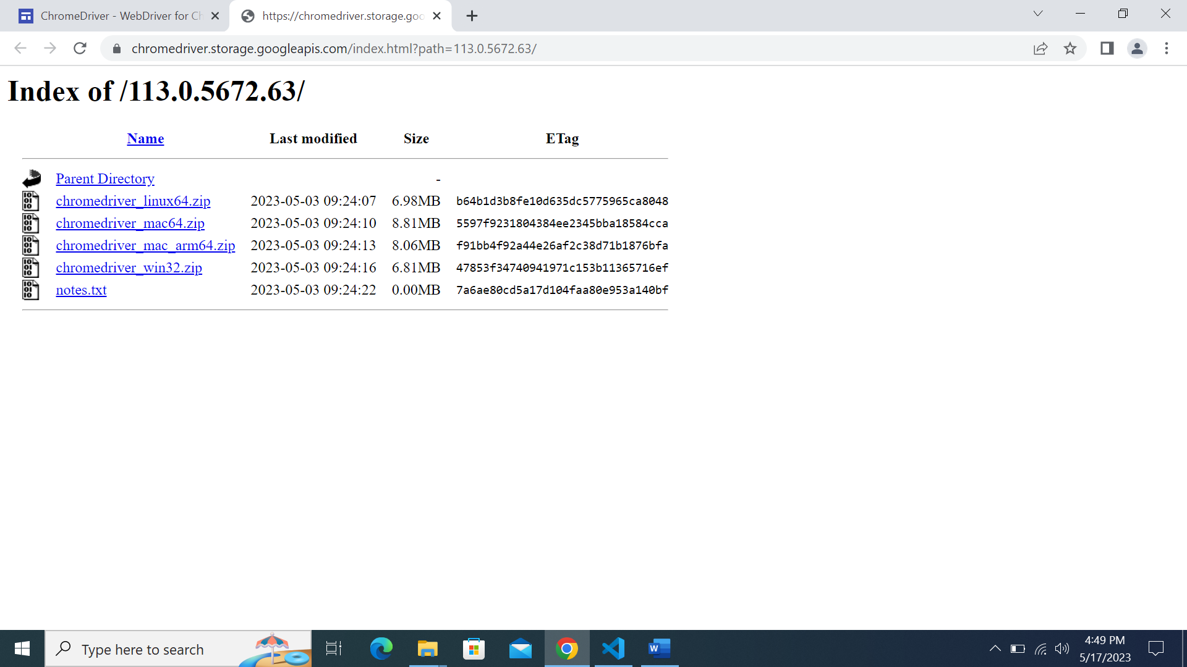

You should be brought to this page after clicking on the Chromedriver download link.

Take note that you are on the right Chromedriver version required.



Click on ‘chromedriver_win32.zip’.

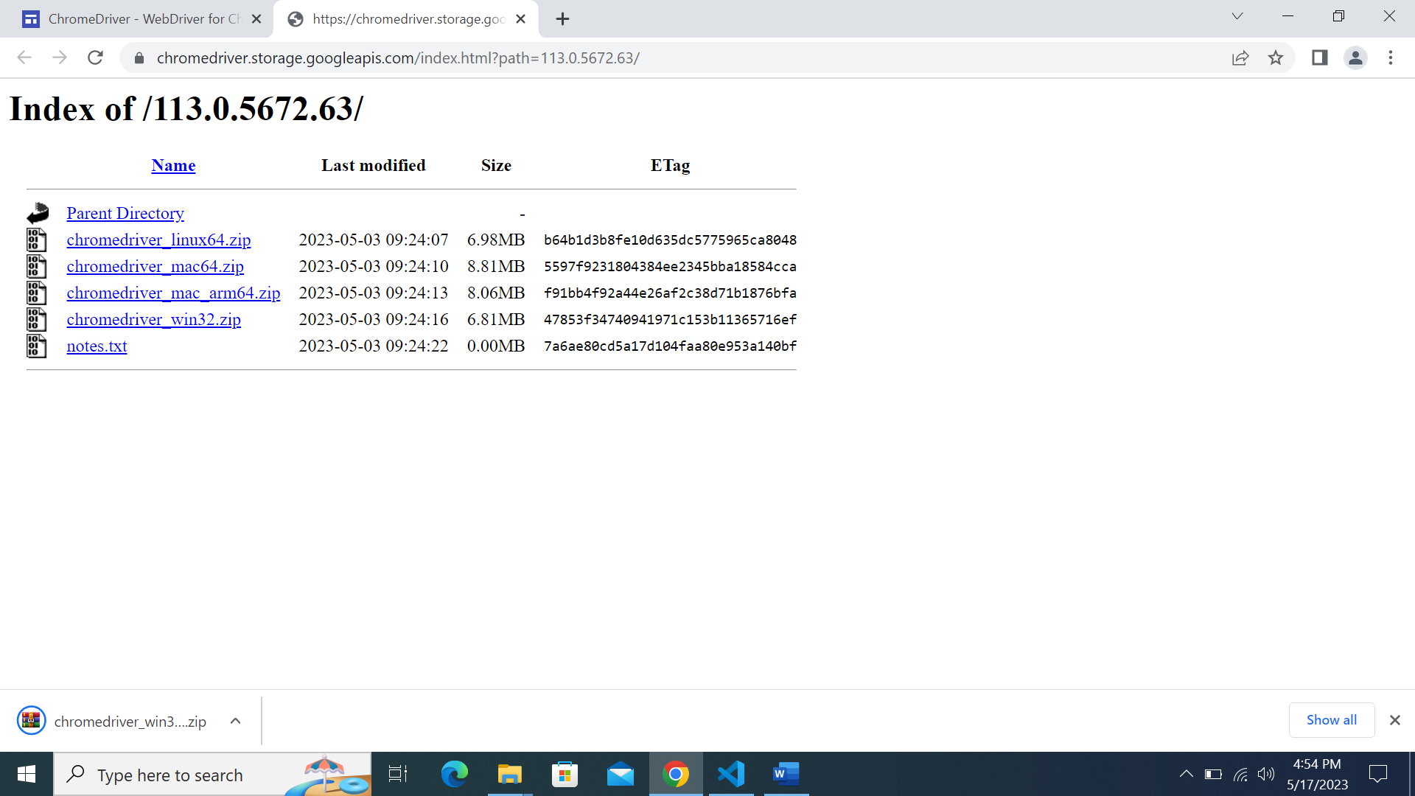

The download will begin automatically.

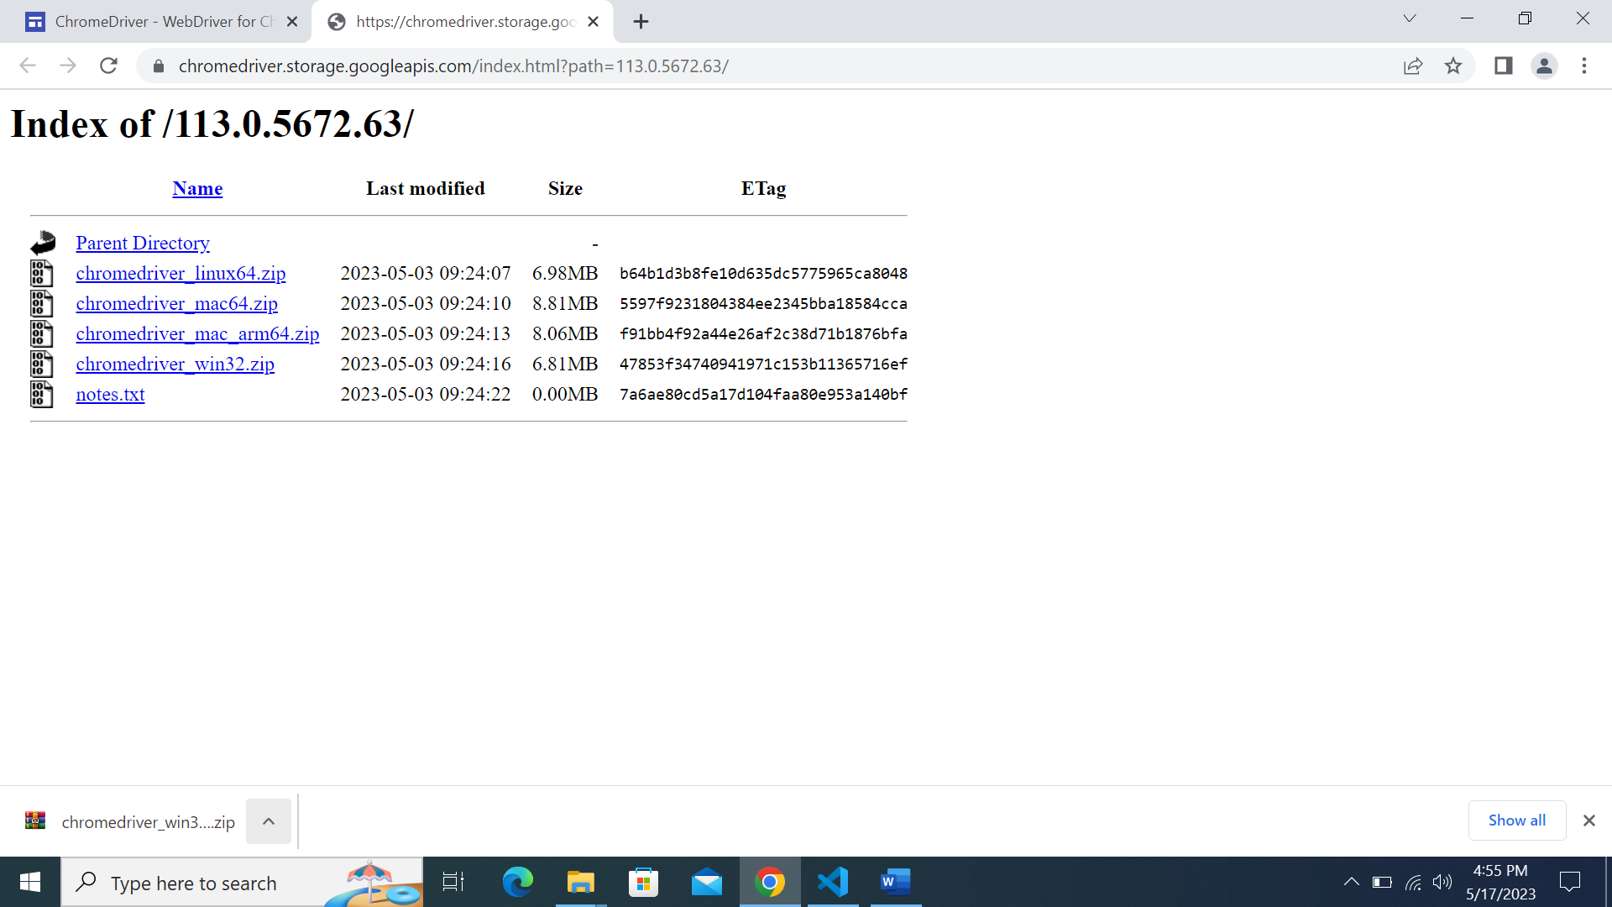

After the download finishes, click on the ^ button.

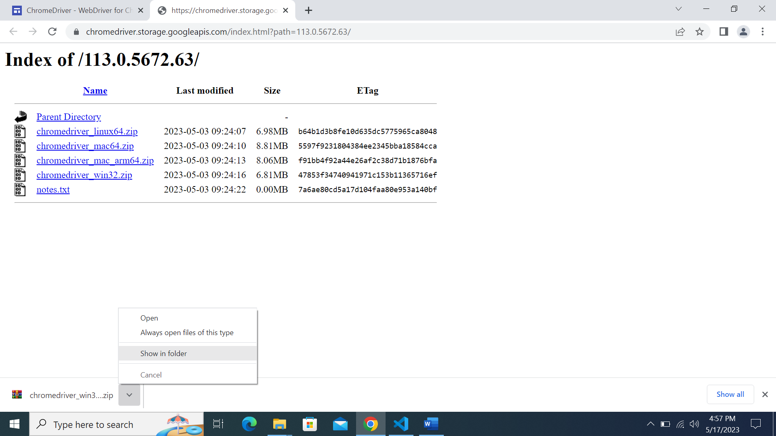

Click on ‘Show in Folder’ option.

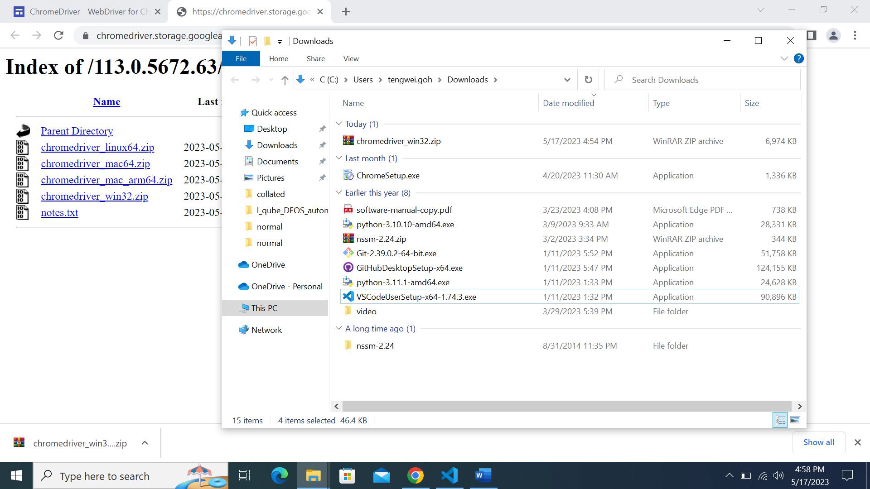

You should be brought to your Downloads directory with the downloaded chromedriver_win32.zip.

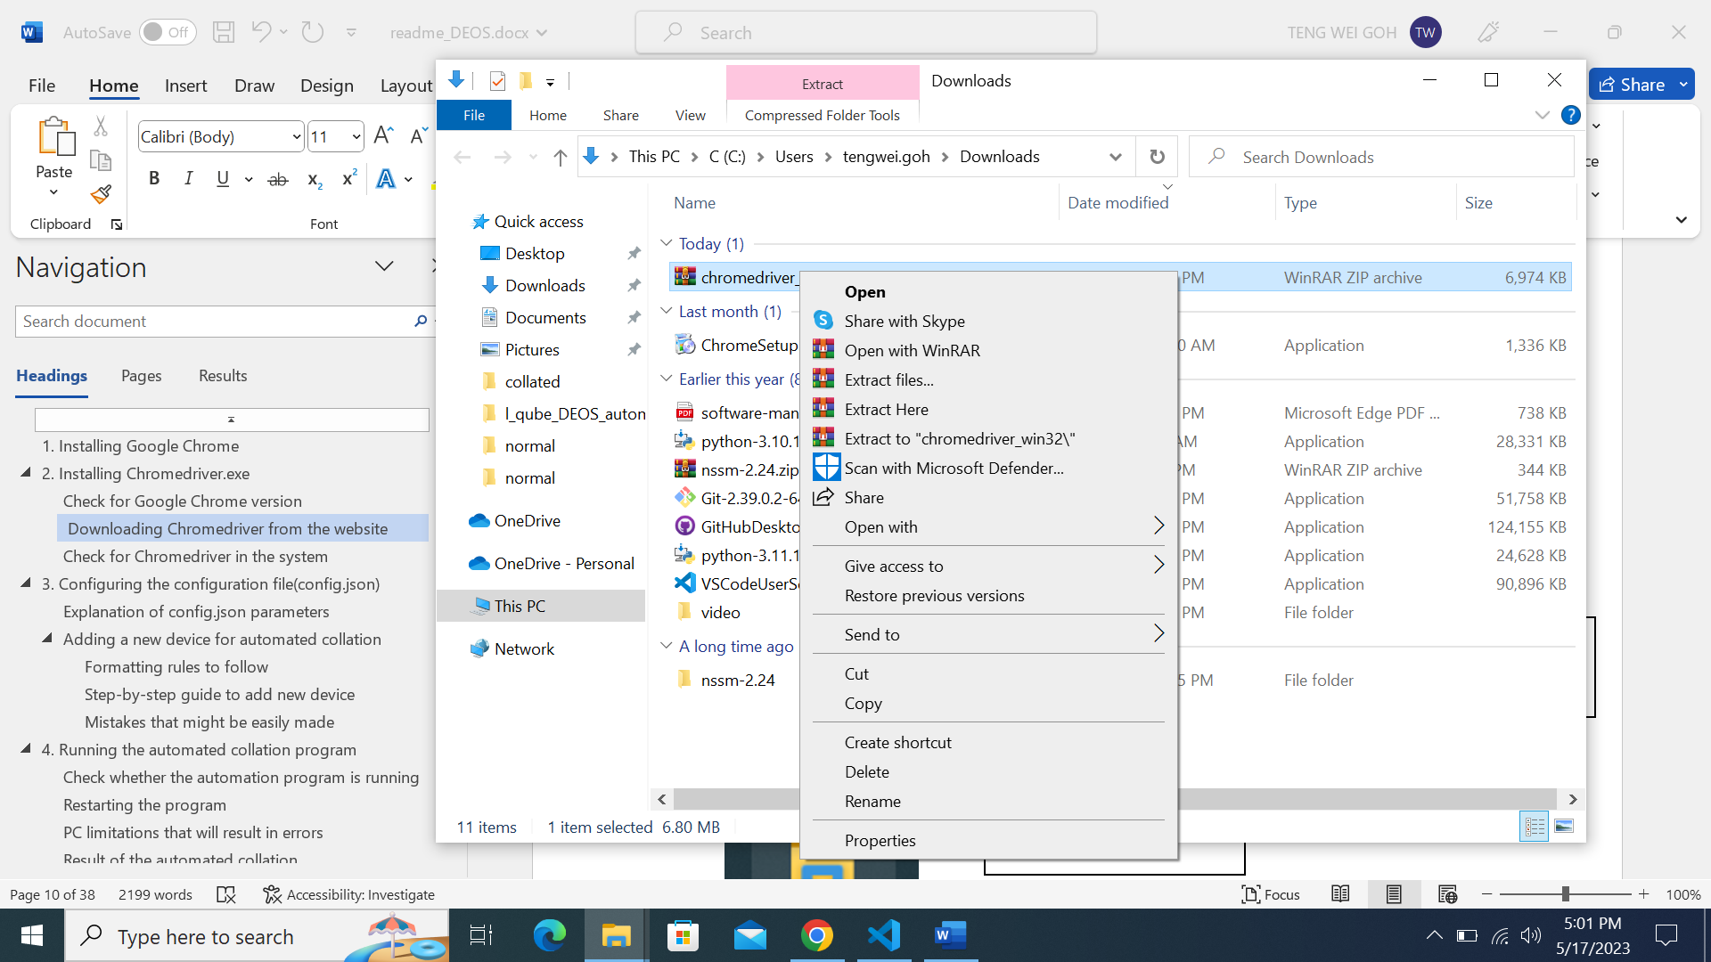

Right-click on the file

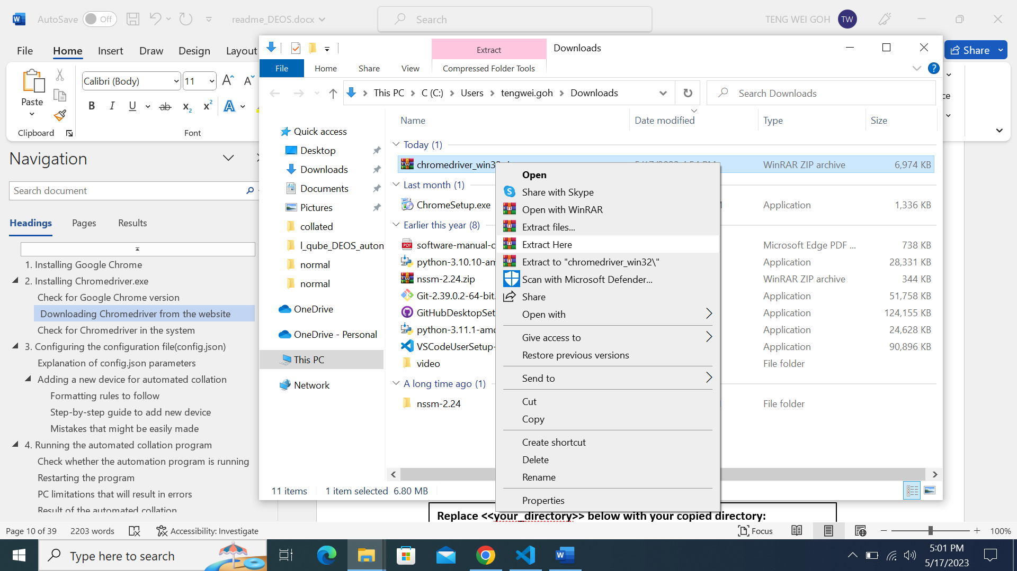

Click on ‘Extract Here’ option.

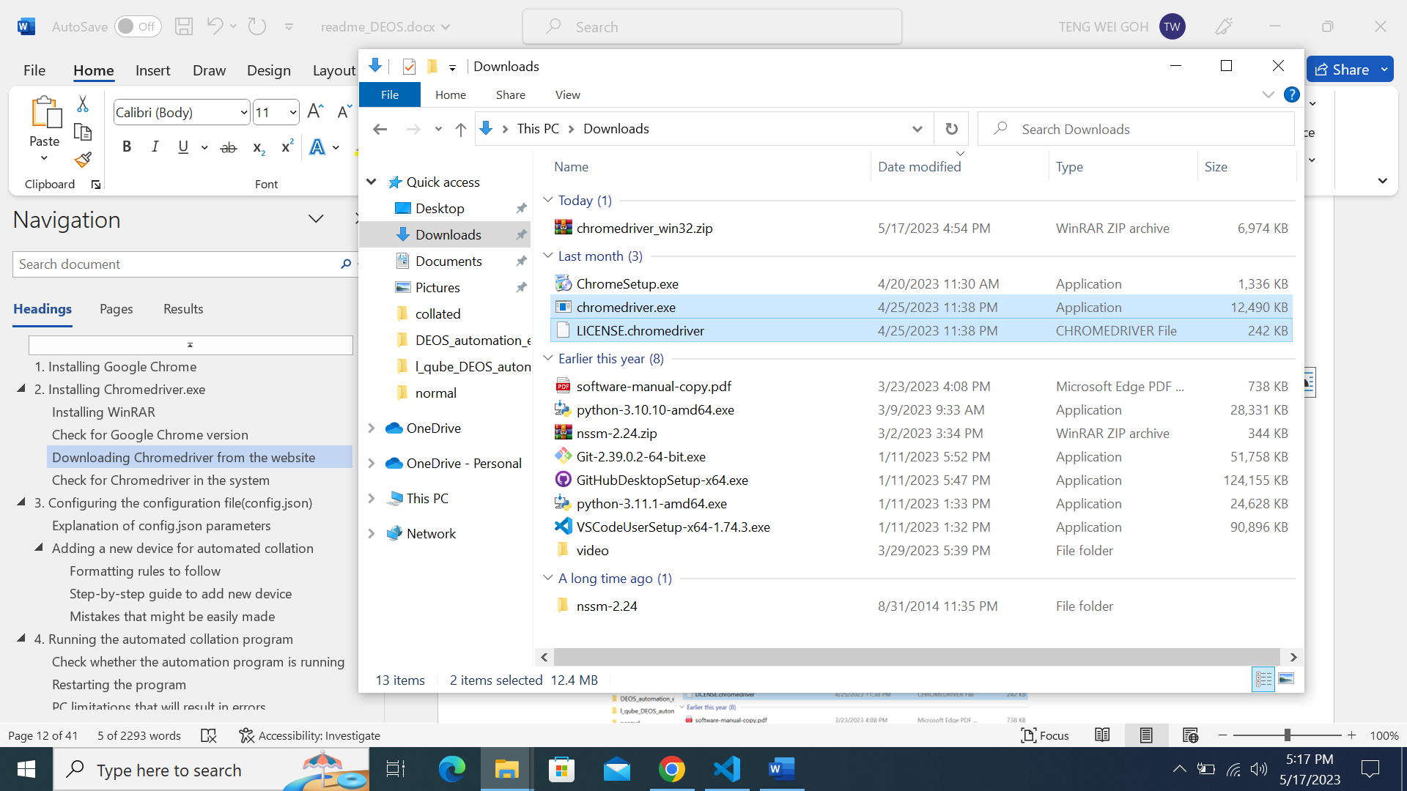

These 2 files should be extracted.

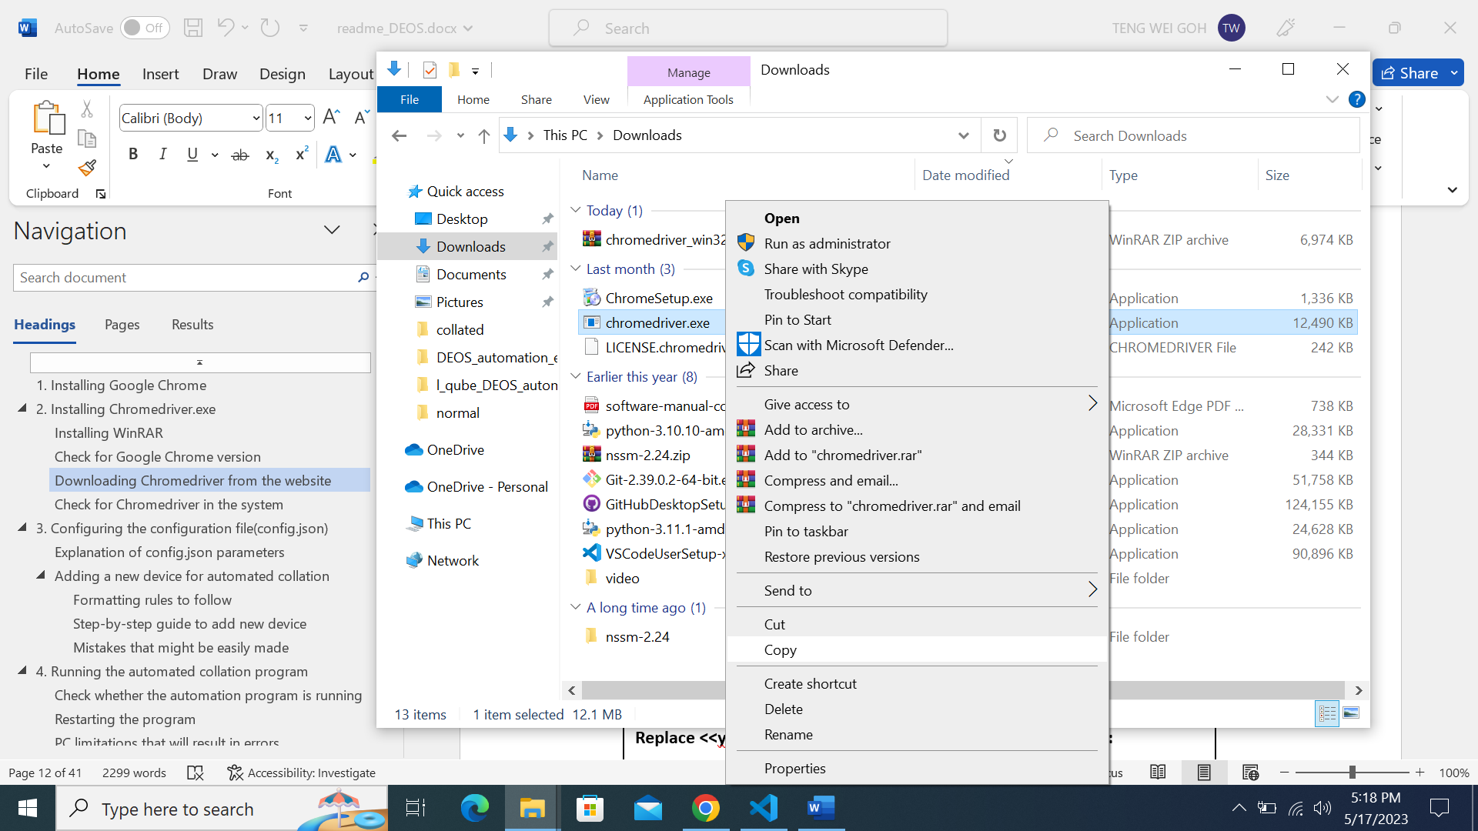

Copy chromedriver.exe: Right-click ‘chromedriver.exe’ file and click on ‘Copy option.

Or

CTRL + C

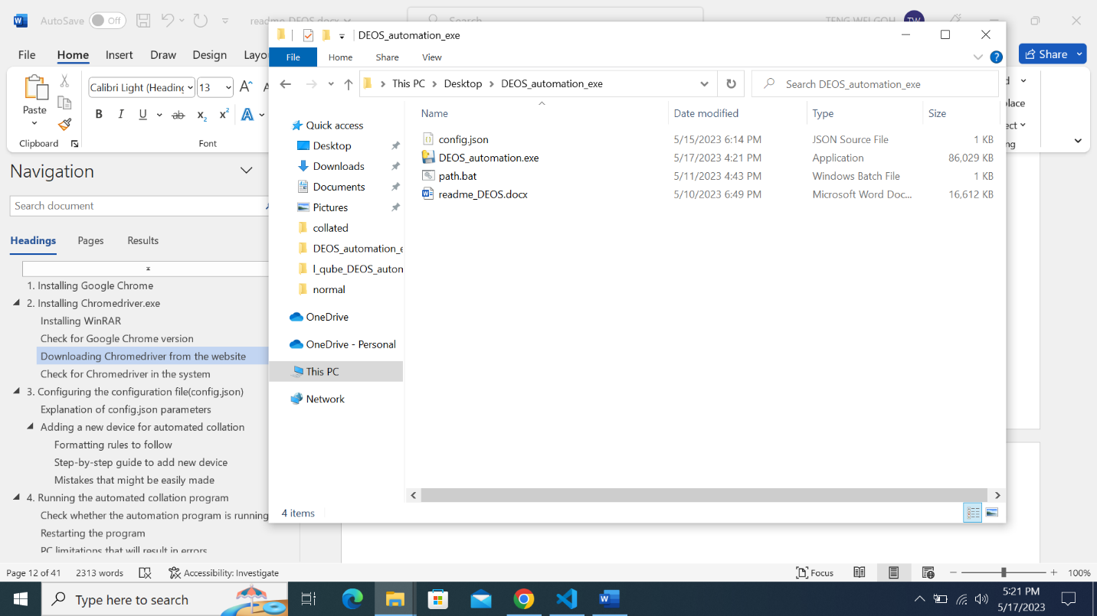

Navigate to the folder where the files are located.

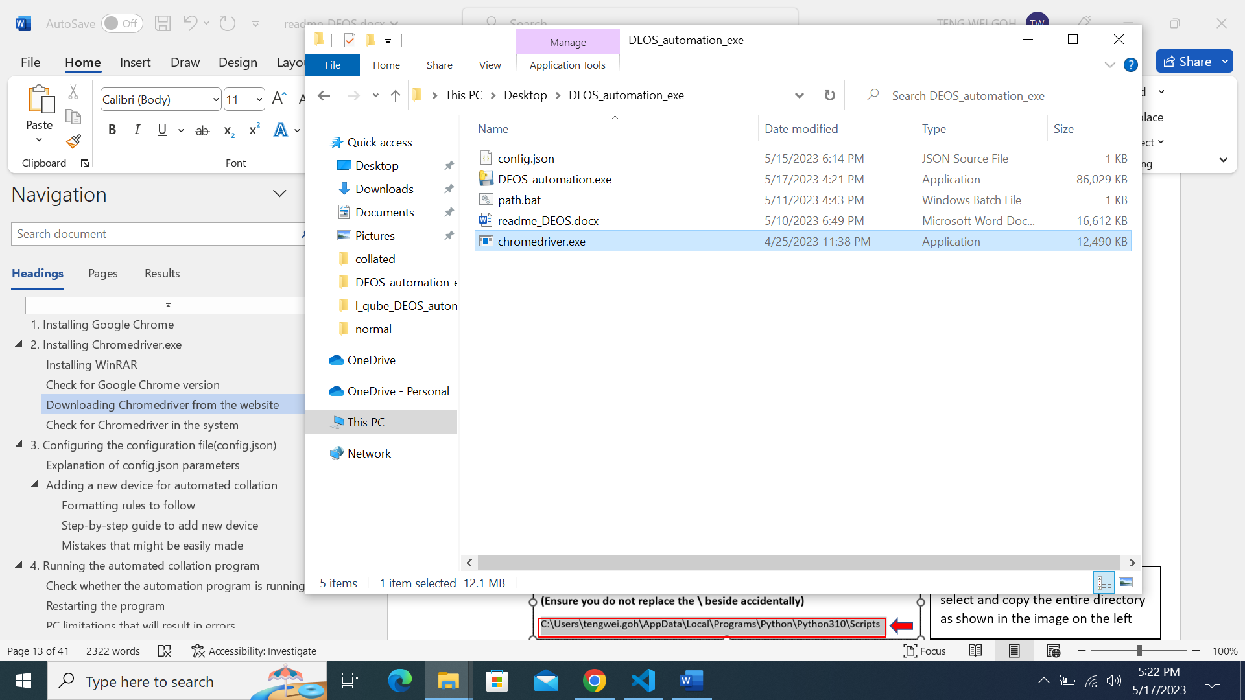

Paste the copied chromedriver.exe into the folder as shown and you are done for this step.

## Check for Chromedriver in the system



2. Click on the Command Prompt App shown under ‘Best match’.

1. Type in ‘cmd’ into the search bar on Windows

2

1

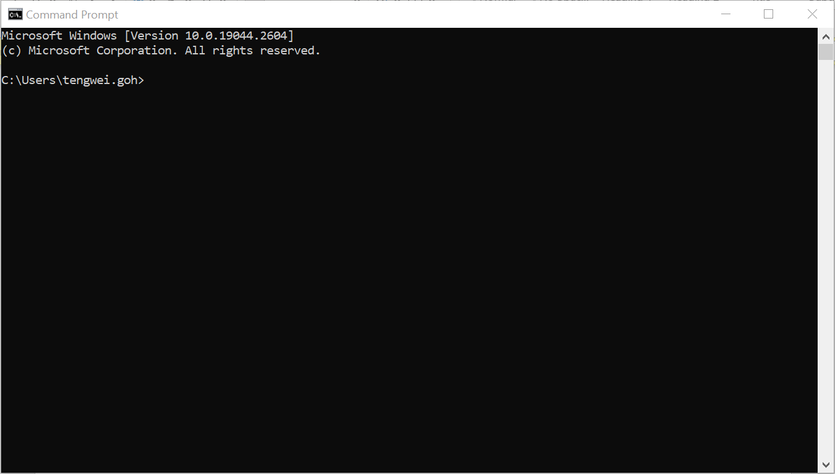

This terminal will show up once the Command Prompt App is Clicked

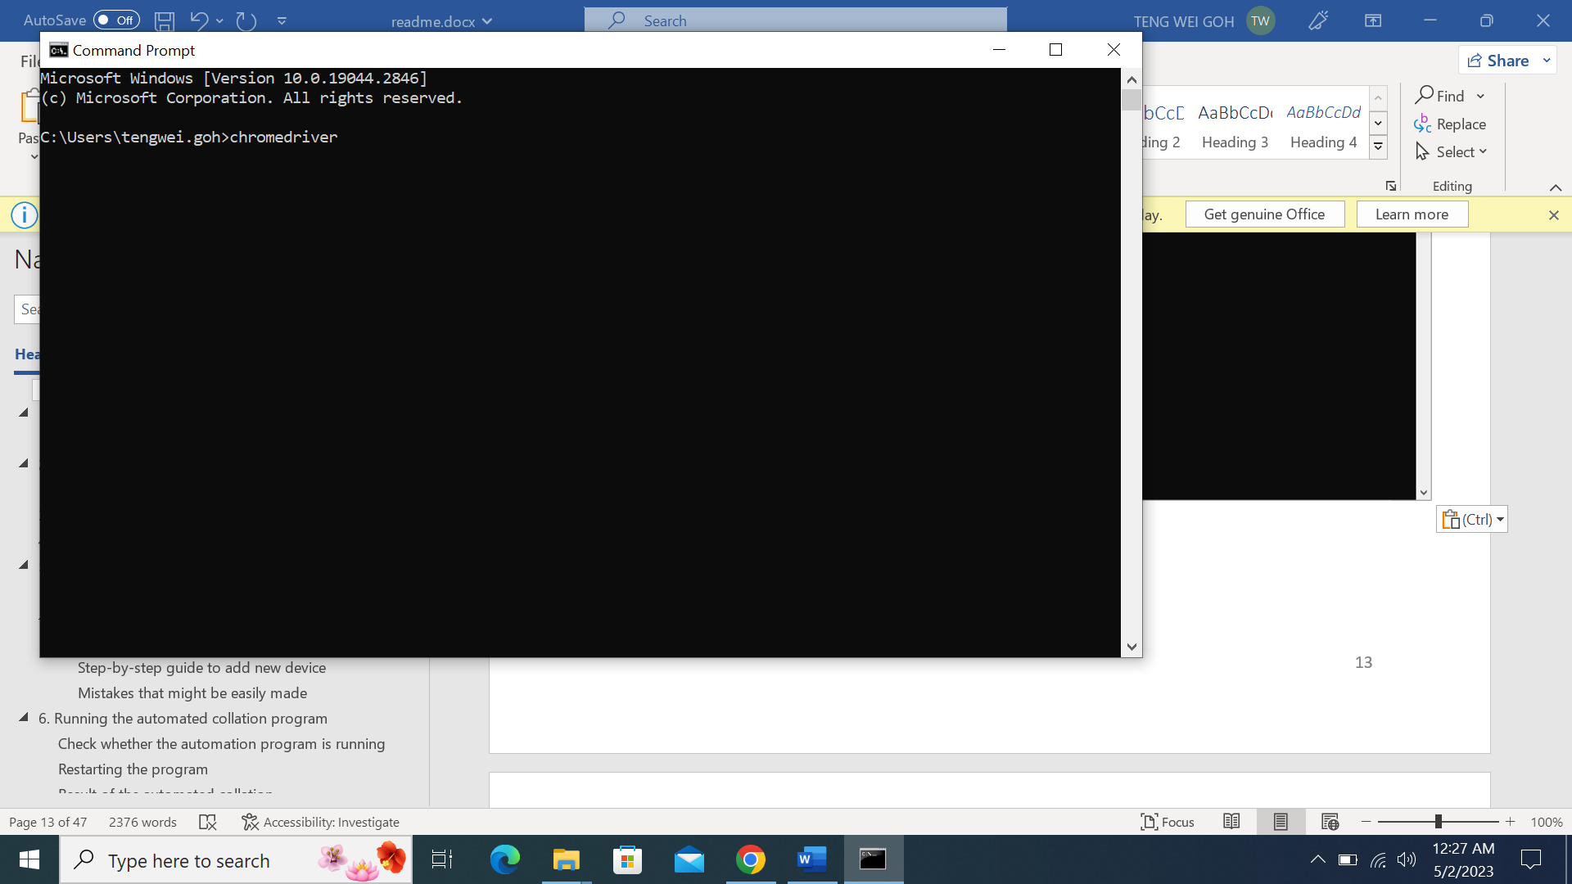

Type in ‘chromedriver’ into command prompt and press Enter.

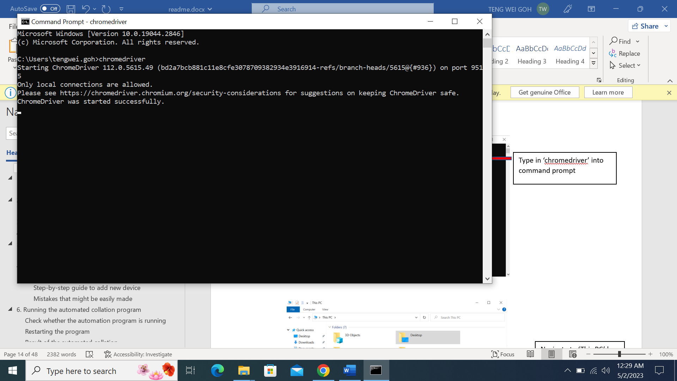

You should see the following message printed. This means that chromedriver has been successfully installed and you can close the command prompt and the file explorer.

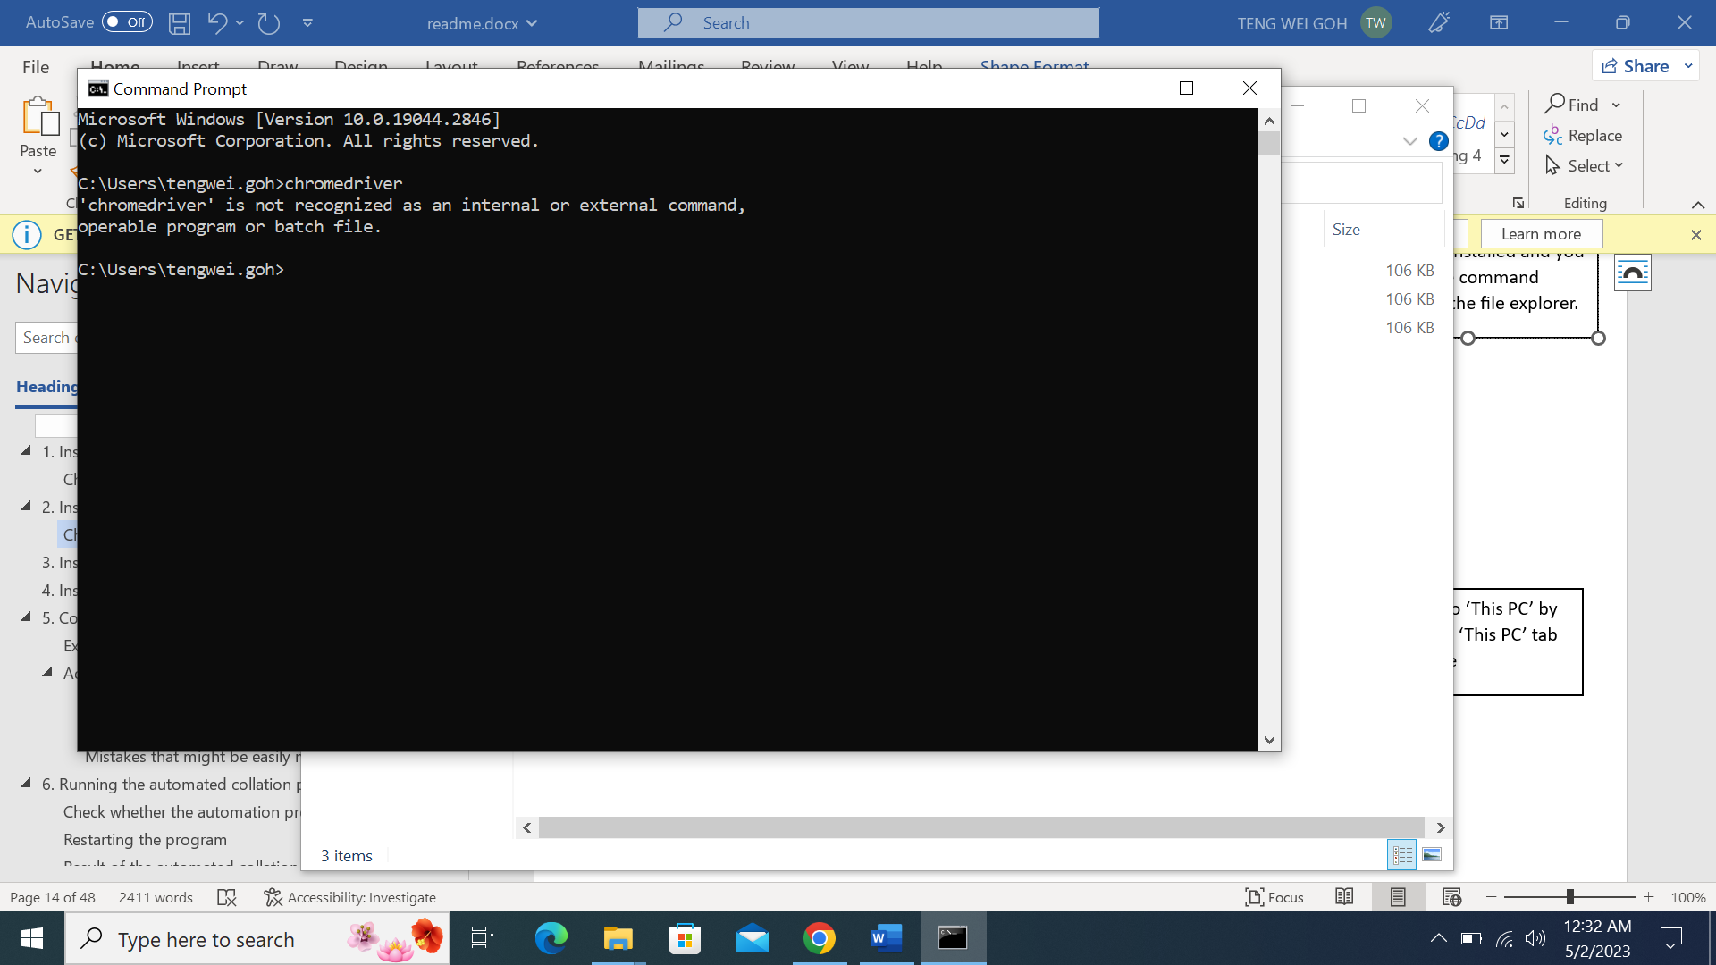

If the chromedriver.exe is not present in the directory set previously, then this message will be printed.

Please repeat the steps above to ensure chromedriver is successfully installed.

# Running DEOS user interface application

**You do not need the Internet for the rest of the steps in this readme. Feel free to disconnect from the Internet if you wish to.**

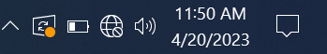

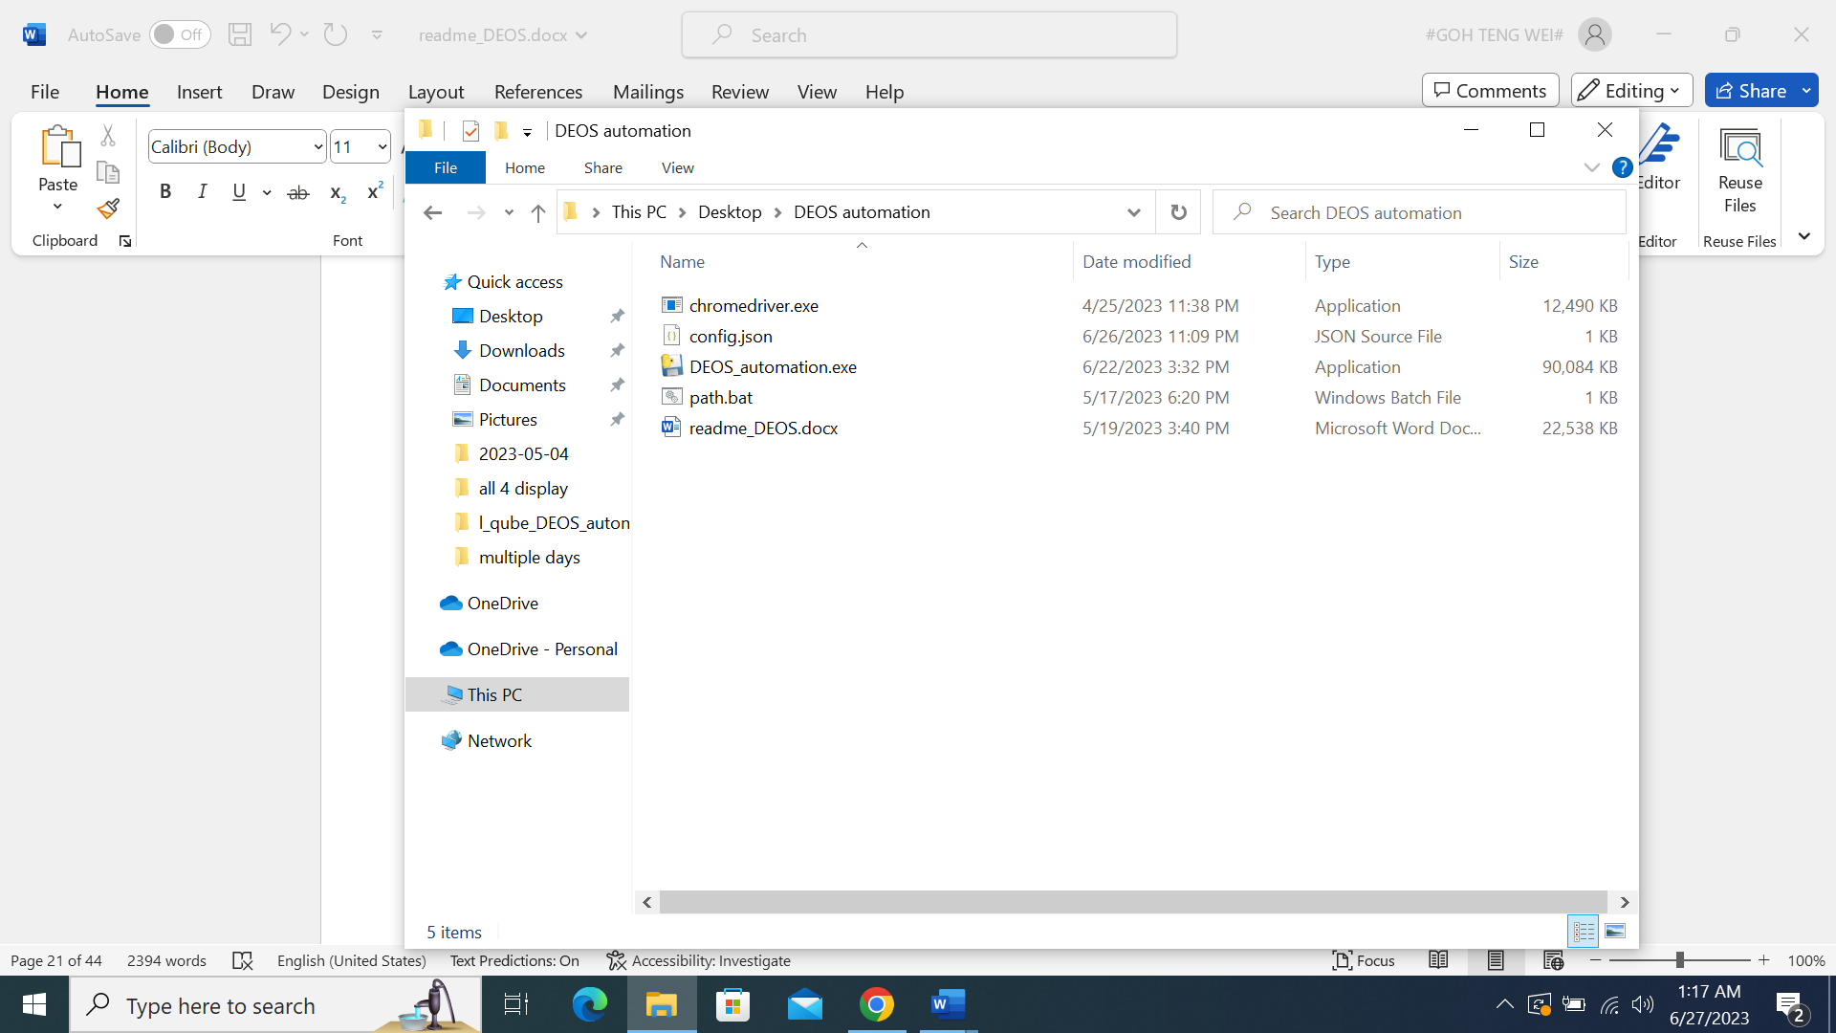

Navigate to the folder where the files are located.

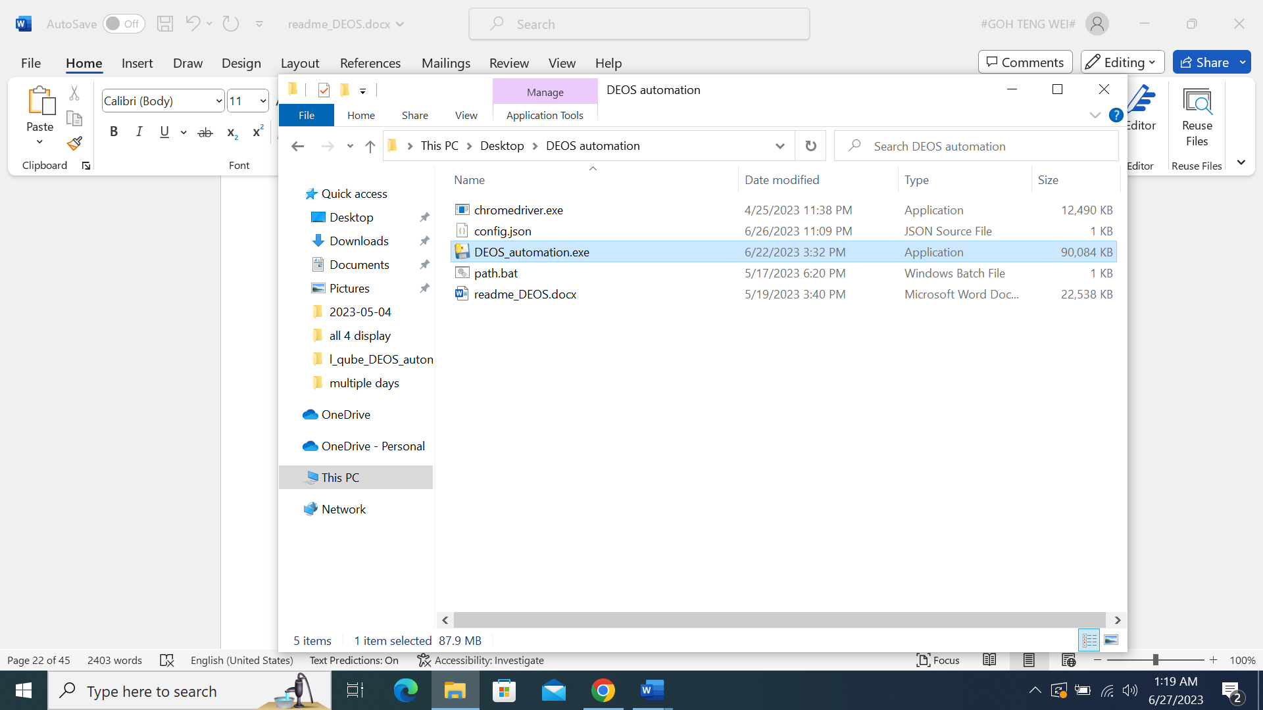

Double click DEOS_automation.exe.

Please wait for ~25 seconds for the program to launch.

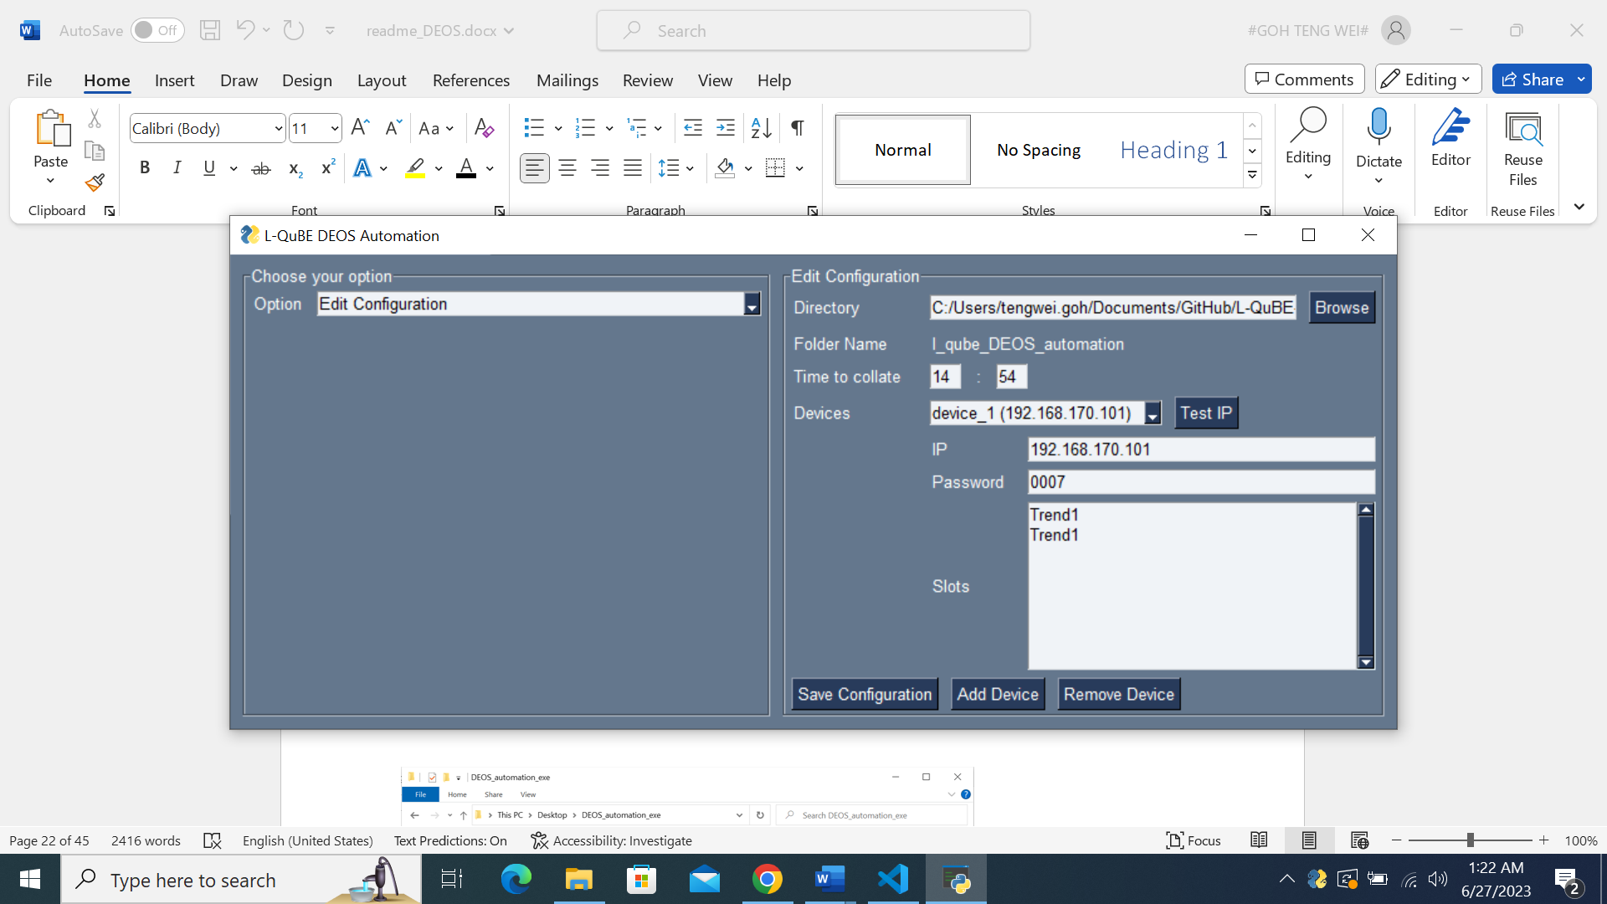

The following Graphical User Interface will be shown by default.

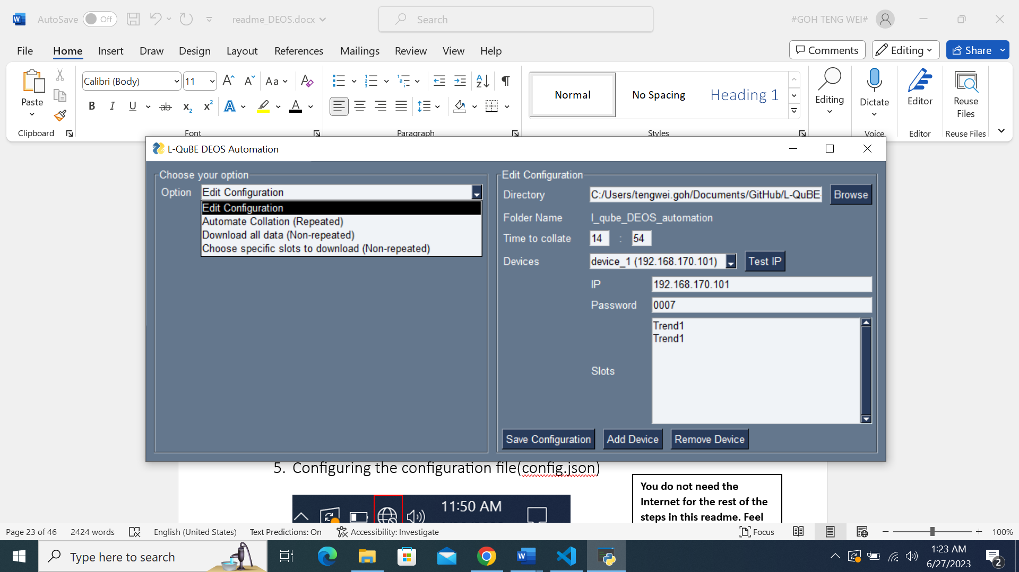

Clicking the Option textbox will reveal four options, with ‘Edit Configuration’ begin the default shown on launch.

Select the option you would like to run.

I will be providing explanations of the various options below.

## Edit Configuration



This will be the interface when the ‘Edit Configuration’ option is selected.



Directory is the folder which you want the DEOS raw data to be downloaded and collated in.



Folder name is to display the name of the folder chosen, to ensure that you have selected the right folder.



Click on the ‘Browse’ button to choose the folder where the DEOS raw data will be collated and downloaded.

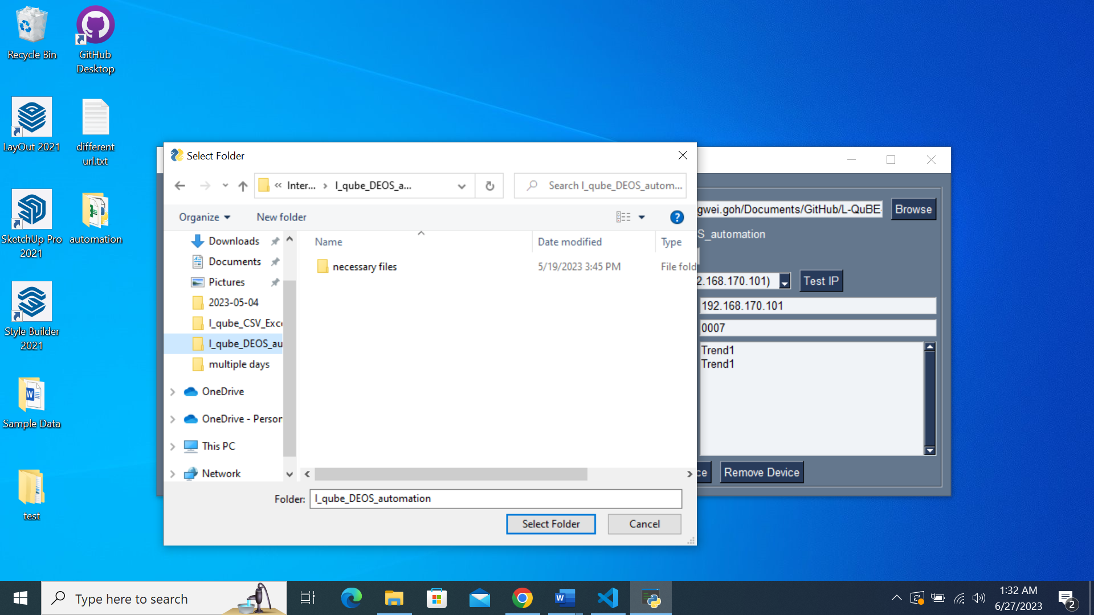

Windows in-built File Explorer will pop up once the ‘Browse’ button is clicked.

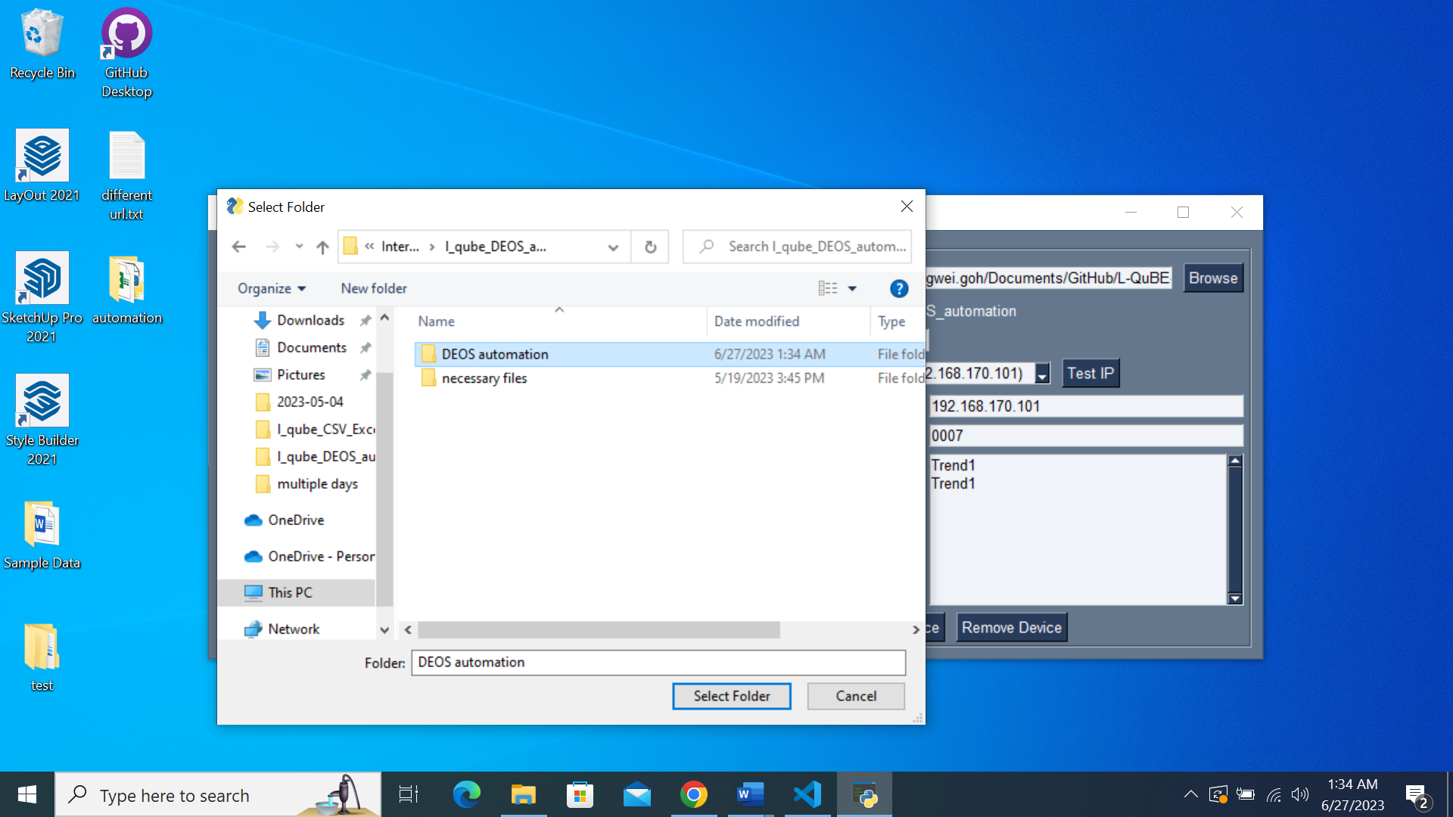

Once you navigate to and select your desired folder by clicking the folder, please click ‘Select Folder’ button.

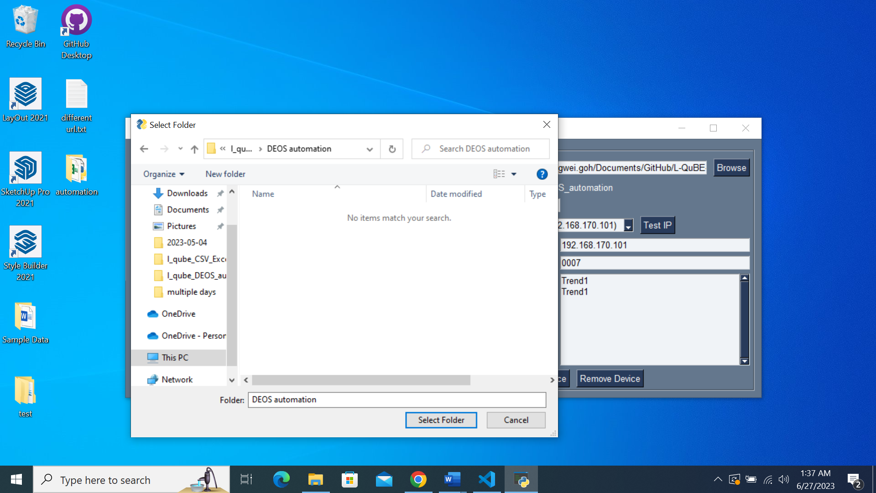

Please take note that you **will not be able to see the files located** inside the folder if you click into the folder.

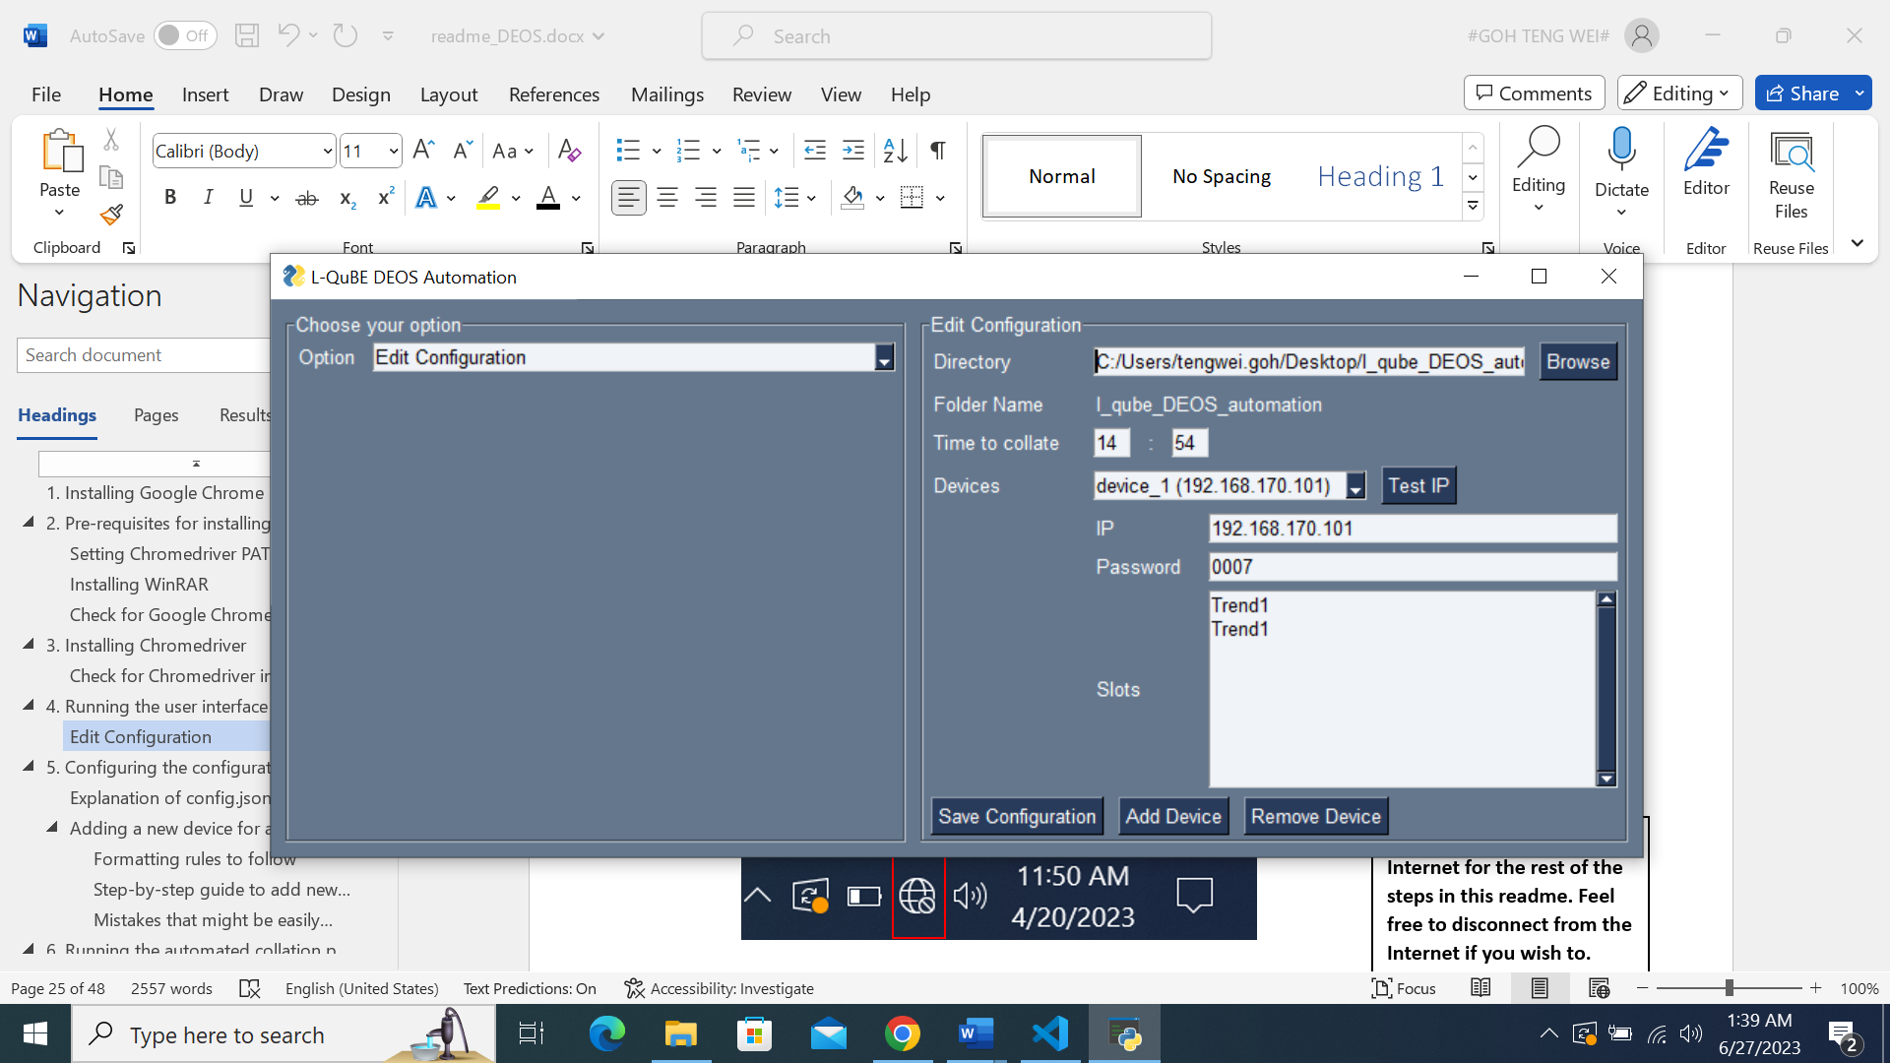

The Directory textbox will be updated with the new folder path chosen.



In order to save the path of the new folder chosen, you must click on the ‘Save Configuration’ button.

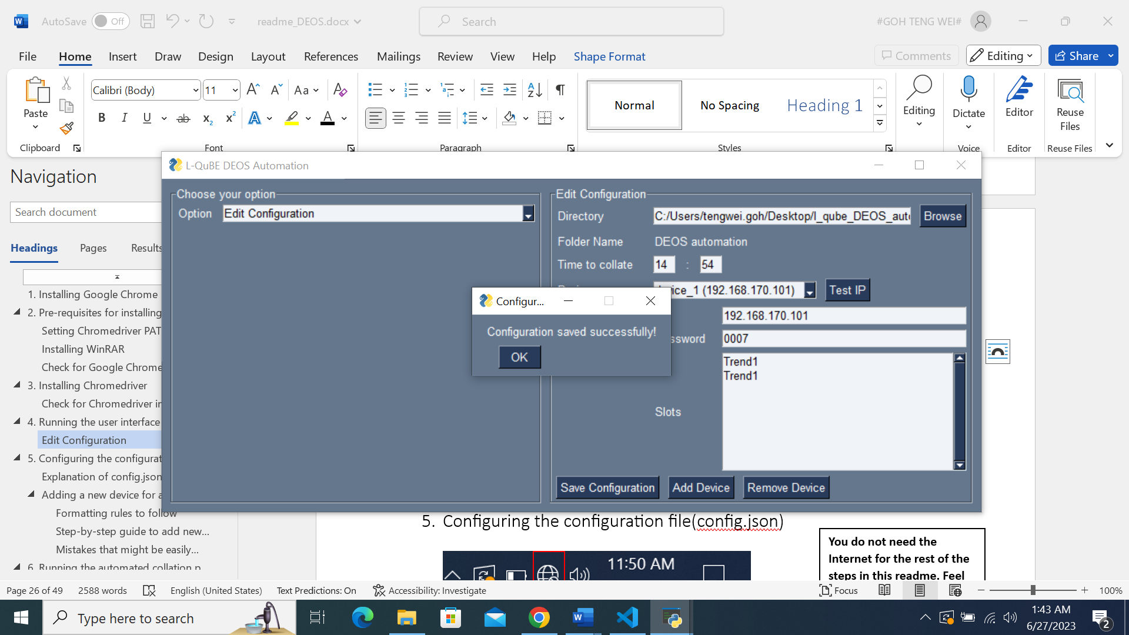

The pop-up will appear after the configuration is saved successfully and the folder name is updated as shown on the image.



You can close the pop-up by clicking on ‘OK’ button or the ‘X’ close button.

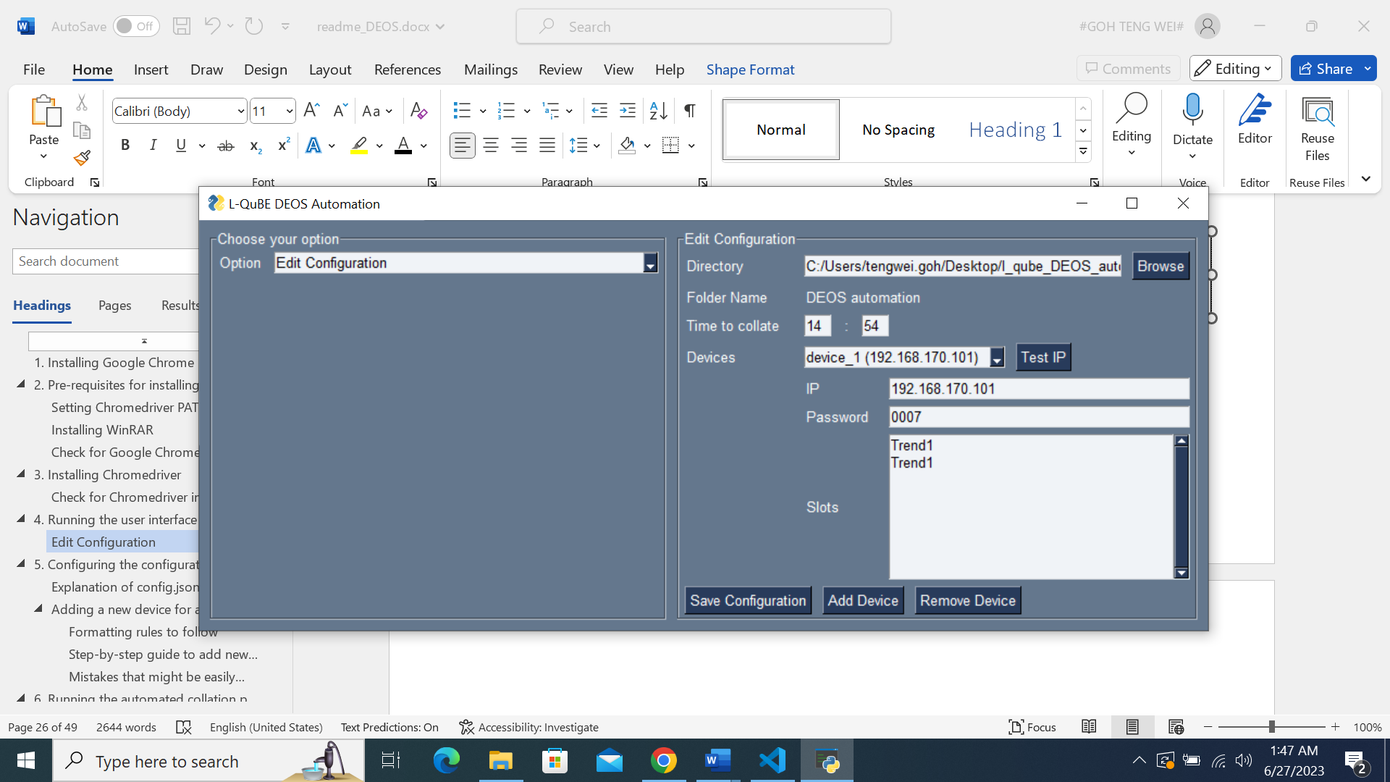

Time to collate is the time which the daily automated downloading and collation of DEOS raw data will begin.

It follows the 24-hour format, from 0000 to 2359.

It is advisable to run the program at a timing where nobody will be using the device.

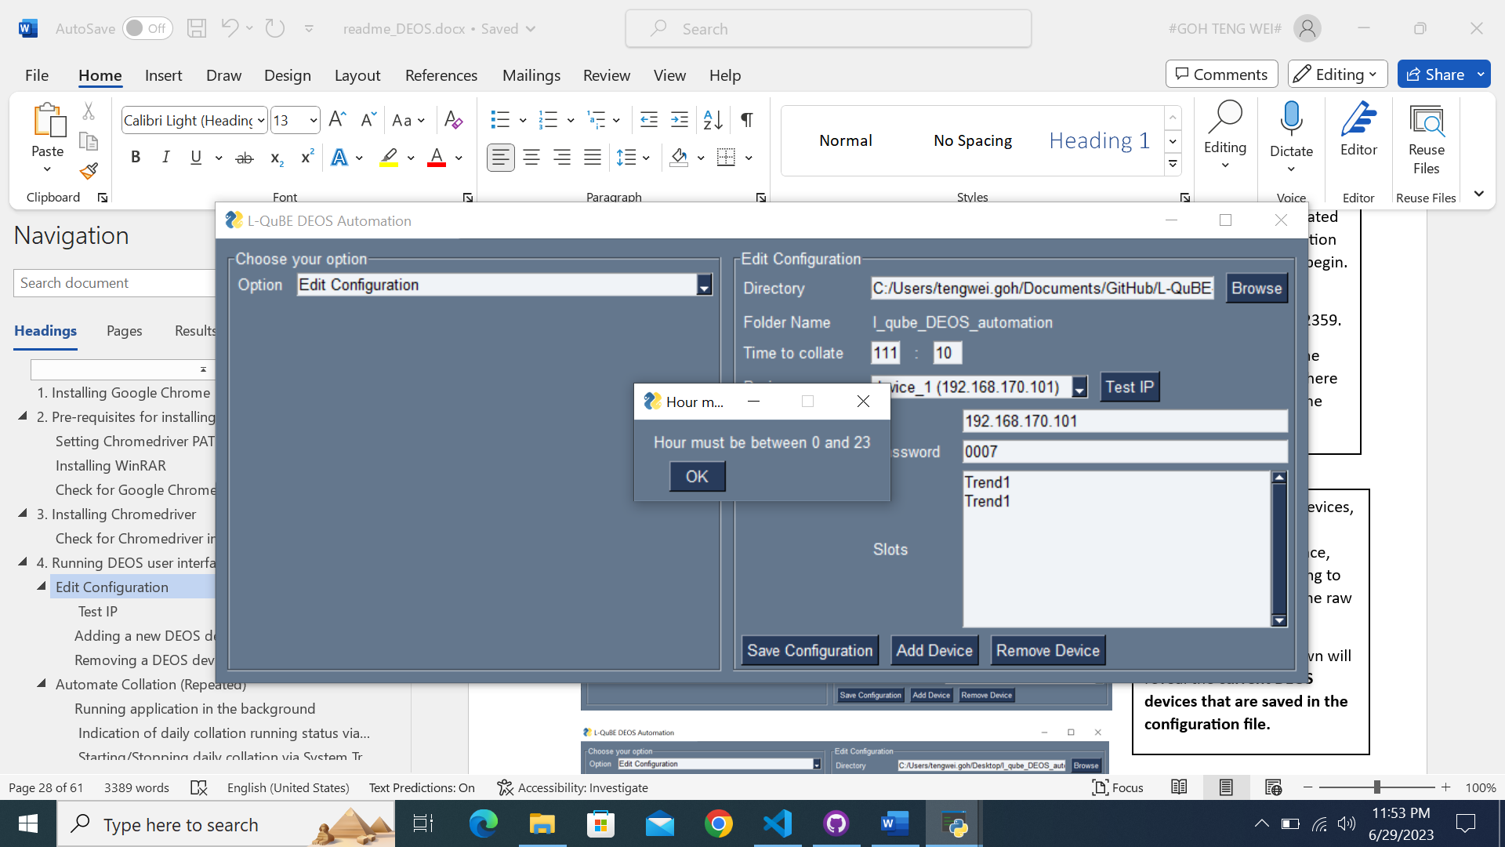

You will be prompted if your collation time falls outside of the 24-hour format.

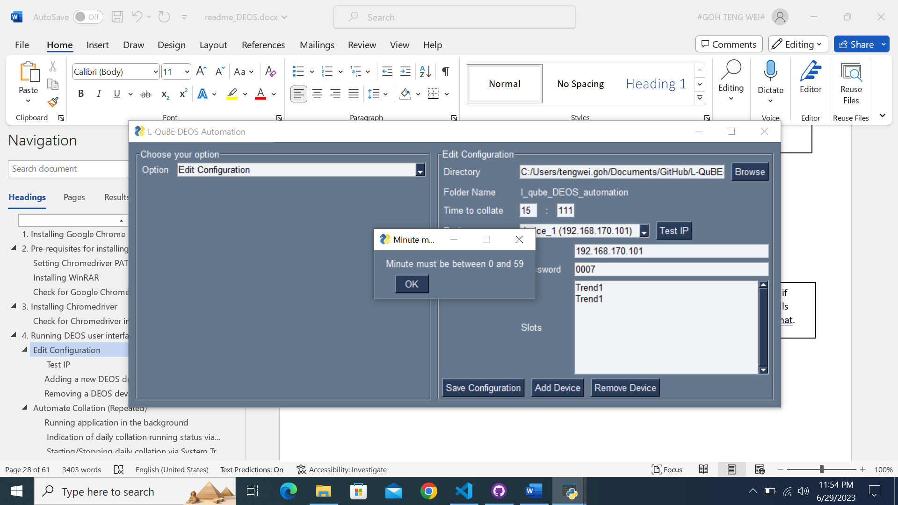

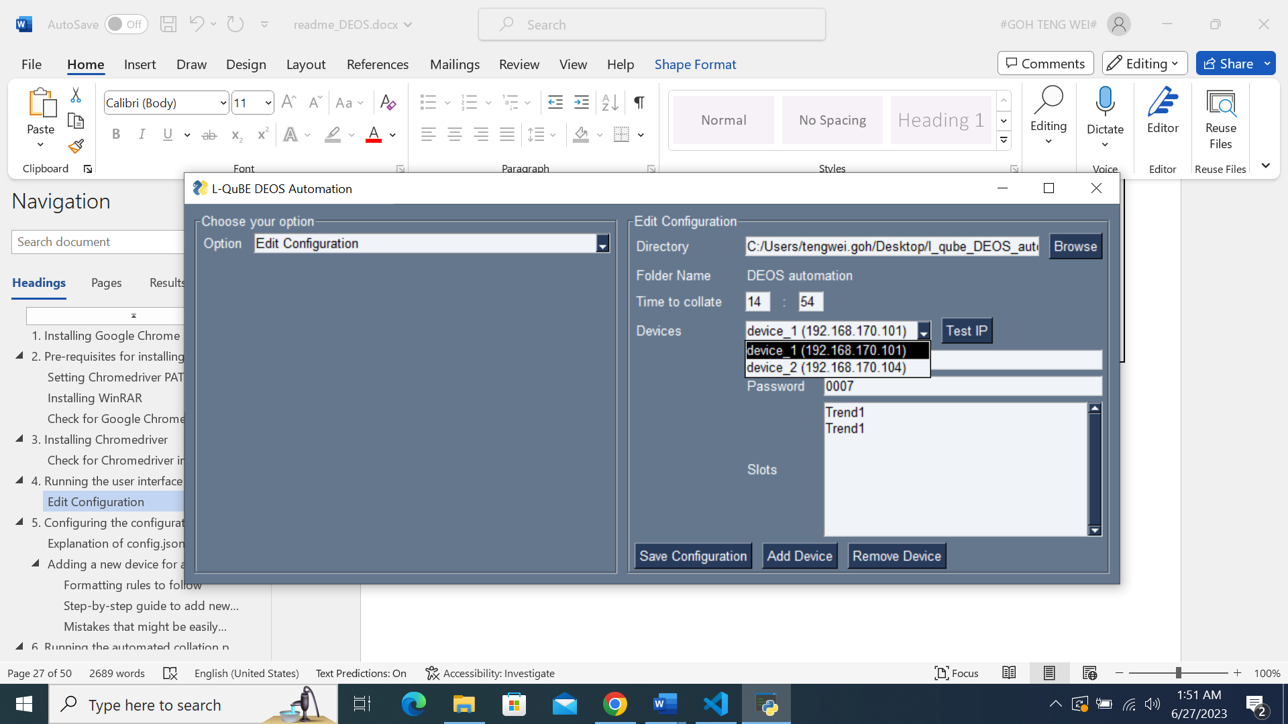

Devices are the DEOS devices, with their IP address displayed for convenience, that the software is going to download and collate the raw data from.

Clicking on the dropdown will reveal the **current DEOS devices that are saved in the configuration file.**

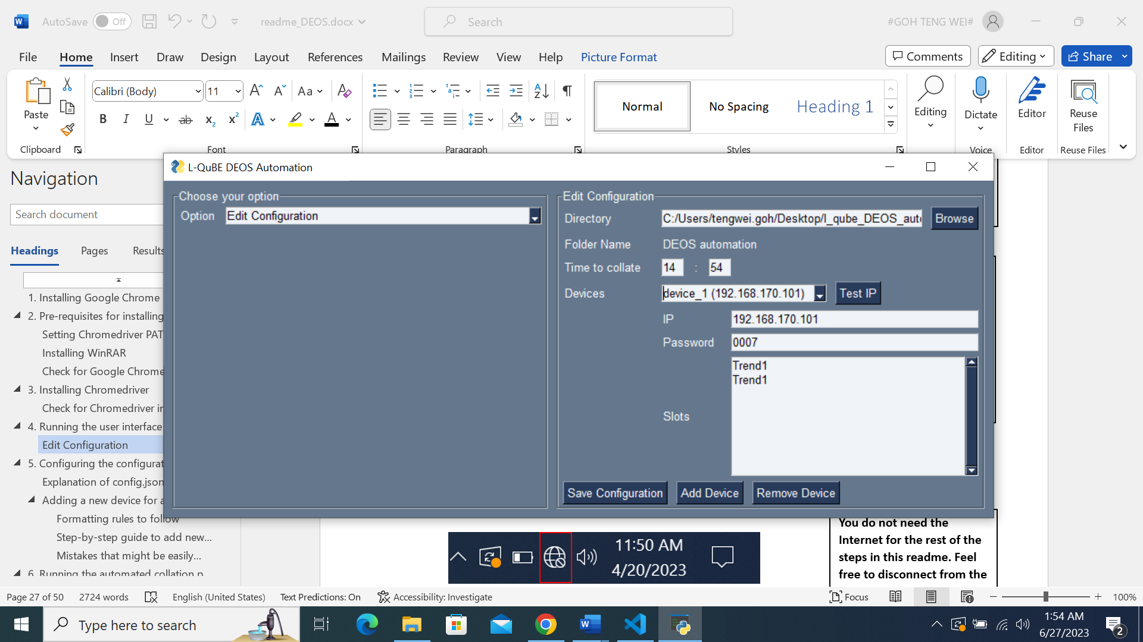

IP is the IP of the DEOS device.

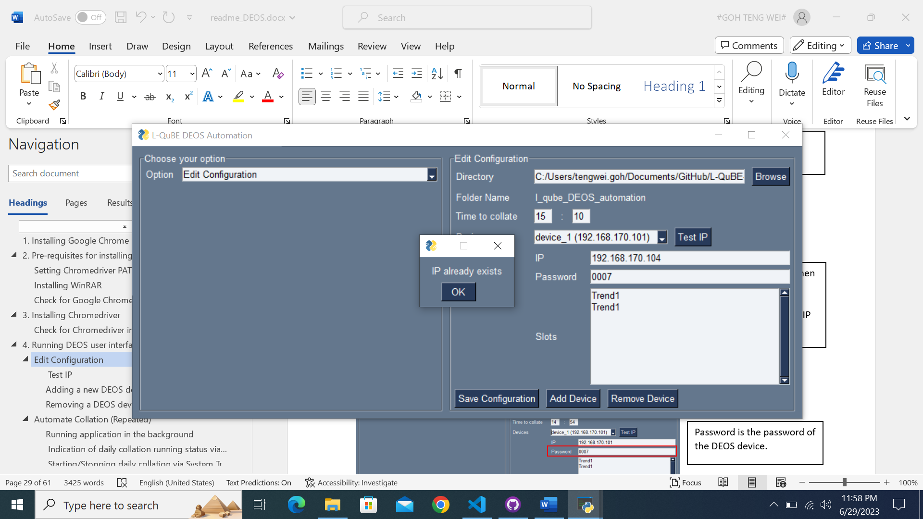

You will be prompted when you try to edit and overwrite a device’s IP address with an existing IP saved in configuration.

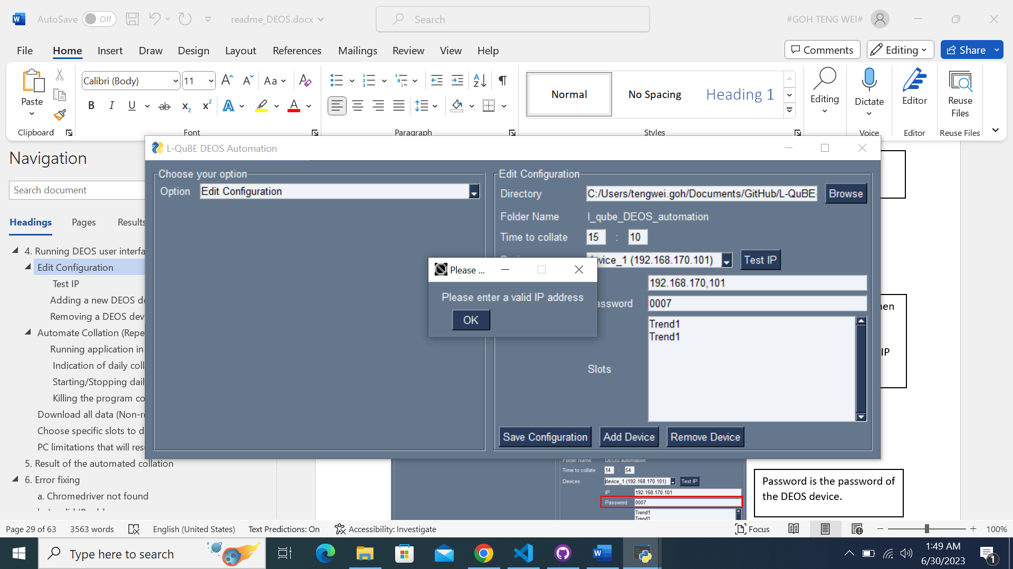

You will also be prompted if you enter an invalid IP address format, by accidentally pressing ‘,’ instead of ‘.’.



Password is the password of the DEOS device.



Slots is the specific slots that you wish to have a separate daily downloading and collation.

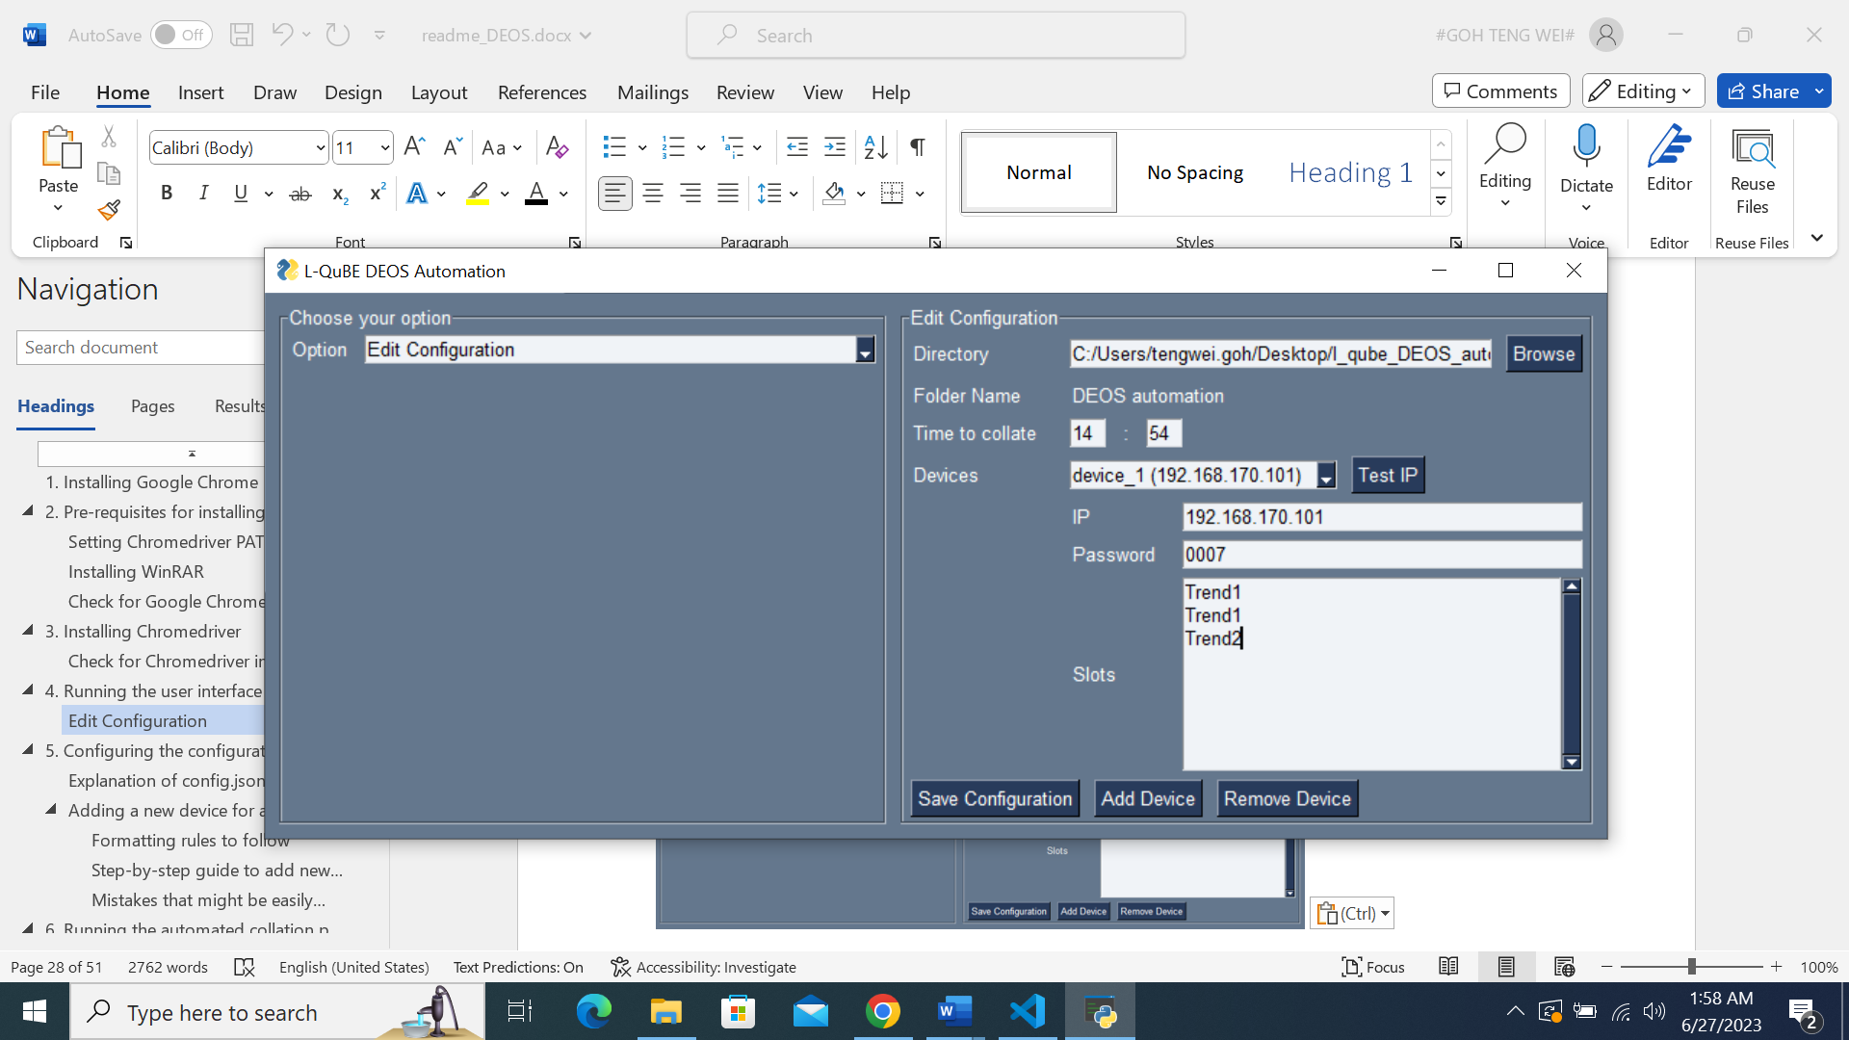

**Ensure that new slots are added on a NEW LINE.**

**Press ‘Enter’ after keying every new slot.**

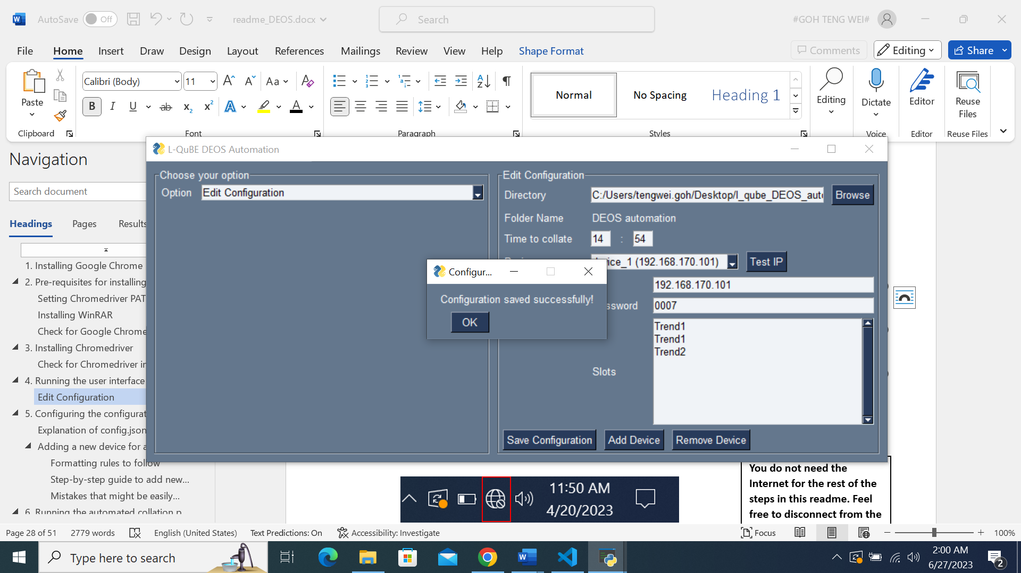

**Remember to click the ‘Save Configuration’ button after every change for the new configuration to be saved.**

### Test IP

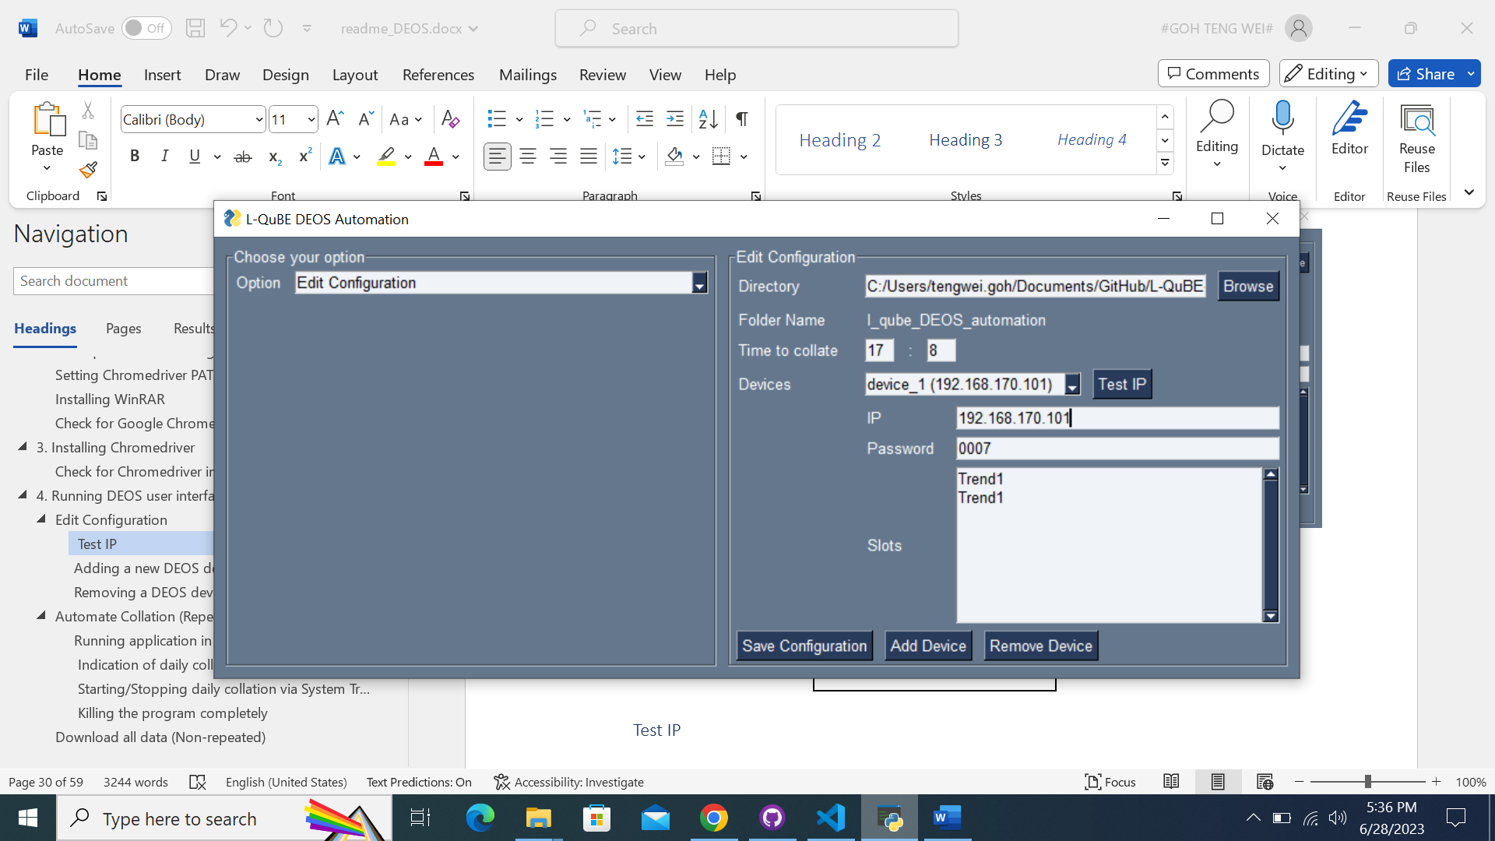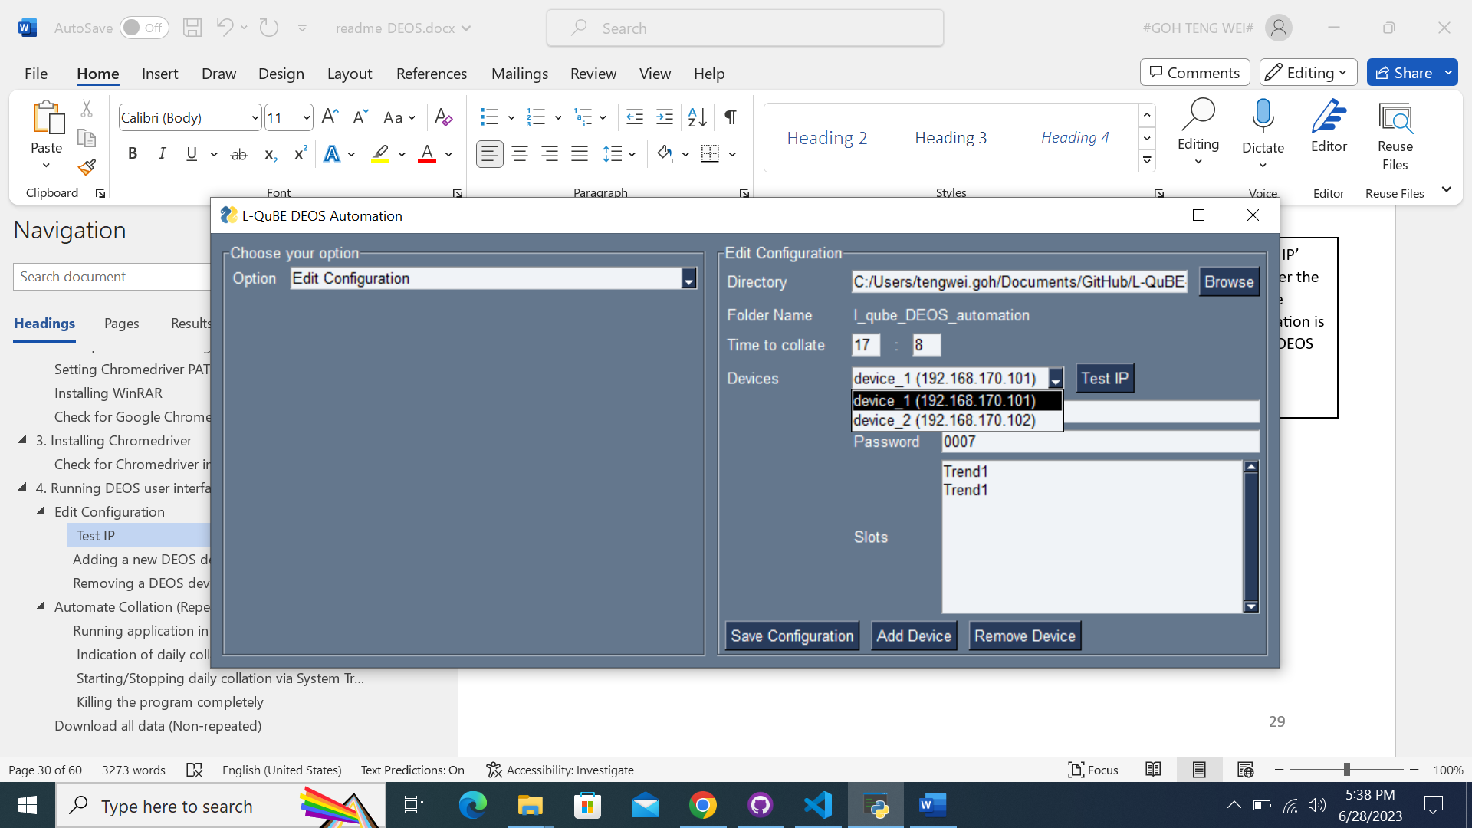

Select the device which you want to test the IP address of.

You can use this ‘Test IP’ feature to test whether the IP addresses you have saved in the configuration is valid or whether the DEOS device is connected properly.

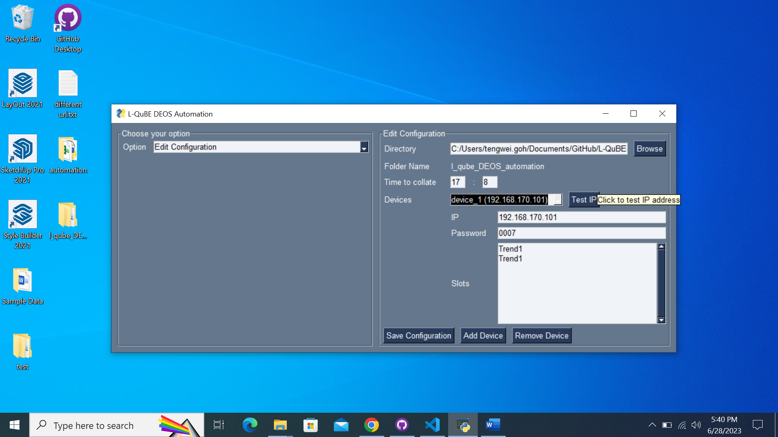

After selecting the device, you can click on the ‘Test IP’ button to test the connection to the device.

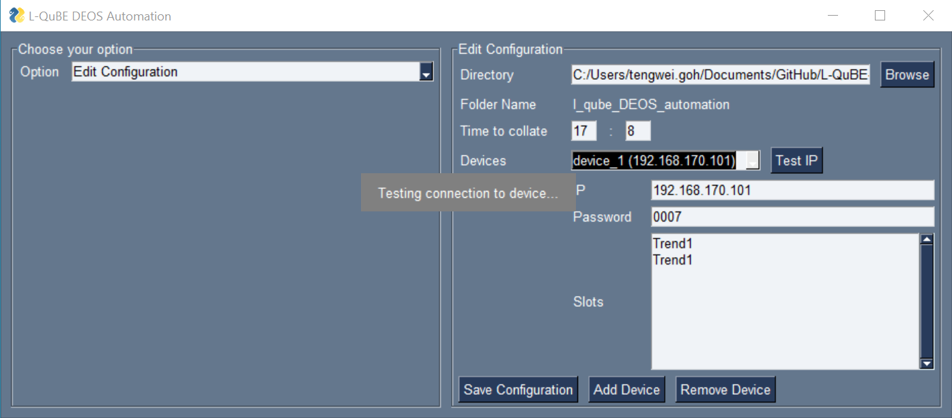

A loading popup message will appear, to indicate that the software is currently testing the connection.

An invalid IP address/ no connection will result in a longer waiting time of ~30 seconds.

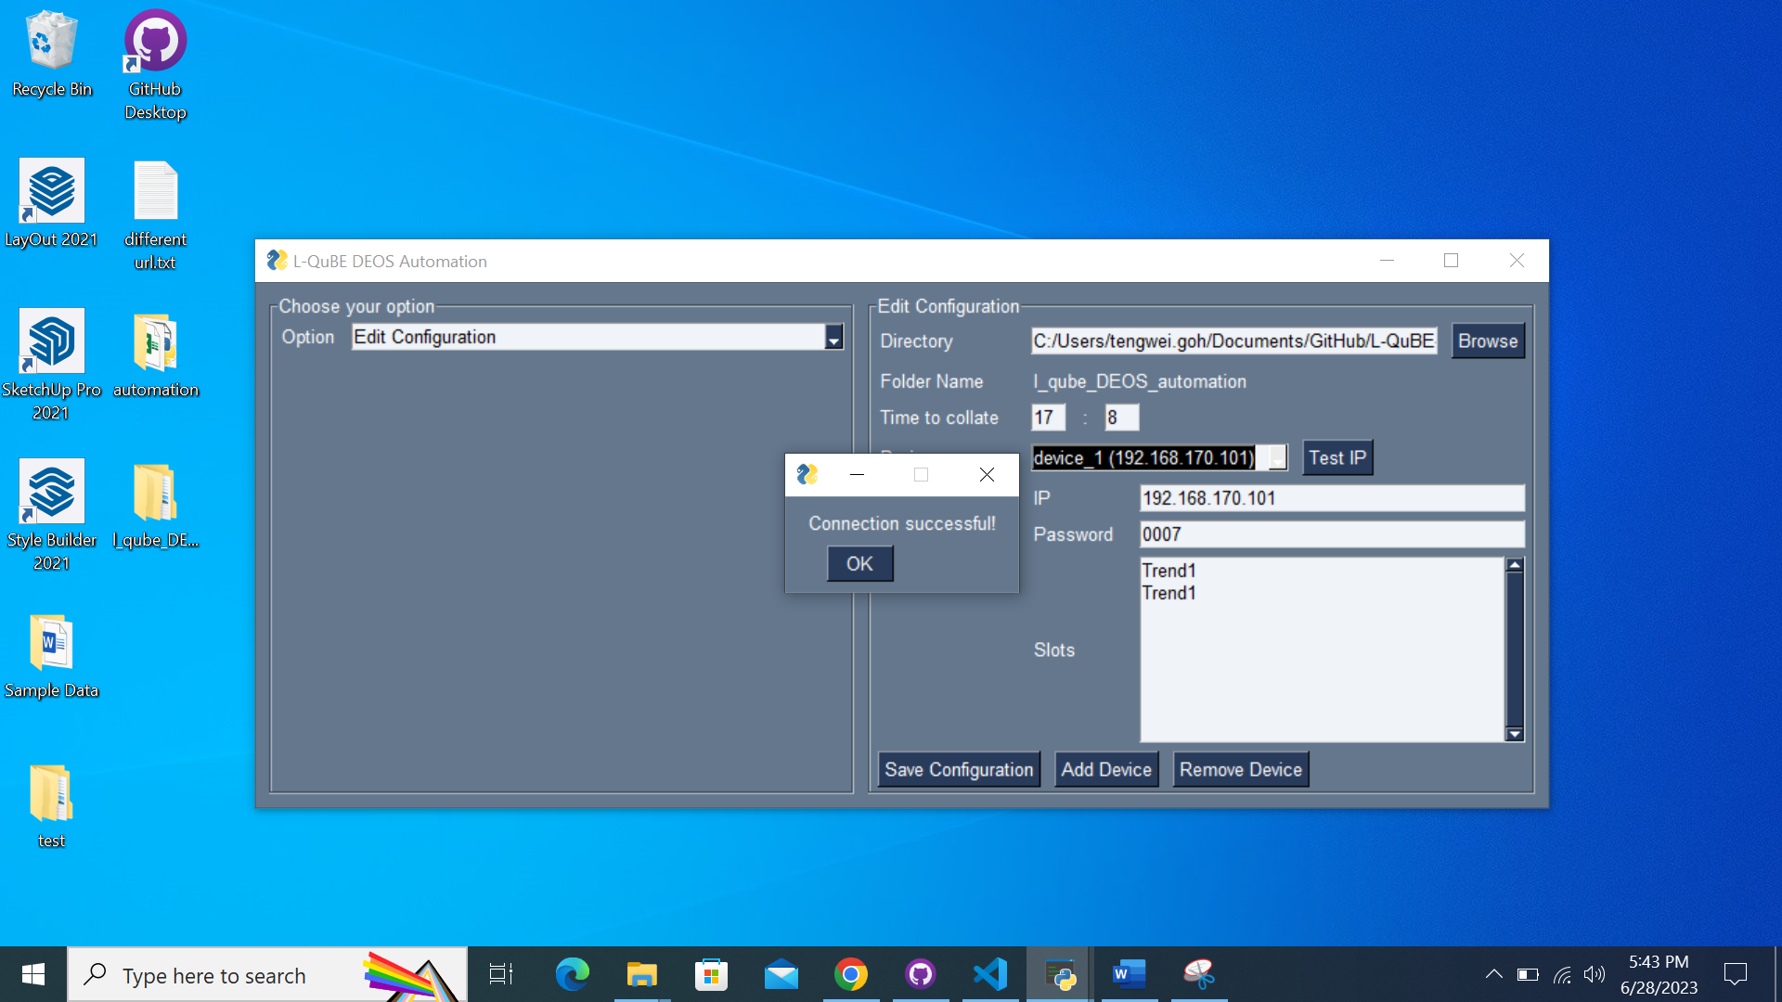

The popup message ‘Connection successful!’ will appear when the IP address is valid, and the connection has no issue.

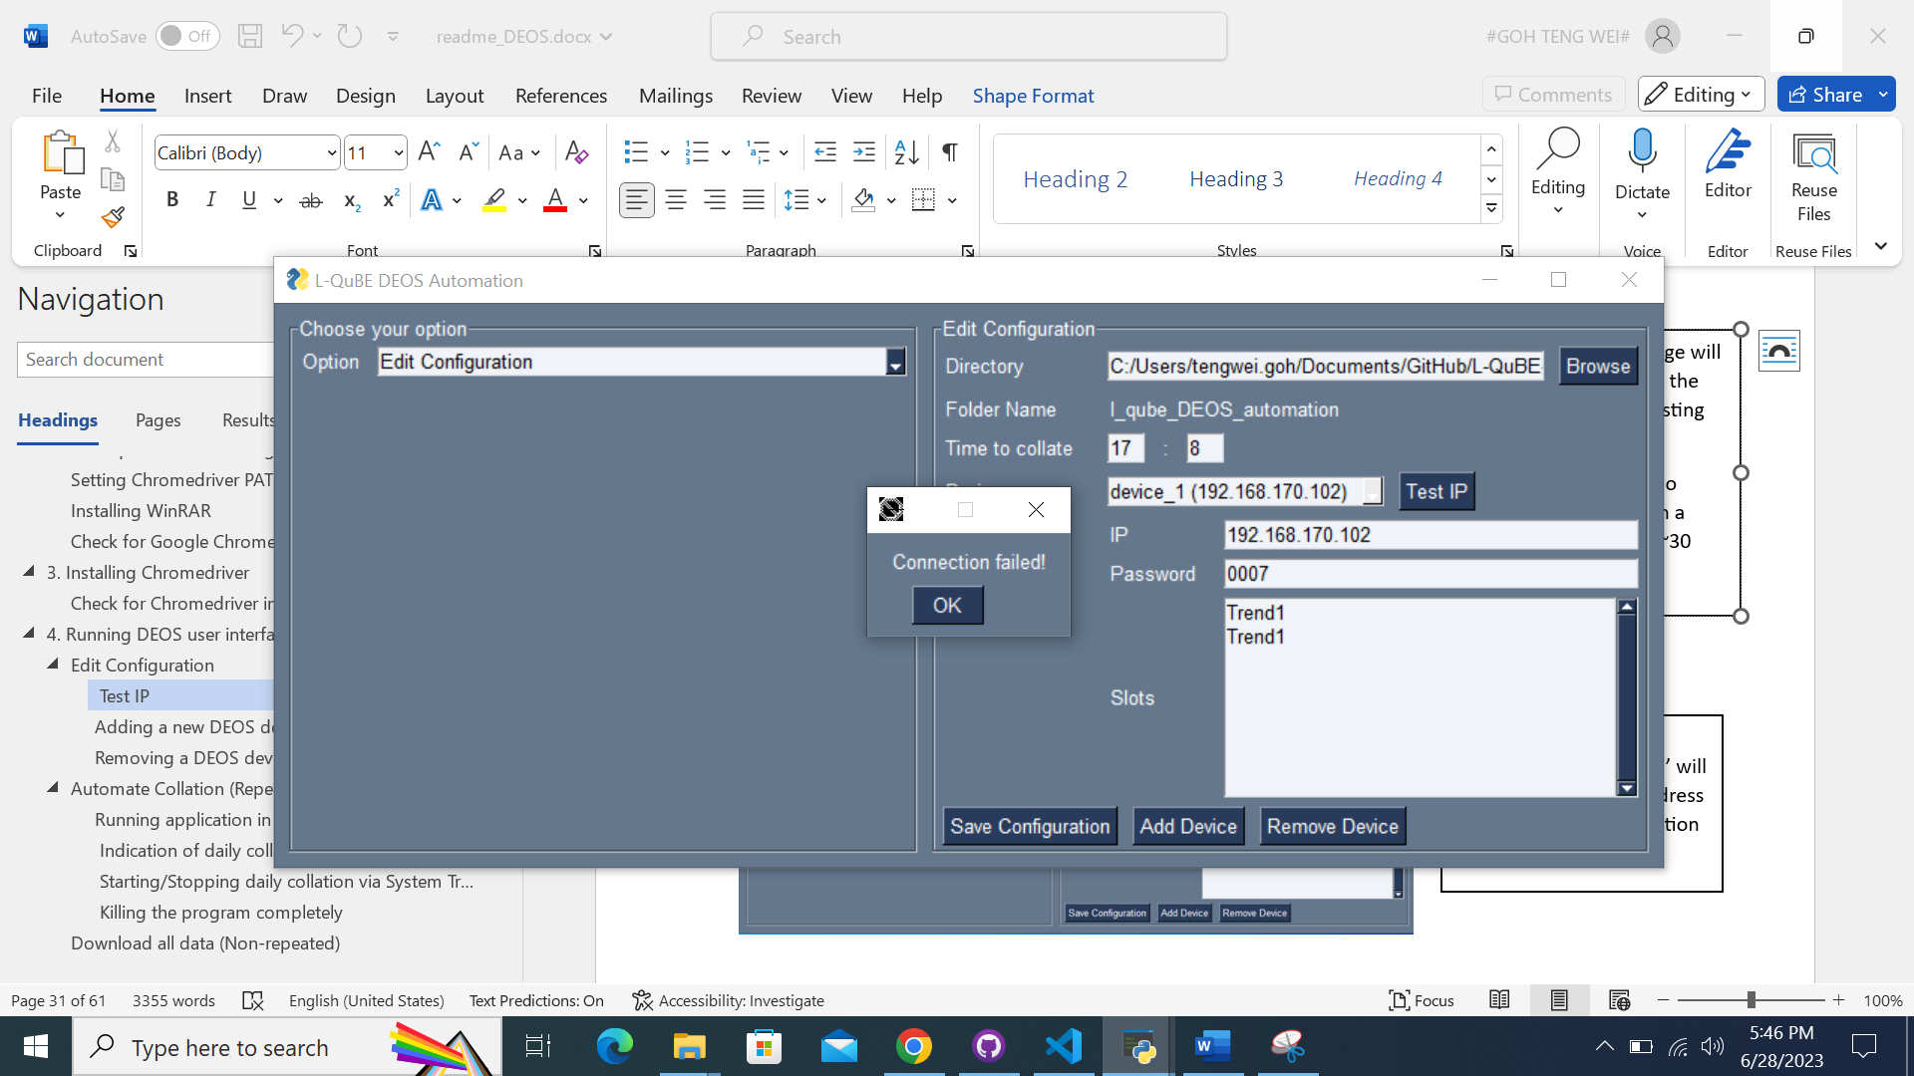

The popup message ‘Connection failed!’ will appear when the IP address is invalid or there is an issue with the connection with the device.

### Adding a new DEOS device

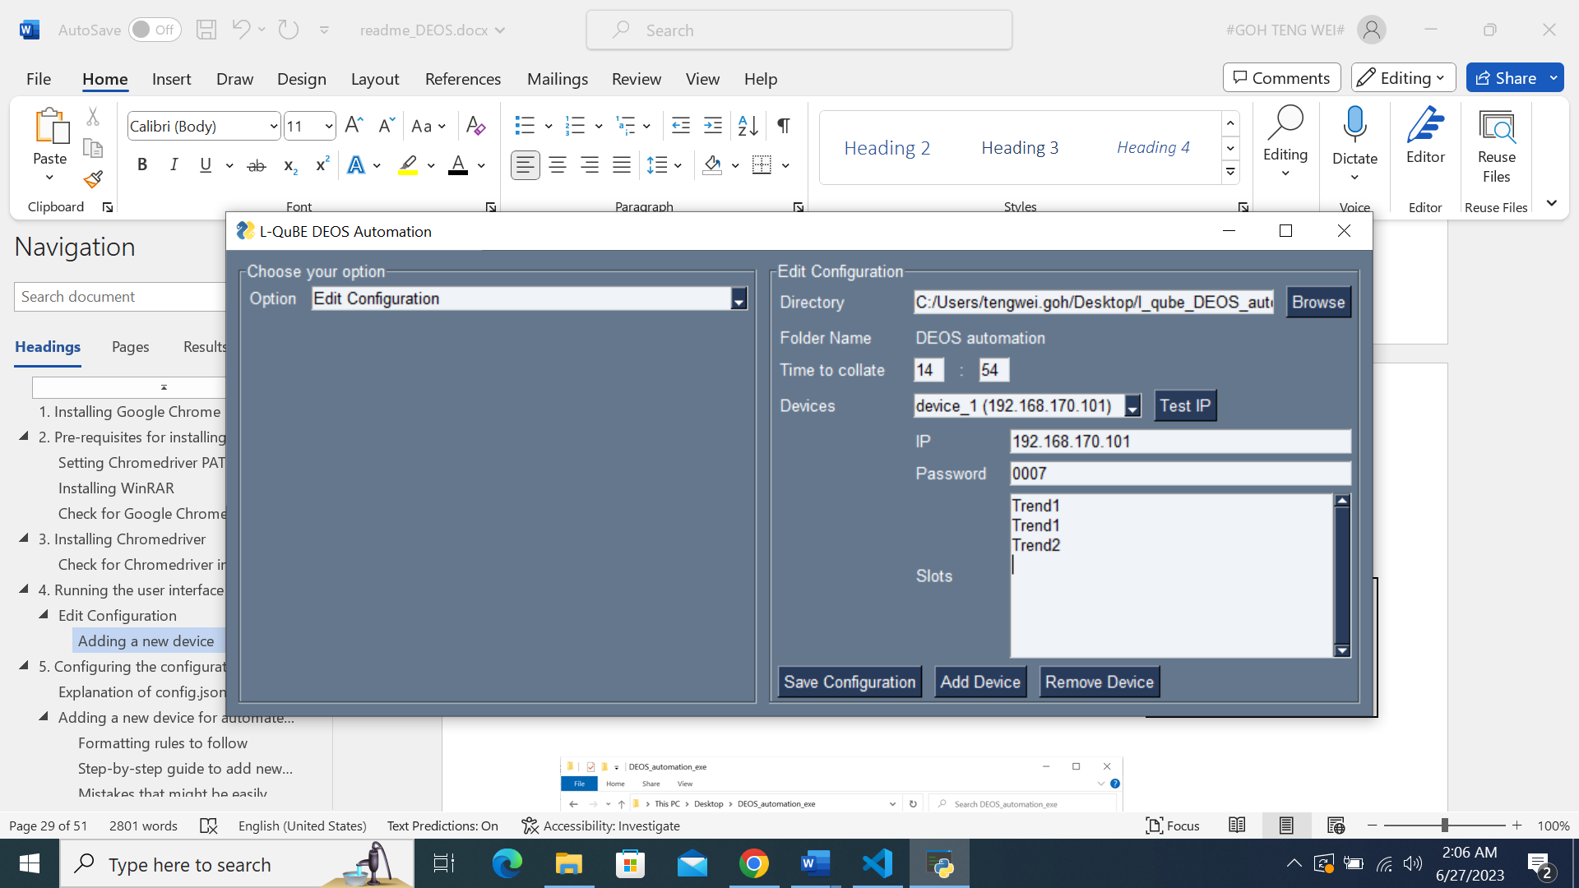

Click on the ‘Add Device’ button to add a new DEOS device.

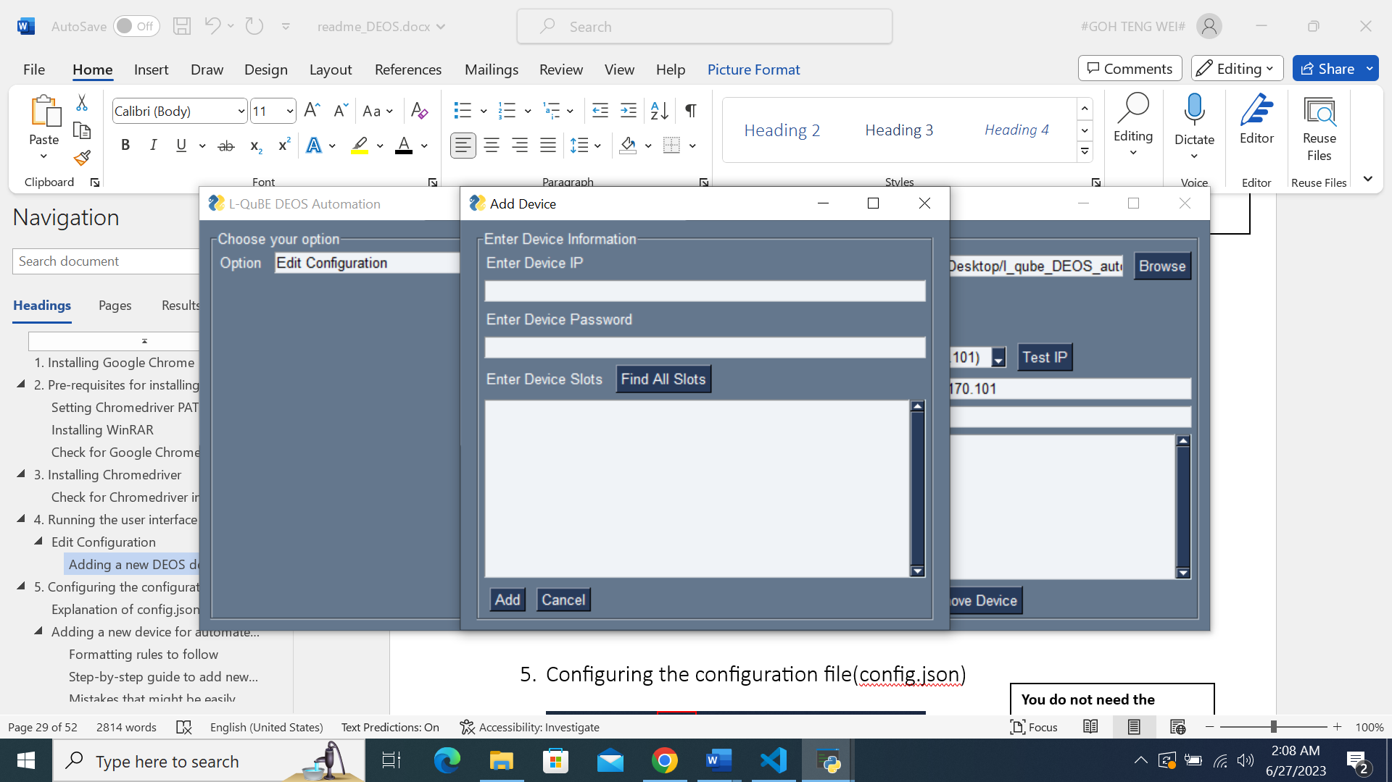

This pop-up window will appear, and you will need to fill in the device information accordingly.

Click on the ‘Add’ button after filling up the necessary fields.

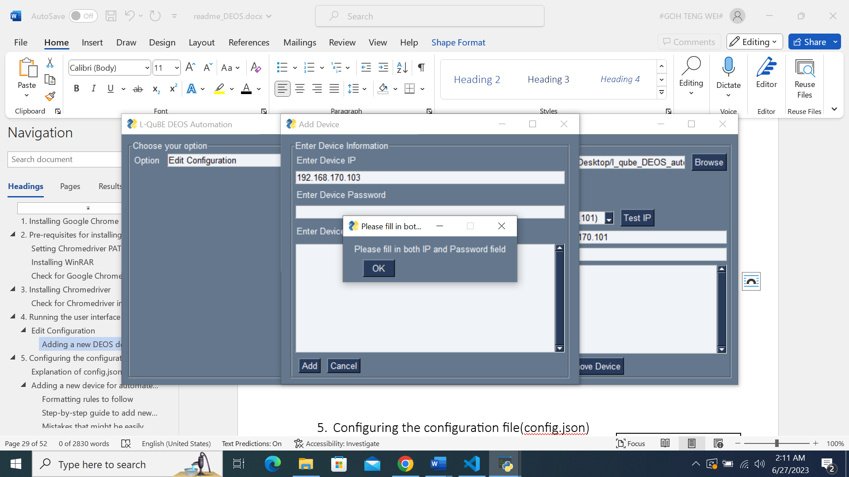

The software will notify you if you leave either the IP field or the Password field empty.

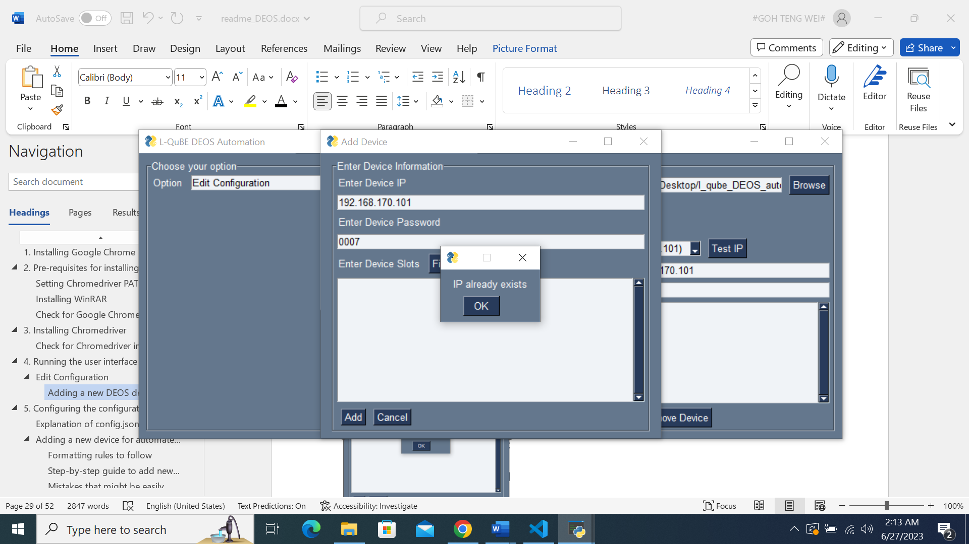

The software will prevent you from saving duplicate IP address too.

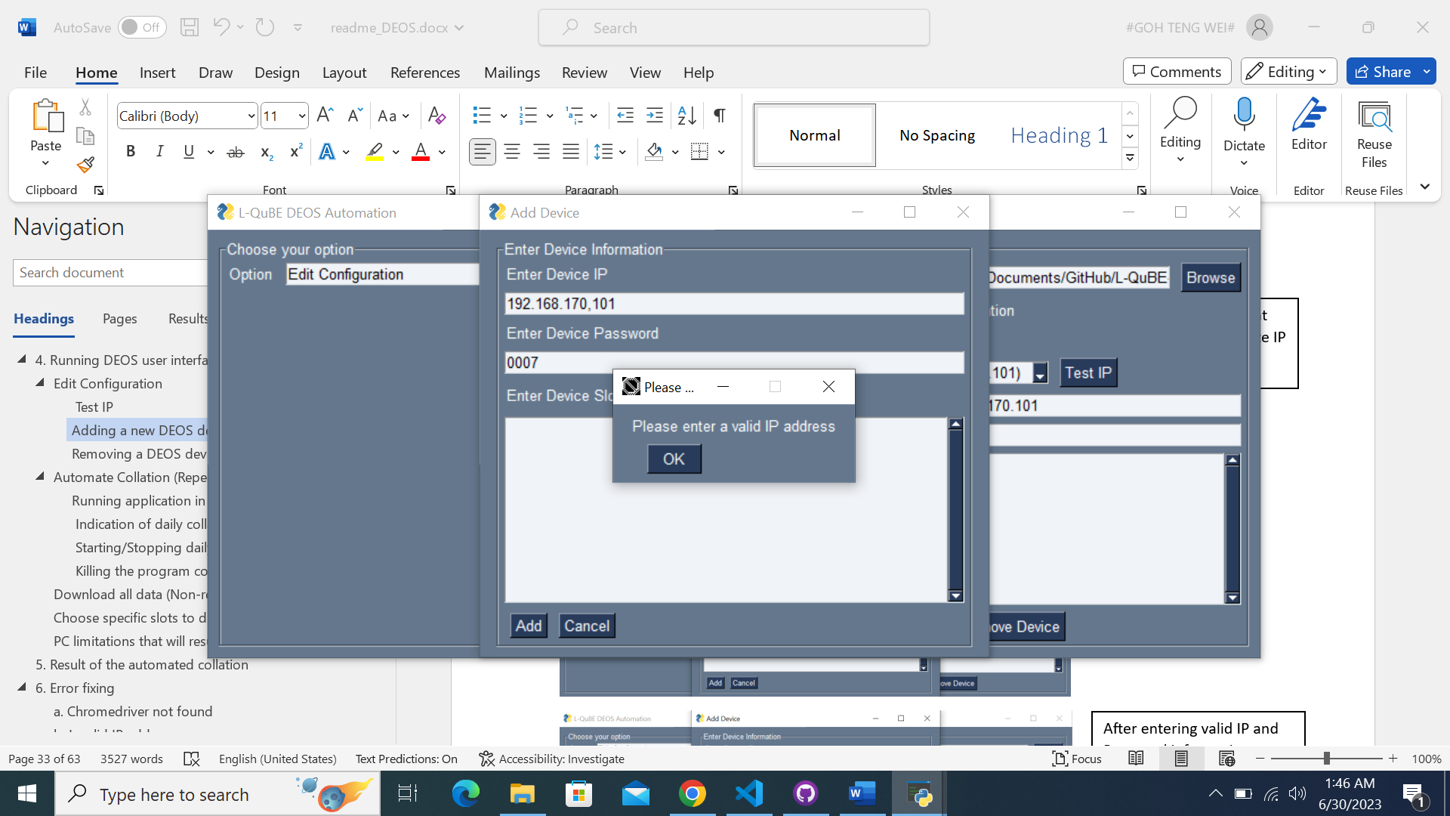

The software will prevent you from saving an invalid IP address format.

As shown on the left, you might accidentally press ‘,’ instead of ‘.’ when entering the IP. This feature helps to rectify that issue.

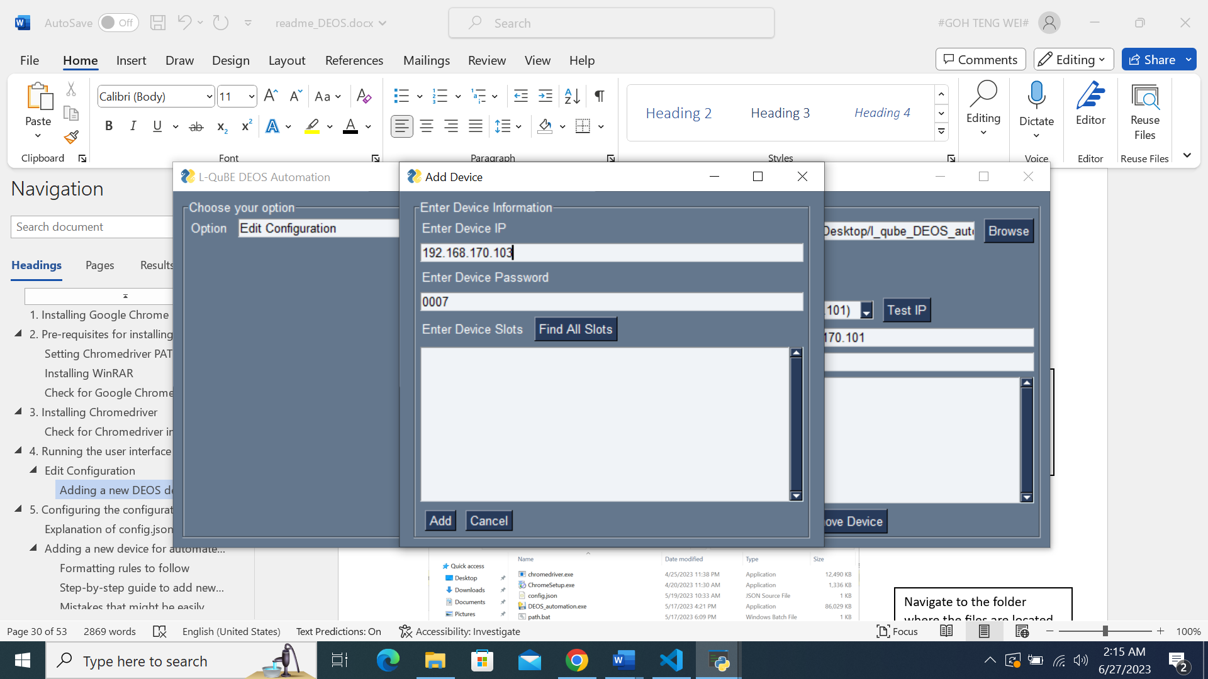

After entering valid IP and Password information, you can then either:

1. Leave the slots field empty.
2. Click on the ‘Find All Slots’ button for you to add slots conveniently.

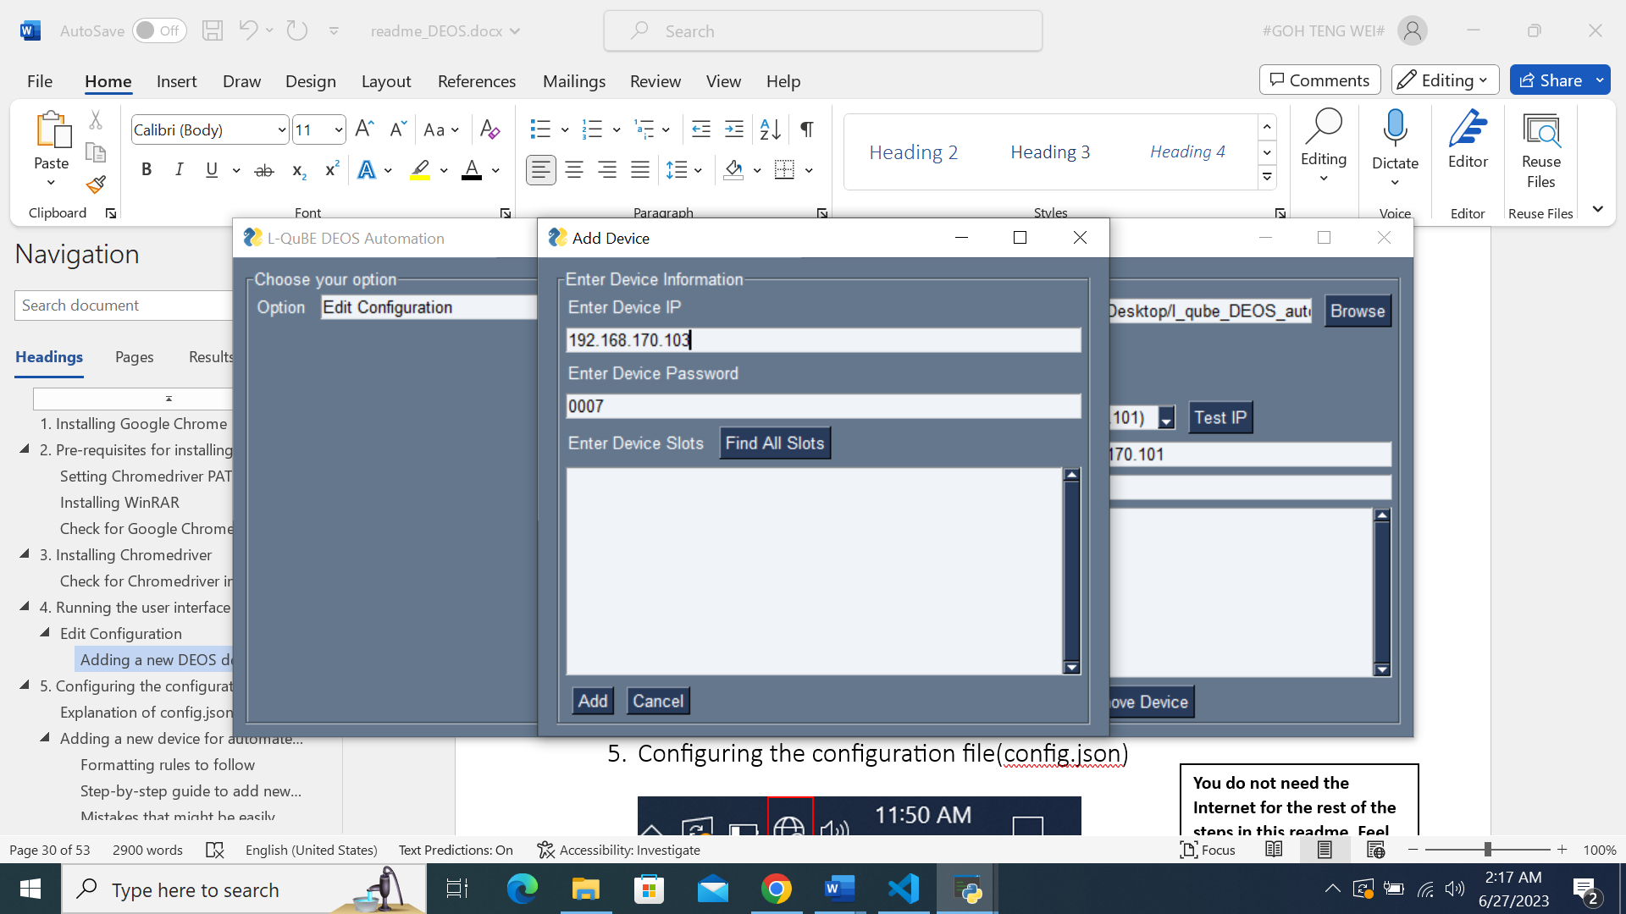

If you wish to add specific slots, click on the ‘Find All Slots’ button for the software to find and display every slot available in the DEOS device.

Please wait for the program to find and display all slots on the device.

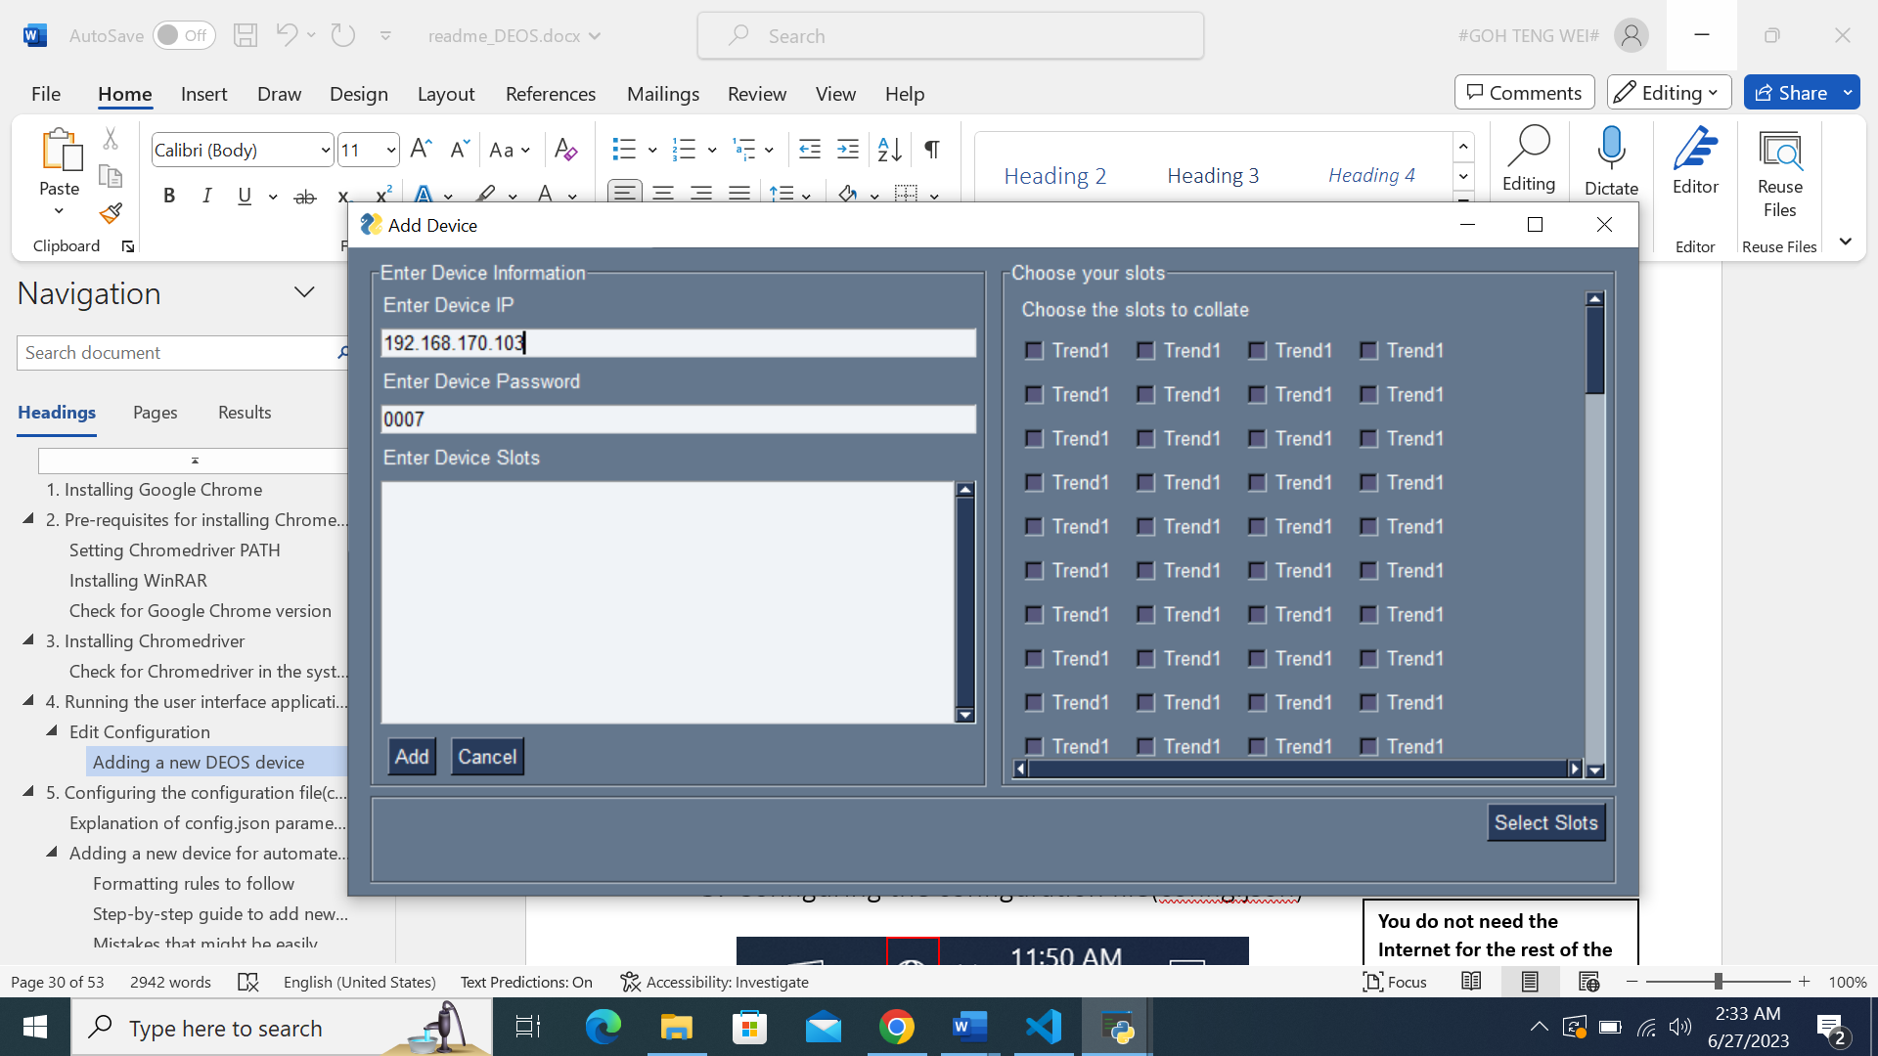

The following interface will be shown, with all the slots displayed.

You can scroll down if there are slots below that you wish to select.

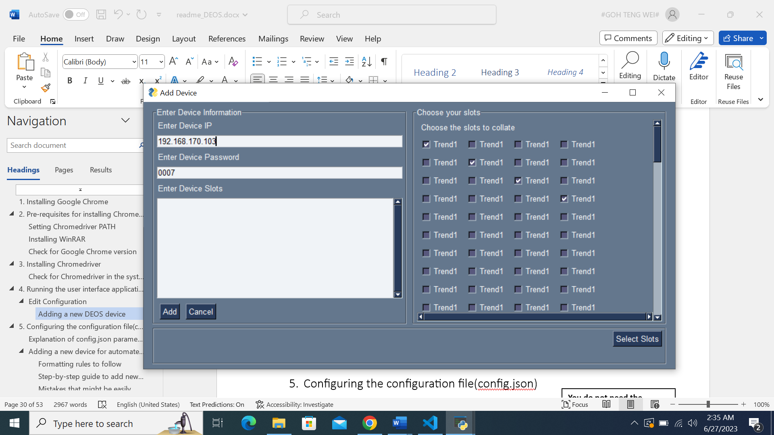

You can select the slots by clicking on the slot name.

The checkbox beside the slot name will be checked after being selected.

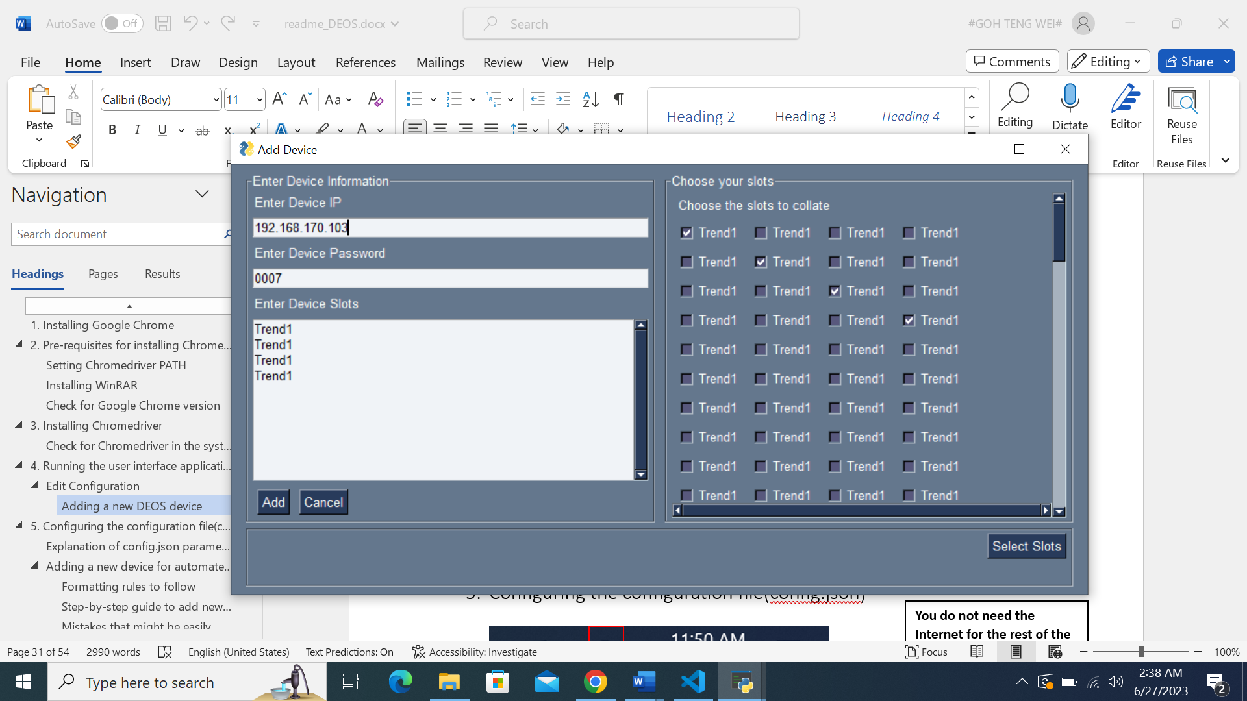

After finishing your selection, you can click on the ‘Select Slots’ button to automatically add the chosen slots to the slots field on the left.

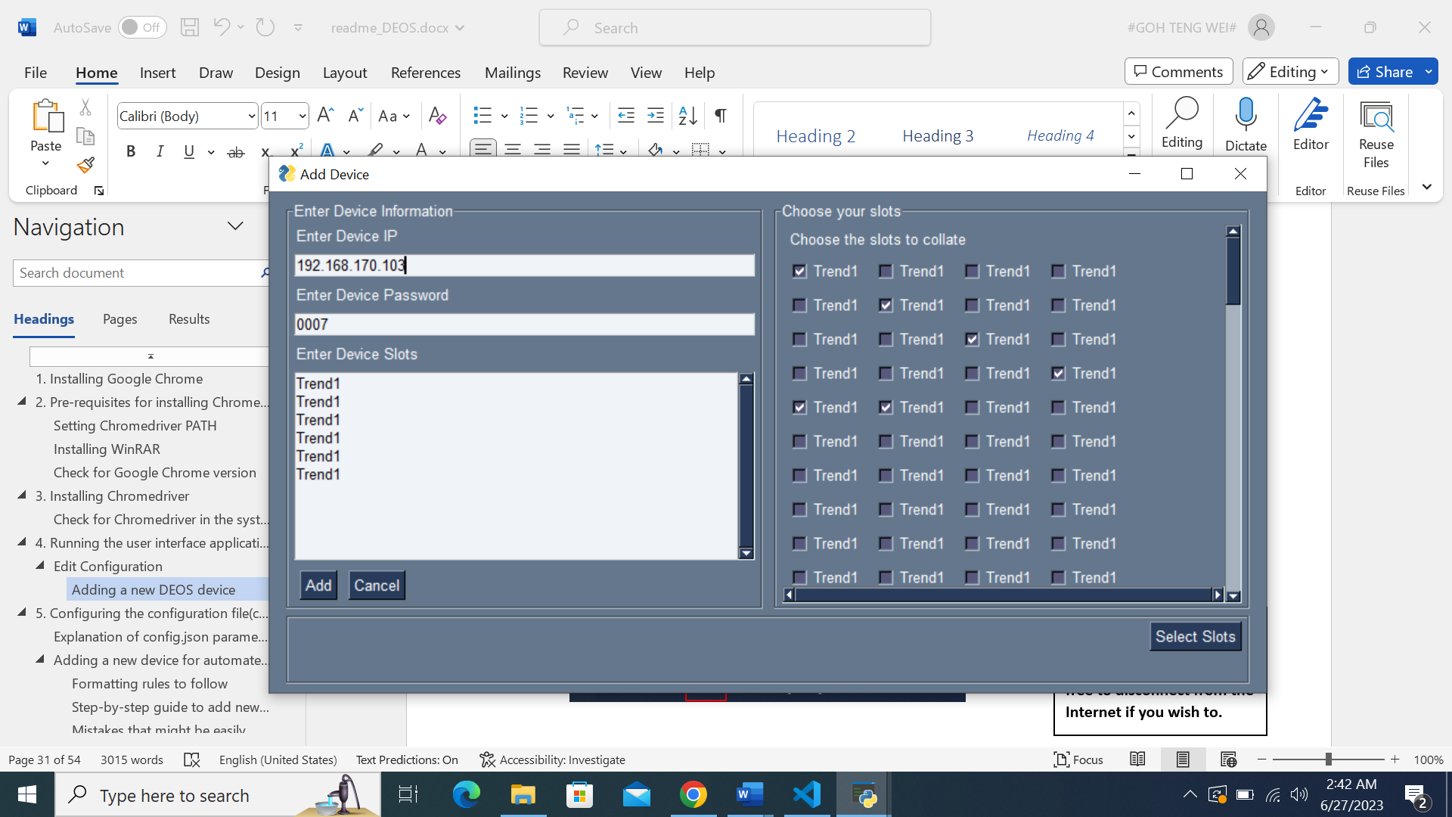

You can select more slots after the initial selection if you wish to.



Click on the ‘Add’ button after you ensure that everything is correct.

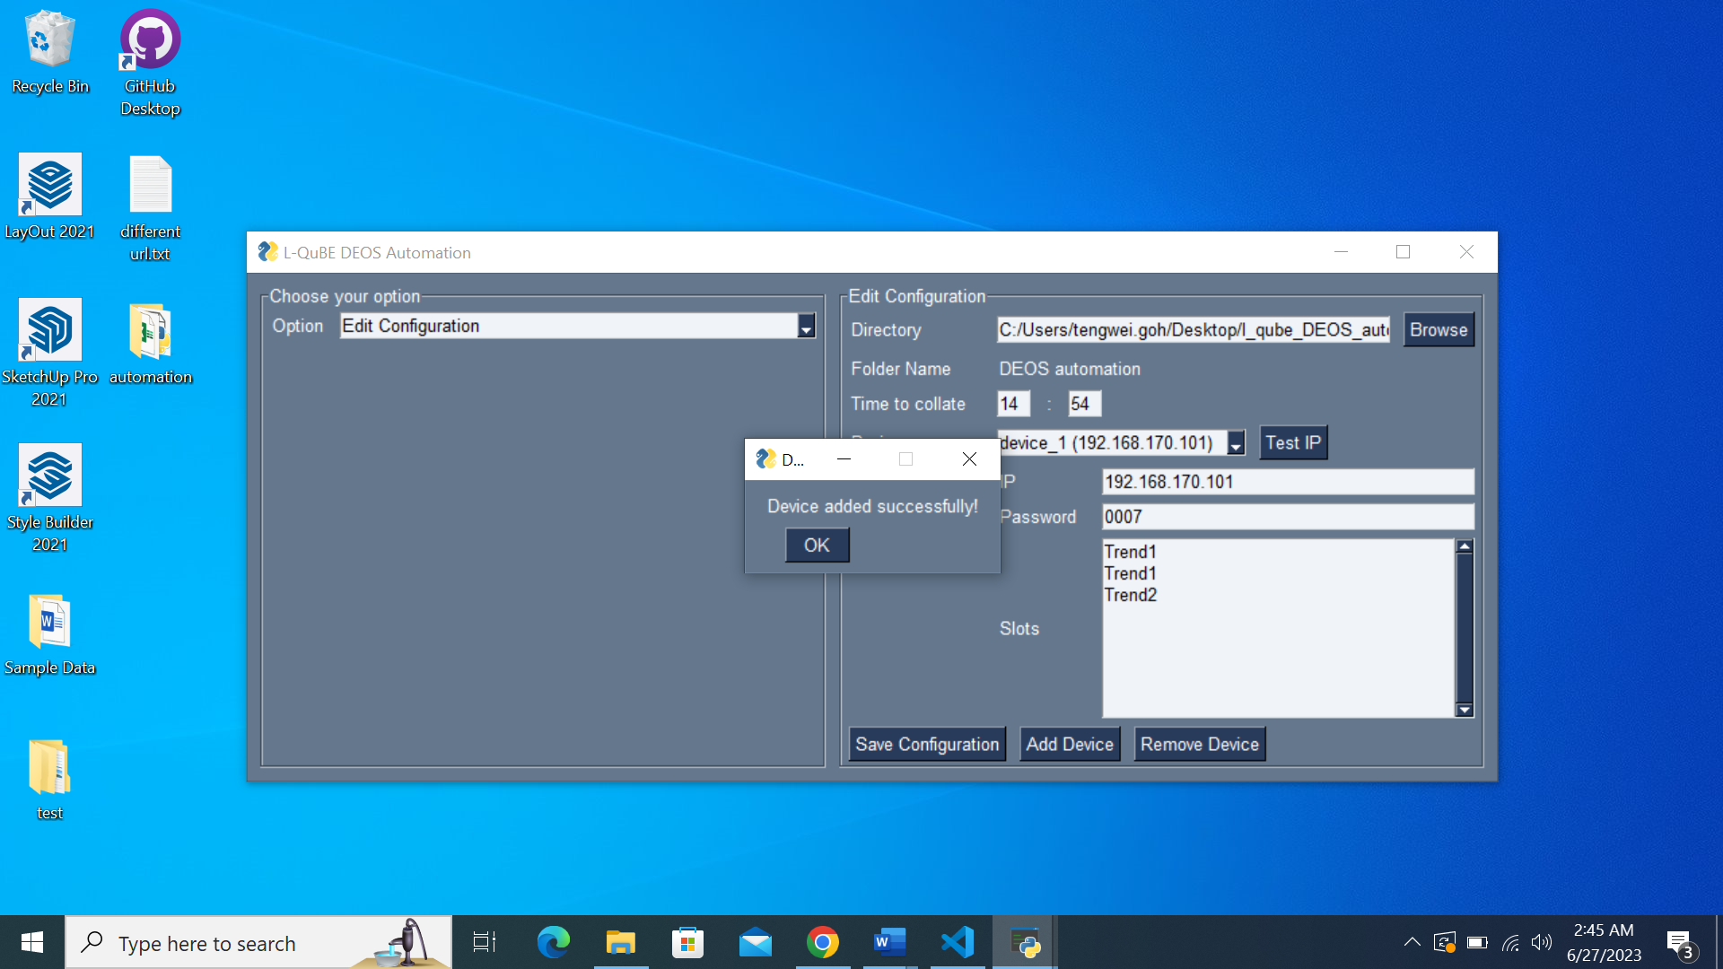

A pop-up will appear to notify you that **the device has successfully been saved in the configuration.**

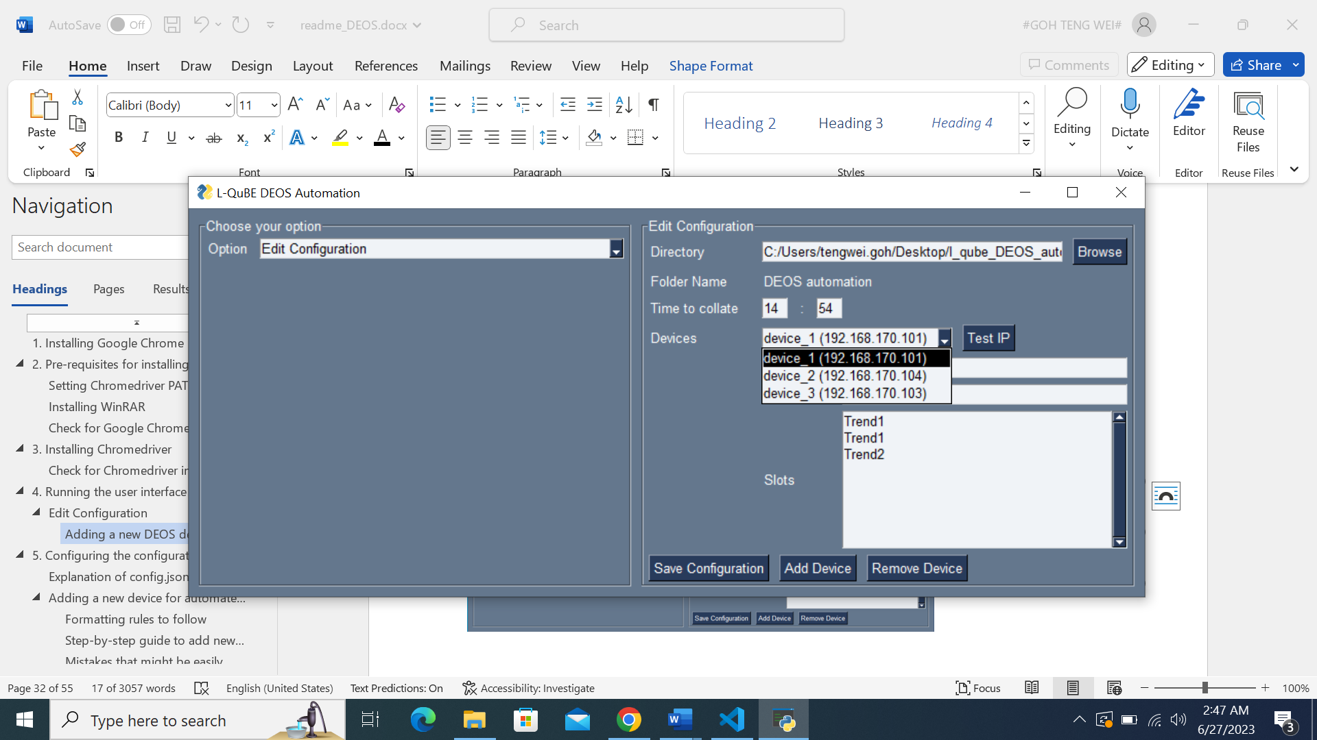

Clicking on the Devices dropdown will reveal the newly added device.

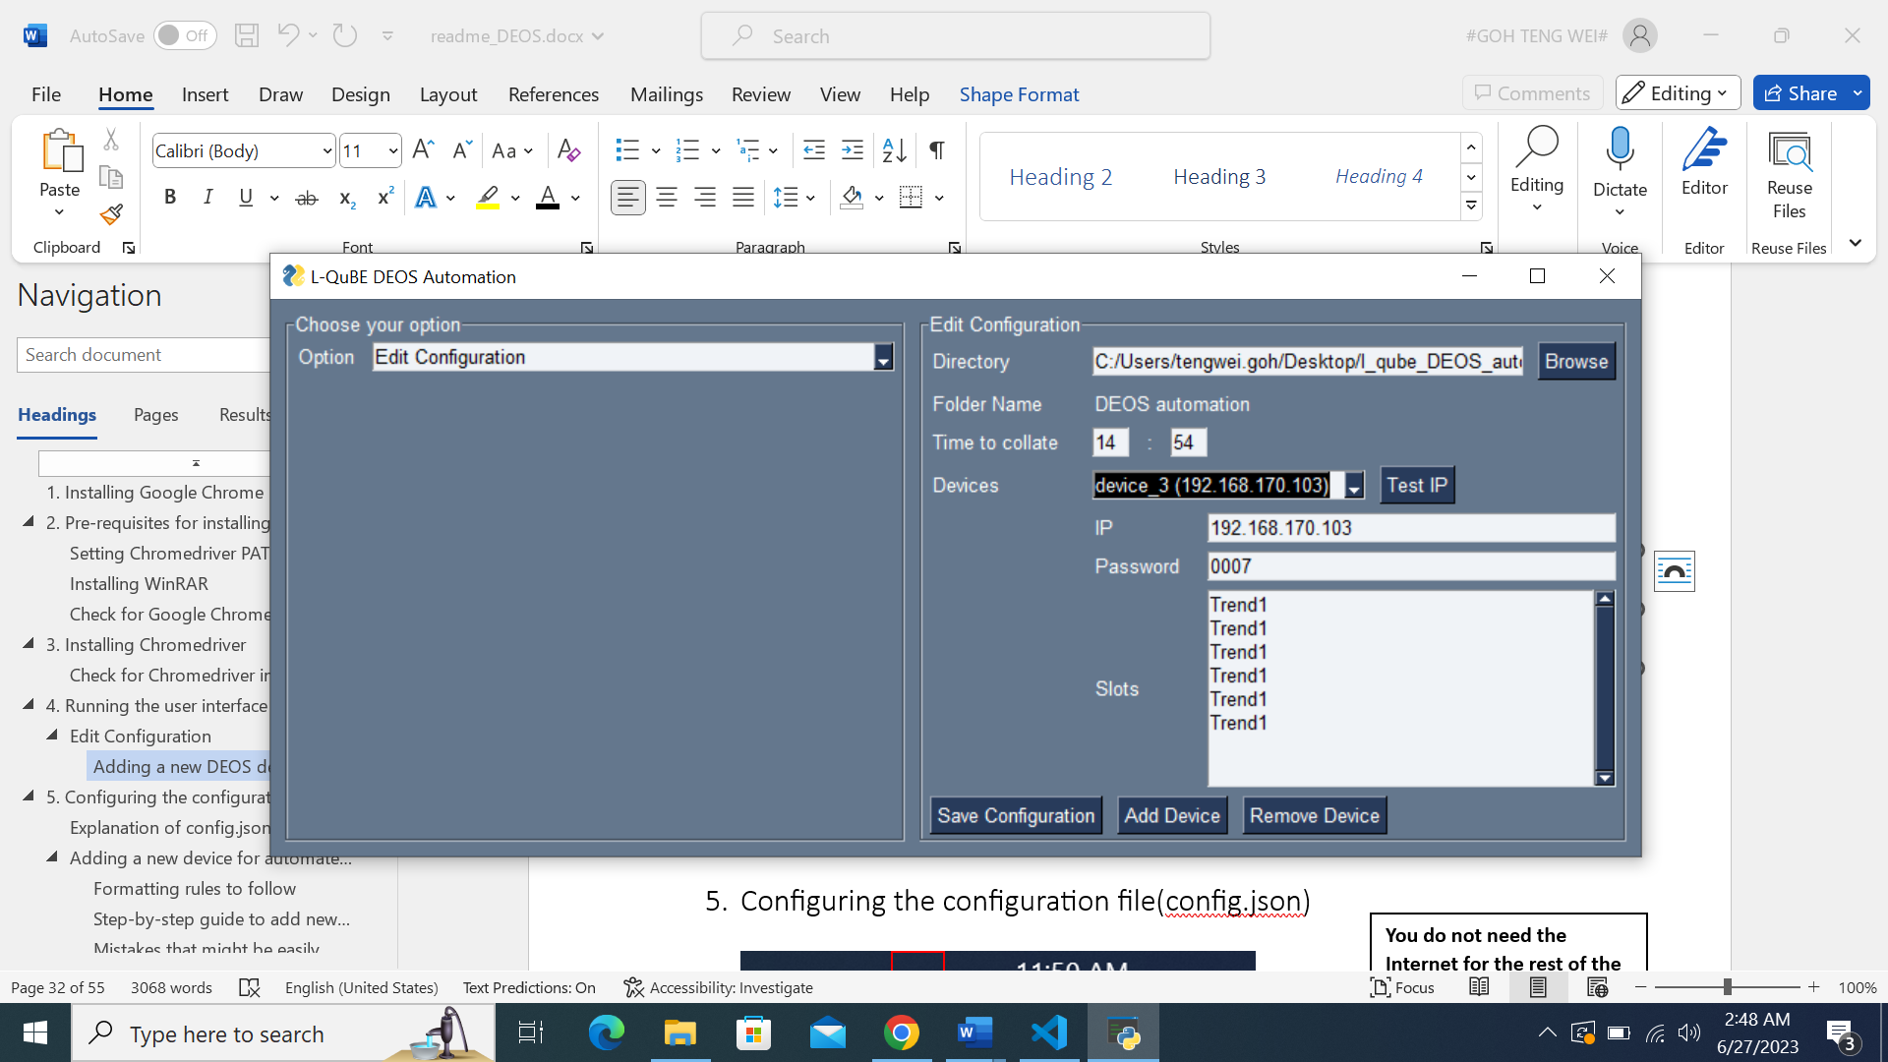

Clicking on the newly added device in the dropdown will display the device’s information that were just keyed in.

### Removing a DEOS device

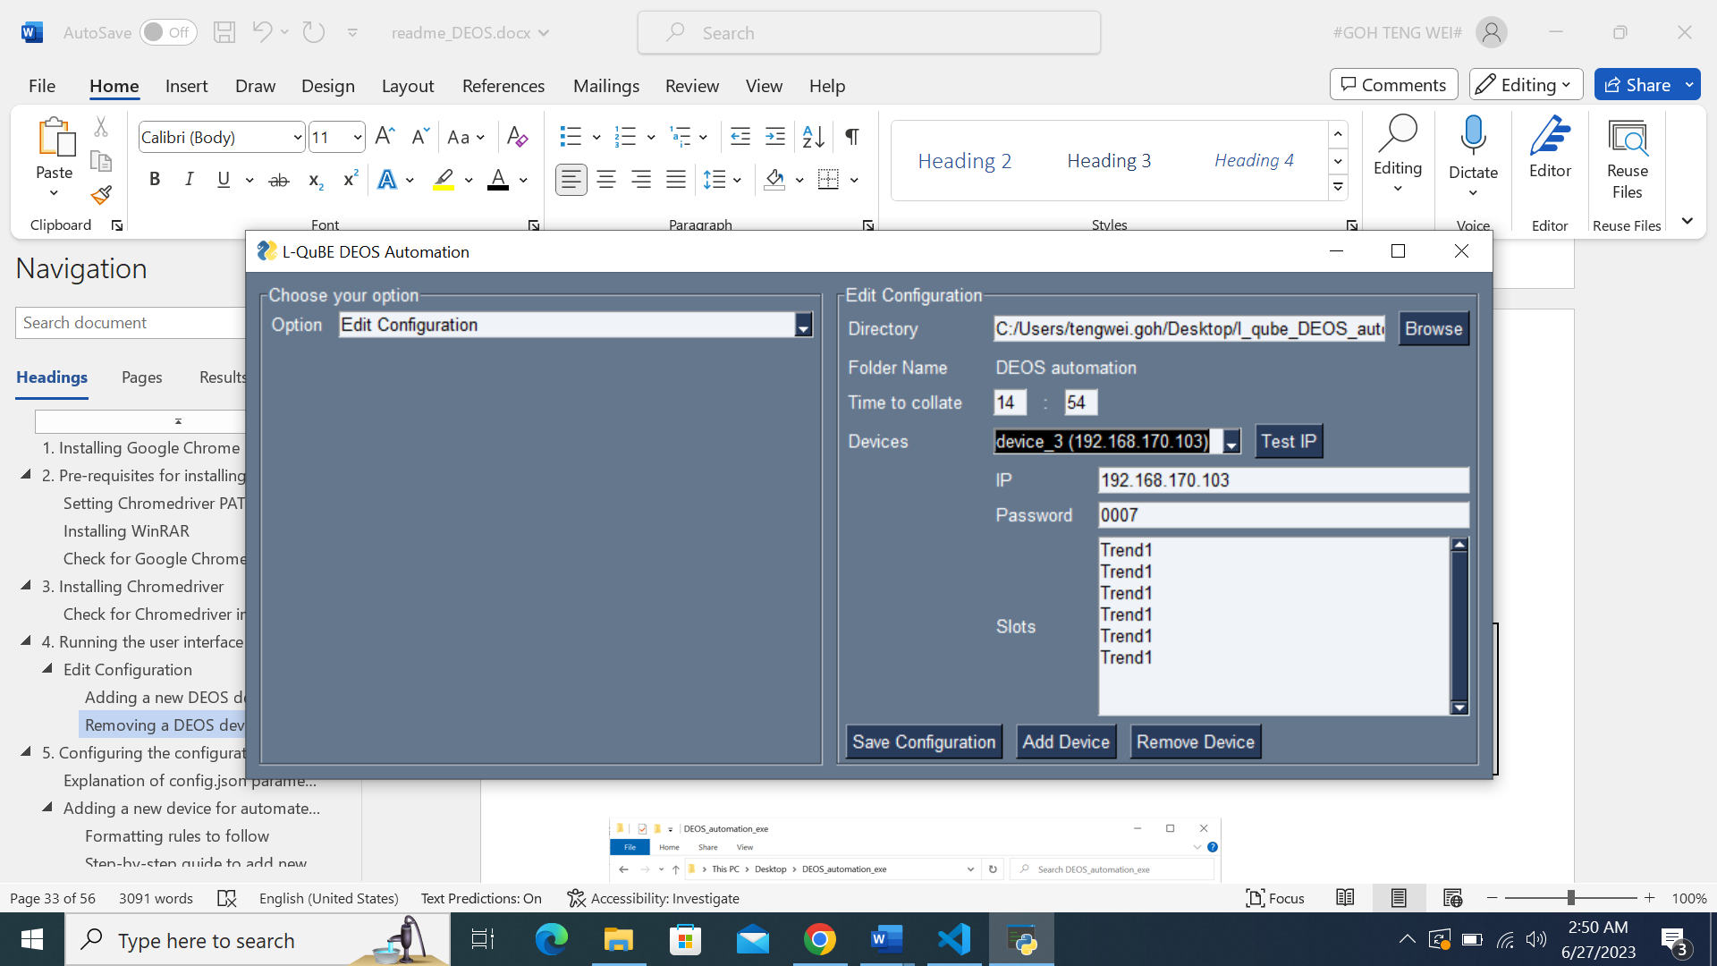

Click on the ‘Remove Device’ button.

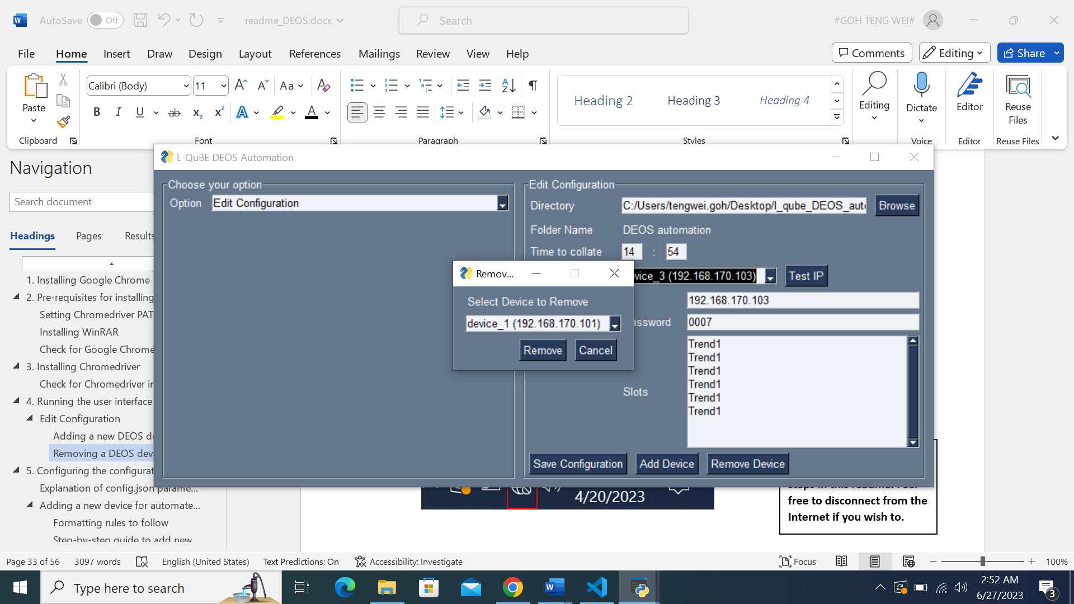

A pop-up will be displayed that requests for the device you wish to remove.

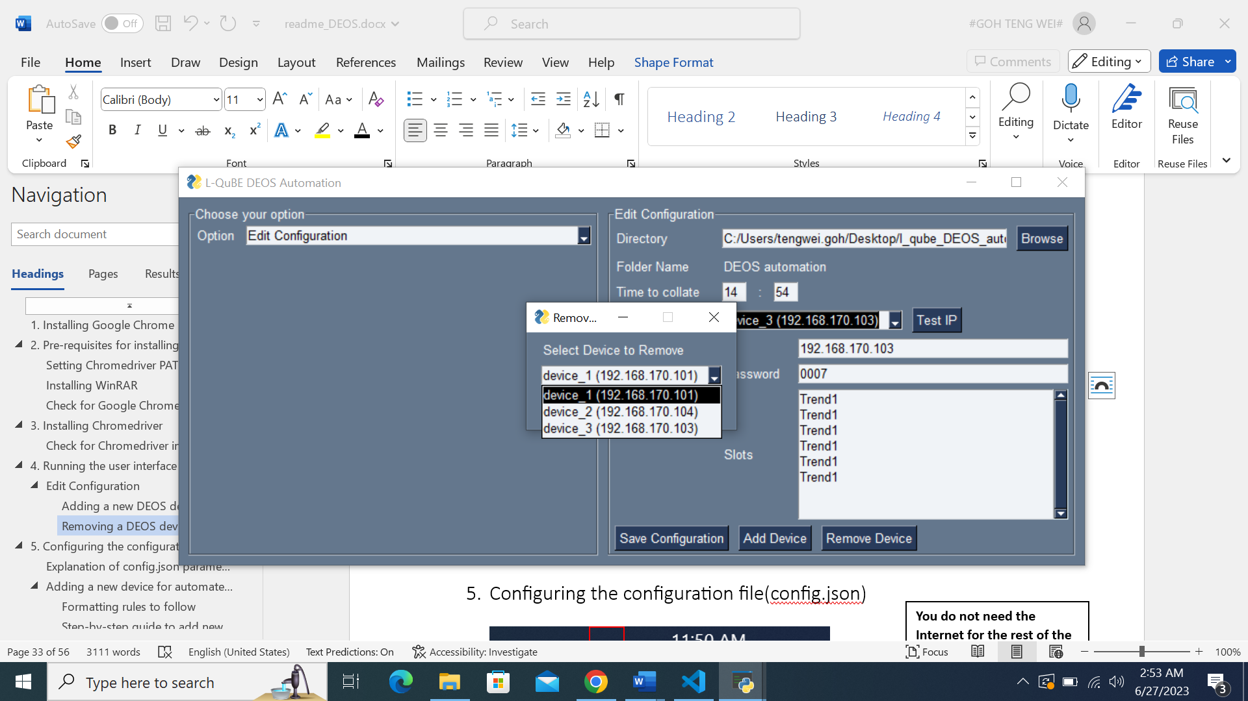

Clicking on the dropdown will reveal all DEOS devices saved in the configuration.

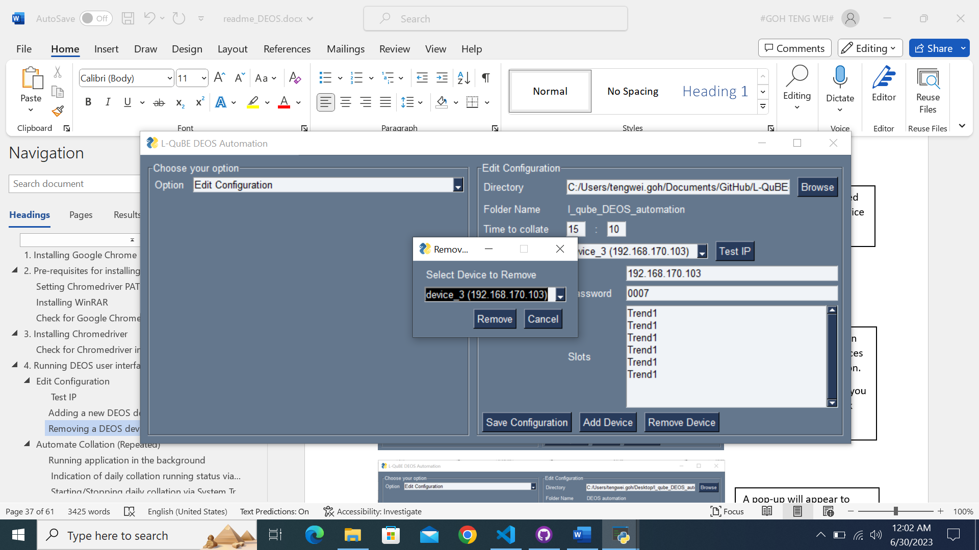

Select the device which you wish to remove and click the ‘Remove button’.

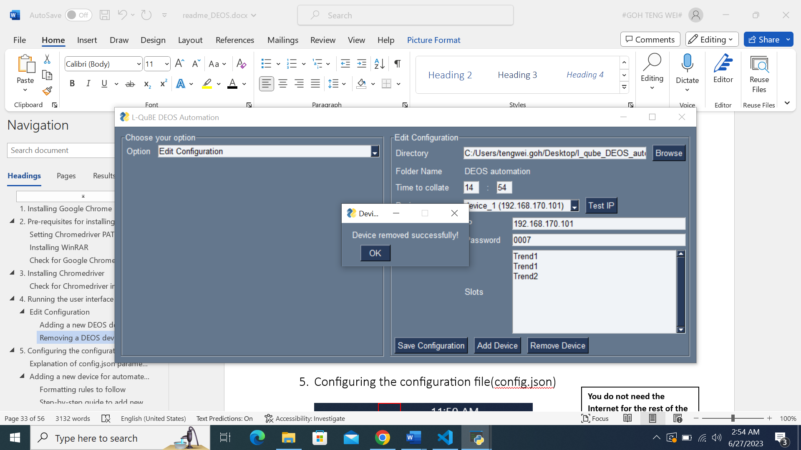

A pop-up will appear to notify you that **the device has successfully been removed from the configuration.**

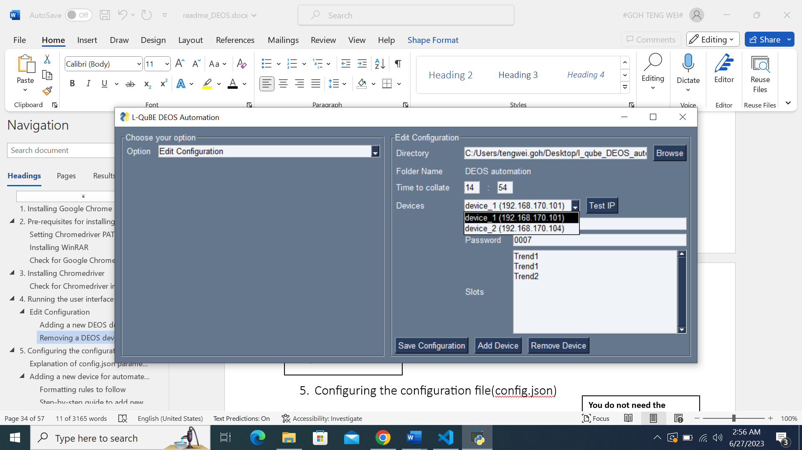

Clicking on the Devices dropdown will reveal the updated device list.

## Automate Collation (Repeated)

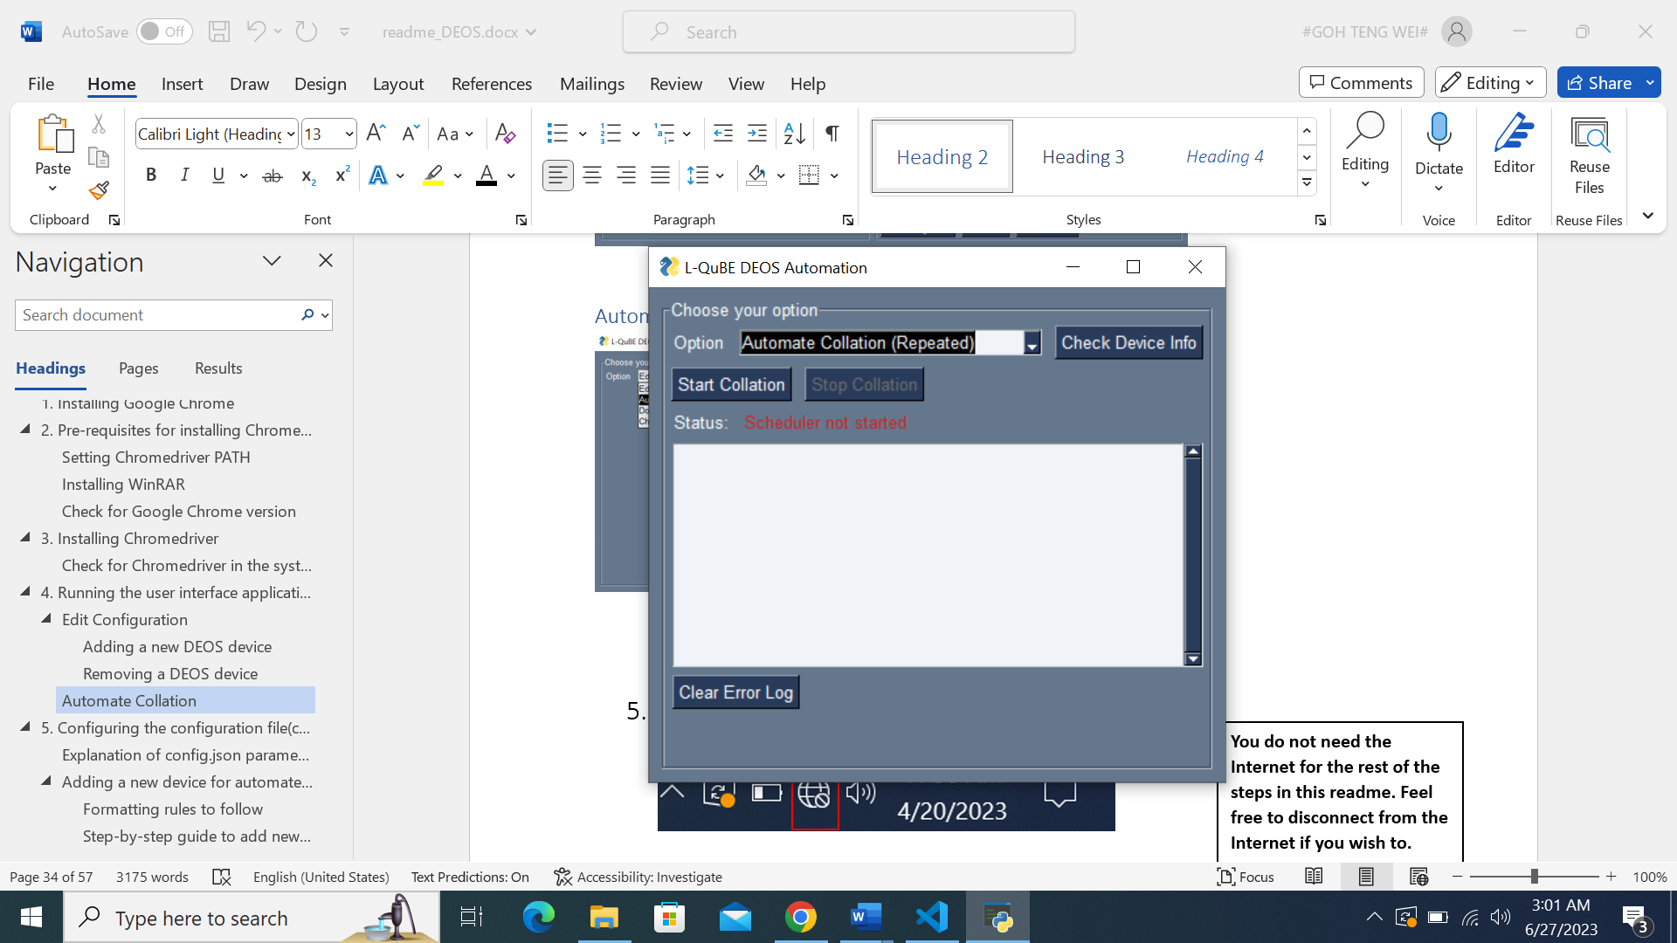

This will be the interface when the ‘Automate Collation (Repeated)’ option is selected.

**Repeated indicates that the process will execute every day at the saved collation time.**



Please run ‘Check Device Info’ before starting the daily collation.

This is to ensure that the information saved in the configuration is correct and able to successfully download the DEOS raw data.

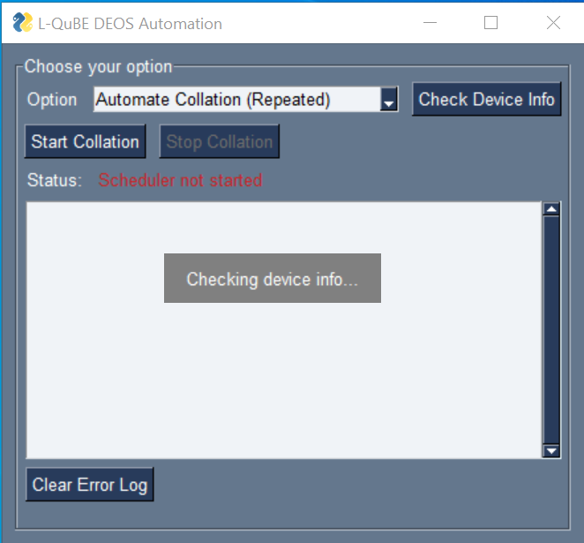

**Note: Invalid device information will result in longer waiting time!**

Please wait for the software to check every device’s information.

It will take approximately ~20 seconds for a device with 10 slots.

The more devices that are added, the longer this process will take.

Please be patient and thank you for waiting!

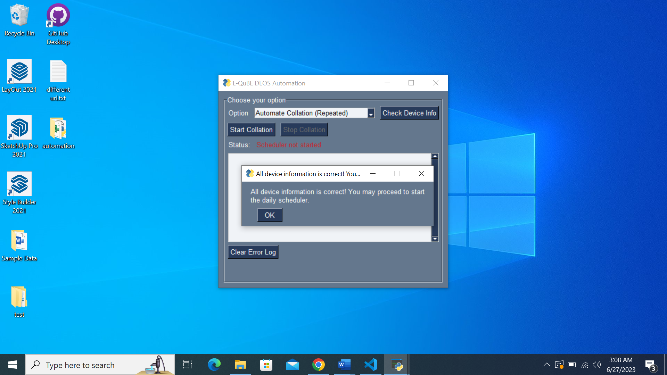

If every device’s information is correct, this pop-up will inform you that everything is okay, and the daily collation can begin.

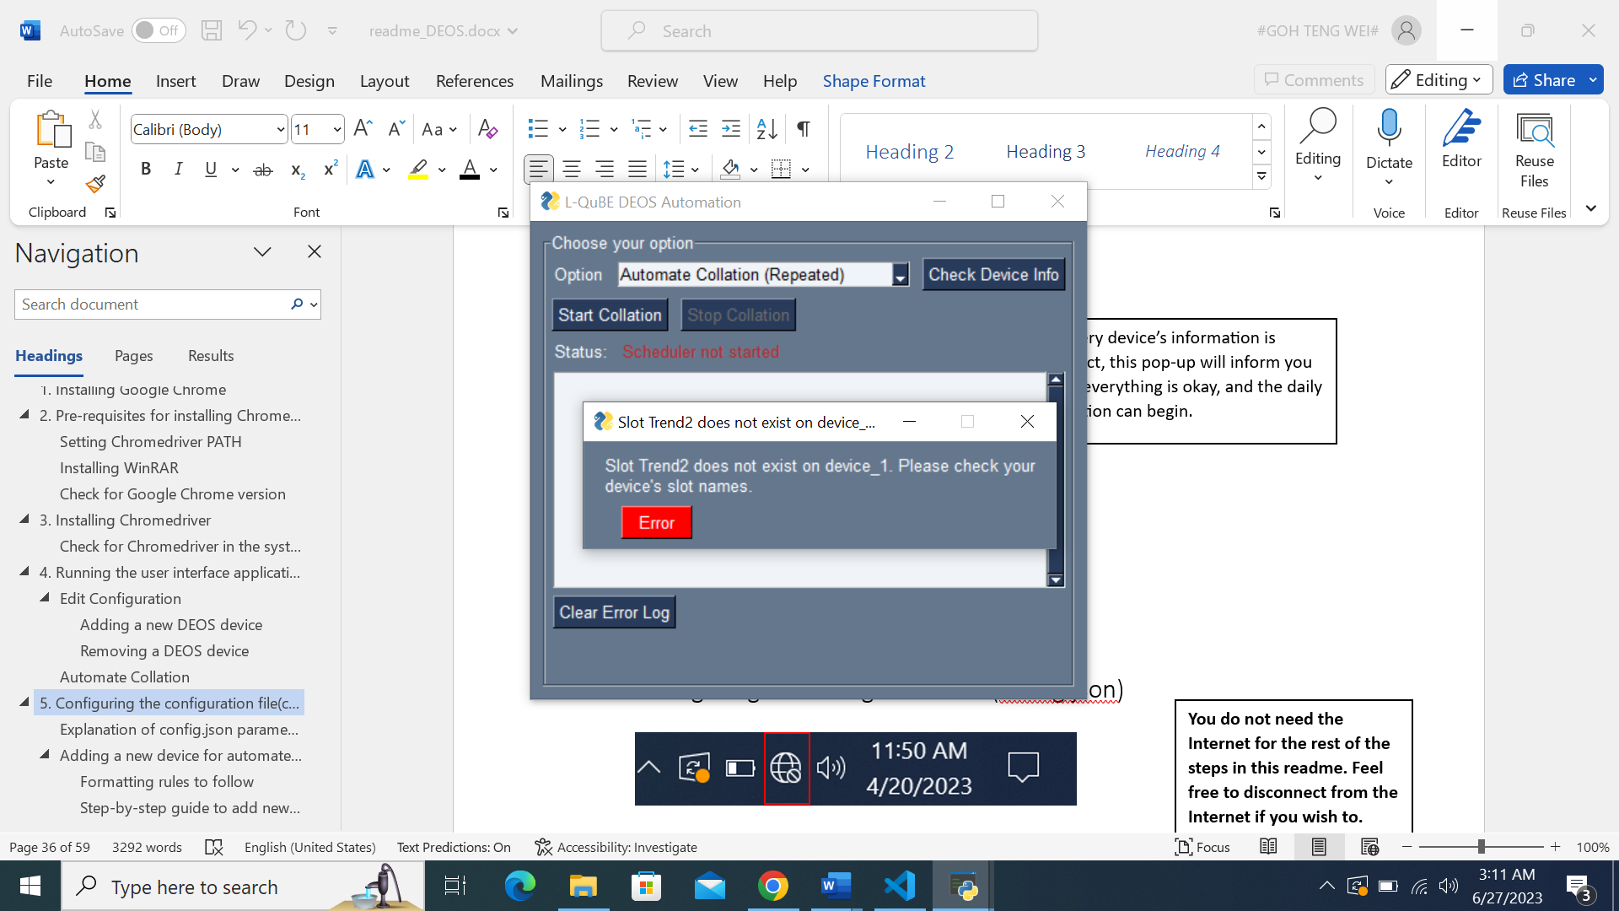

If there are errors in device’s information, an error pop-up will be shown, notifying you of the specific error in the device’s information.

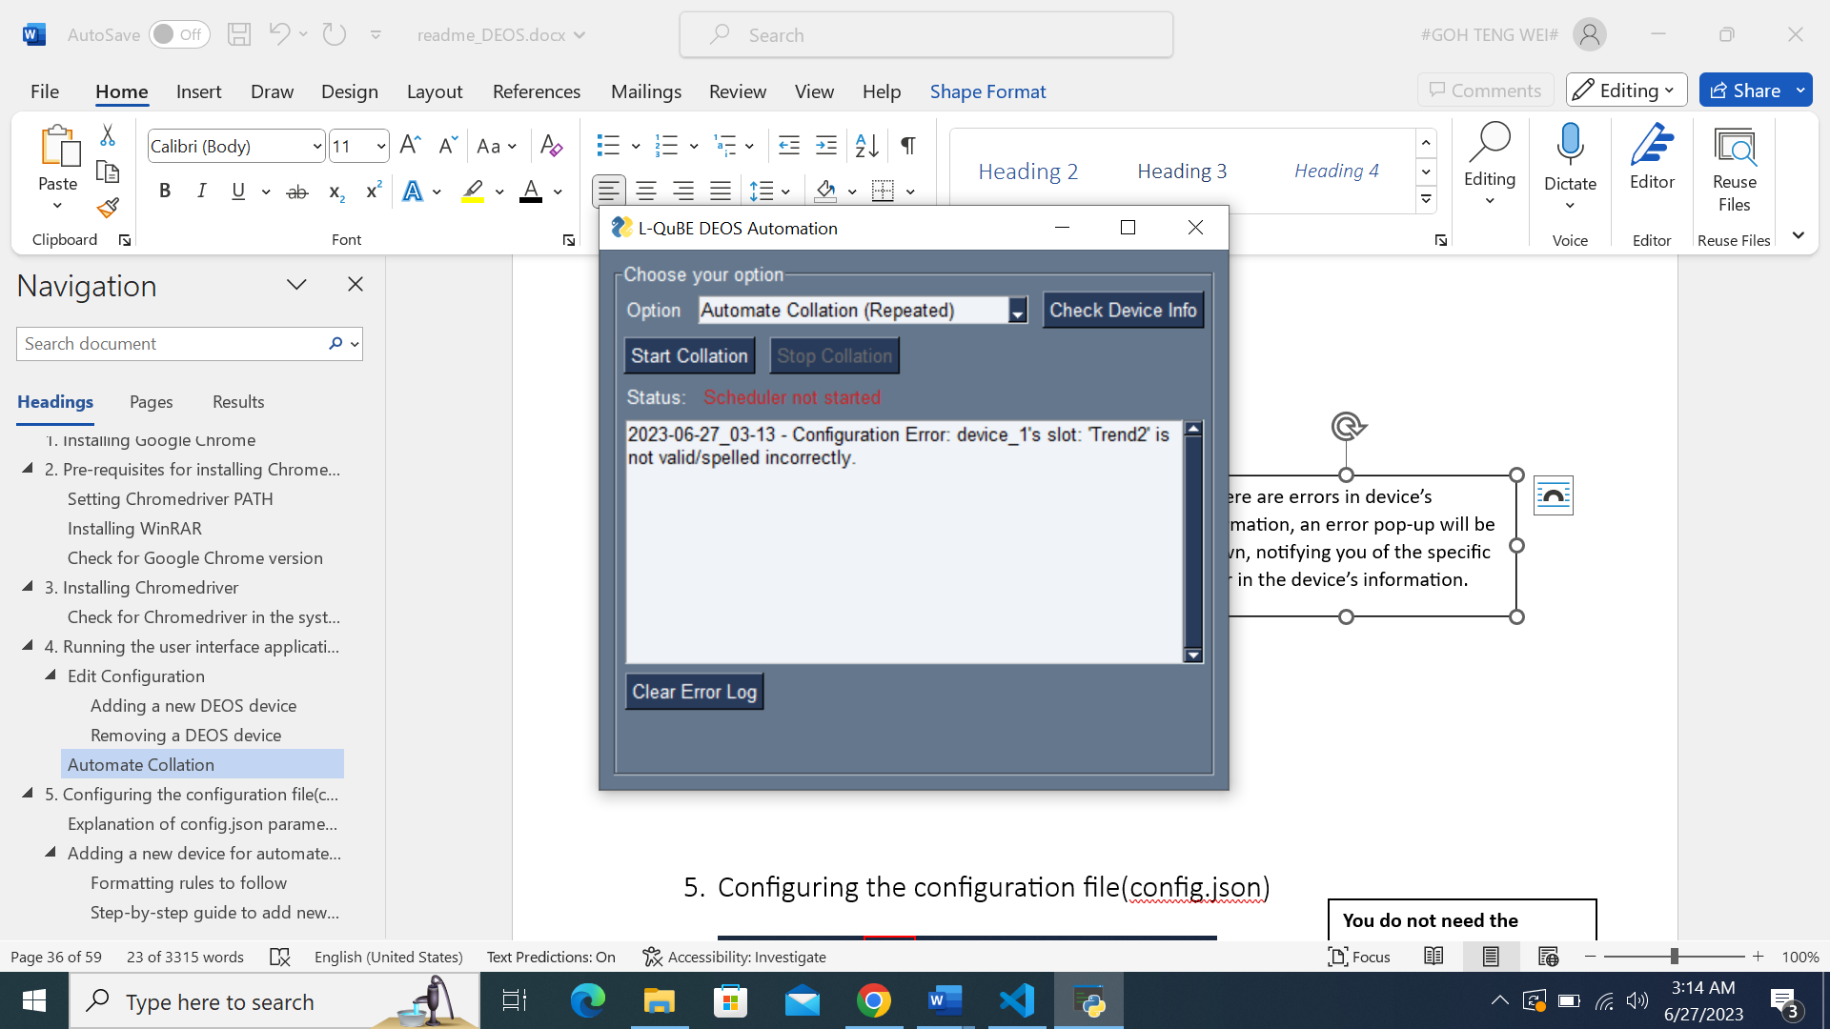

Please head over to Section 6. Error fixing for more information on the types of errors.

The error log will then be updated with the error faced in the ‘Check Device Info’ process, with the date and time paired with the error.



You may wish to clear the error log when there are too many past error logs, by clicking on the ‘Clear Error Log’ button.



The status informs you whether the daily collation process has started or not.

After checking and rectifying any errors in the devices’ information, you may proceed to start the daily collation schedule by clicking on the ‘Start Collation’ button.

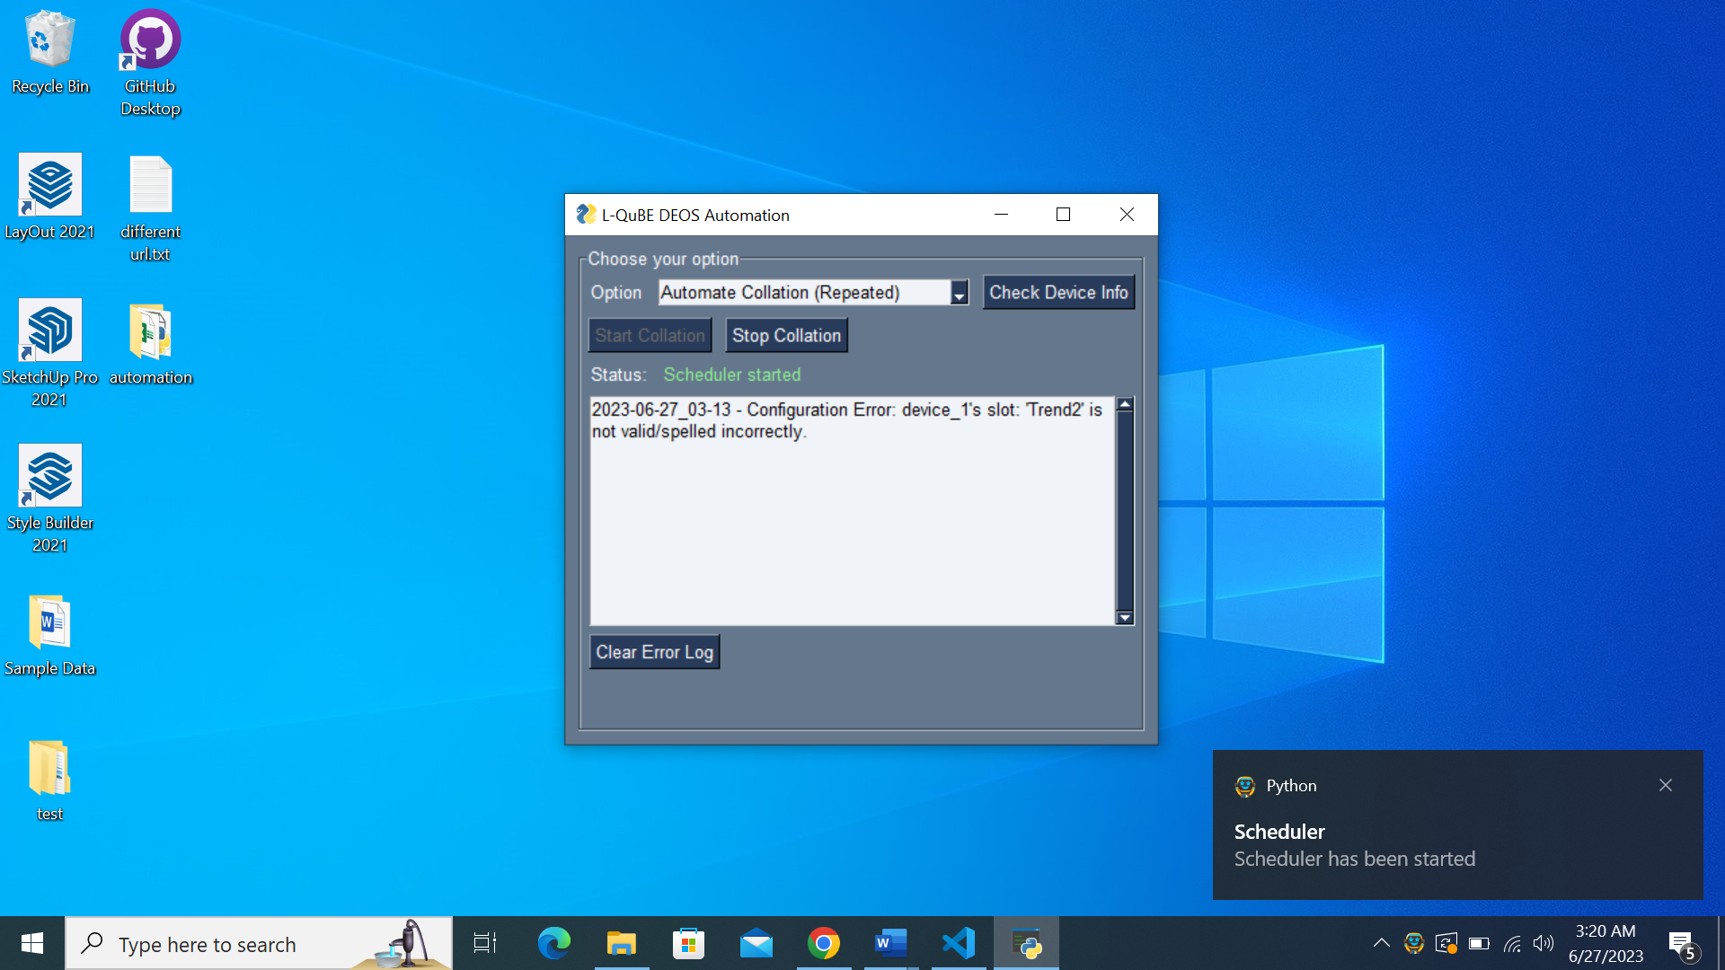

Once the daily collation process has started, there will be 3 indicators that will confirm that the process has indeed started.

1. The ‘Start Collation’ button will be disabled.
2. The status will be changed to ‘Scheduler started’ with green text colour.
3. There will be a Windows system notification of the process being started.



Once the daily collation process has stopped, there will be 3 indicators that will confirm that the process has indeed stopped.

1. The ‘Stop Collation’ button will be disabled.
2. The status will be changed to ‘Scheduler stopped’ with red text colour.
3. There will be a Windows system notification of the process being stopped.

Click on the ‘Stop Collation’ button to kill and stop the current daily collation process.

**If you wish to edit the configuration, you must stop the collation for the new configurations to be reflected in the daily collation.**

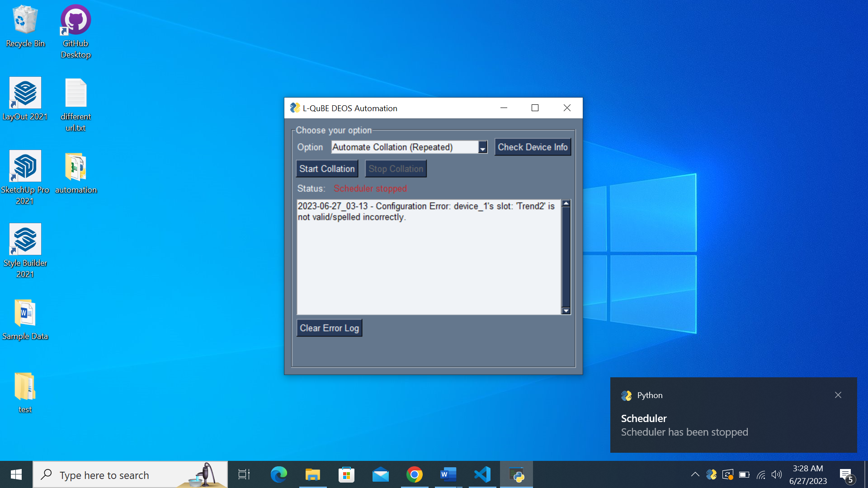

### Running application in the background

As we do not want any user to accidentally close our daily collation program, there is a feature in the program that will allow our software to run in the background. The program will be available to be relaunched from Windows System Tray anytime you need to.

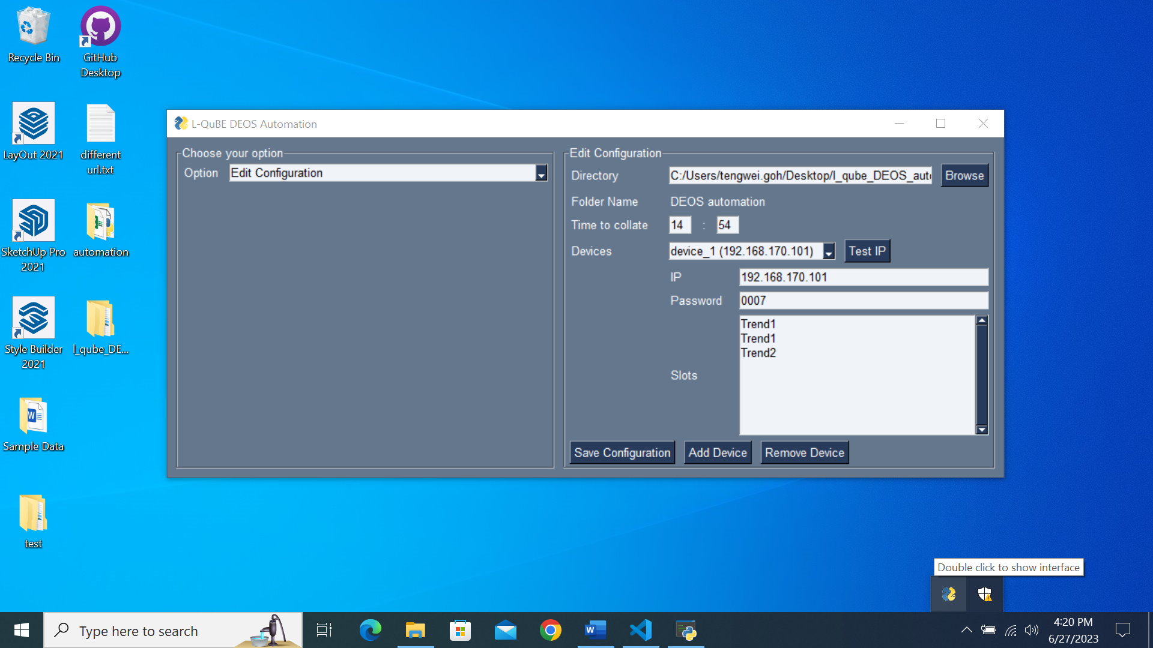

Windows System Tray refers to these icons on the right side of the taskbar.

Click on the arrow to reveal the DEOS interface application.

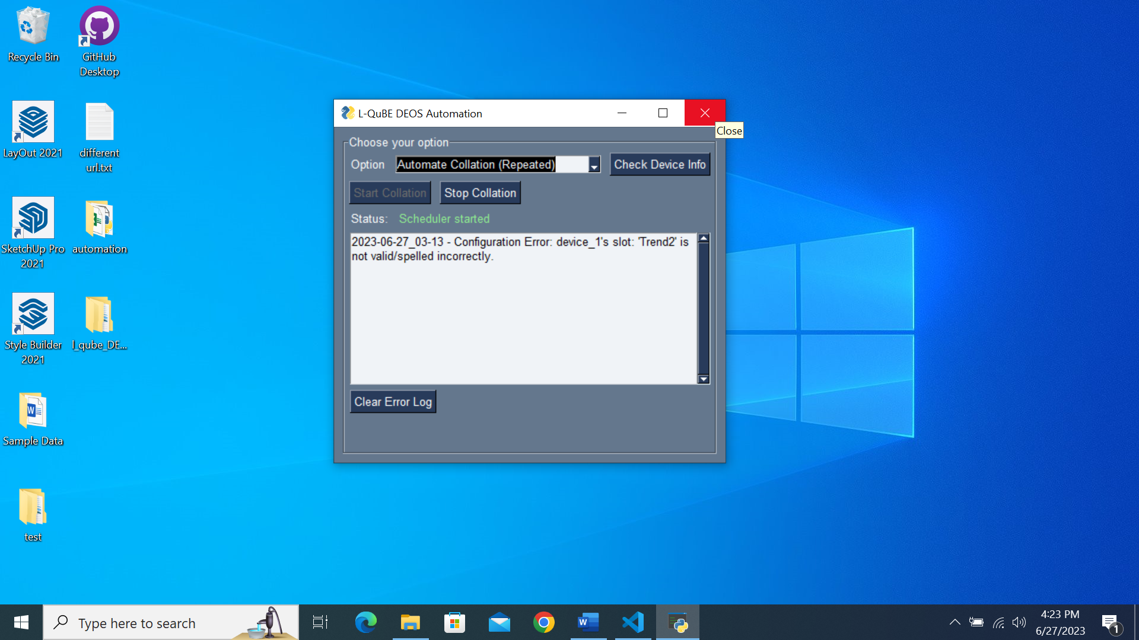

After closing the interface, there will be a Windows notification to inform you that the program is now running in the background.

Notice that the interface icon from the taskbar will disappear.

After you have started the daily collation process, you may close the interface by clicking on the ‘X’ button located on the top right of the interface.

Please be assured that this will not kill the program!

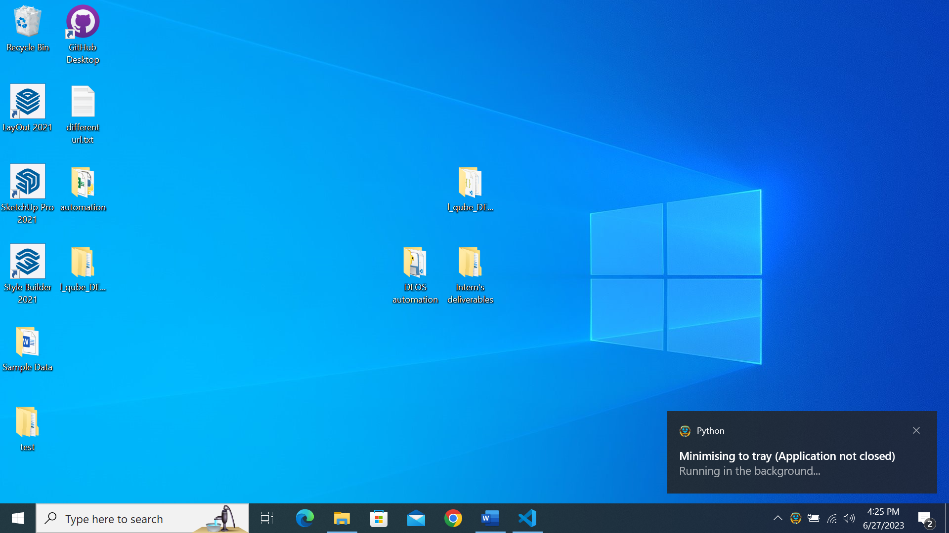

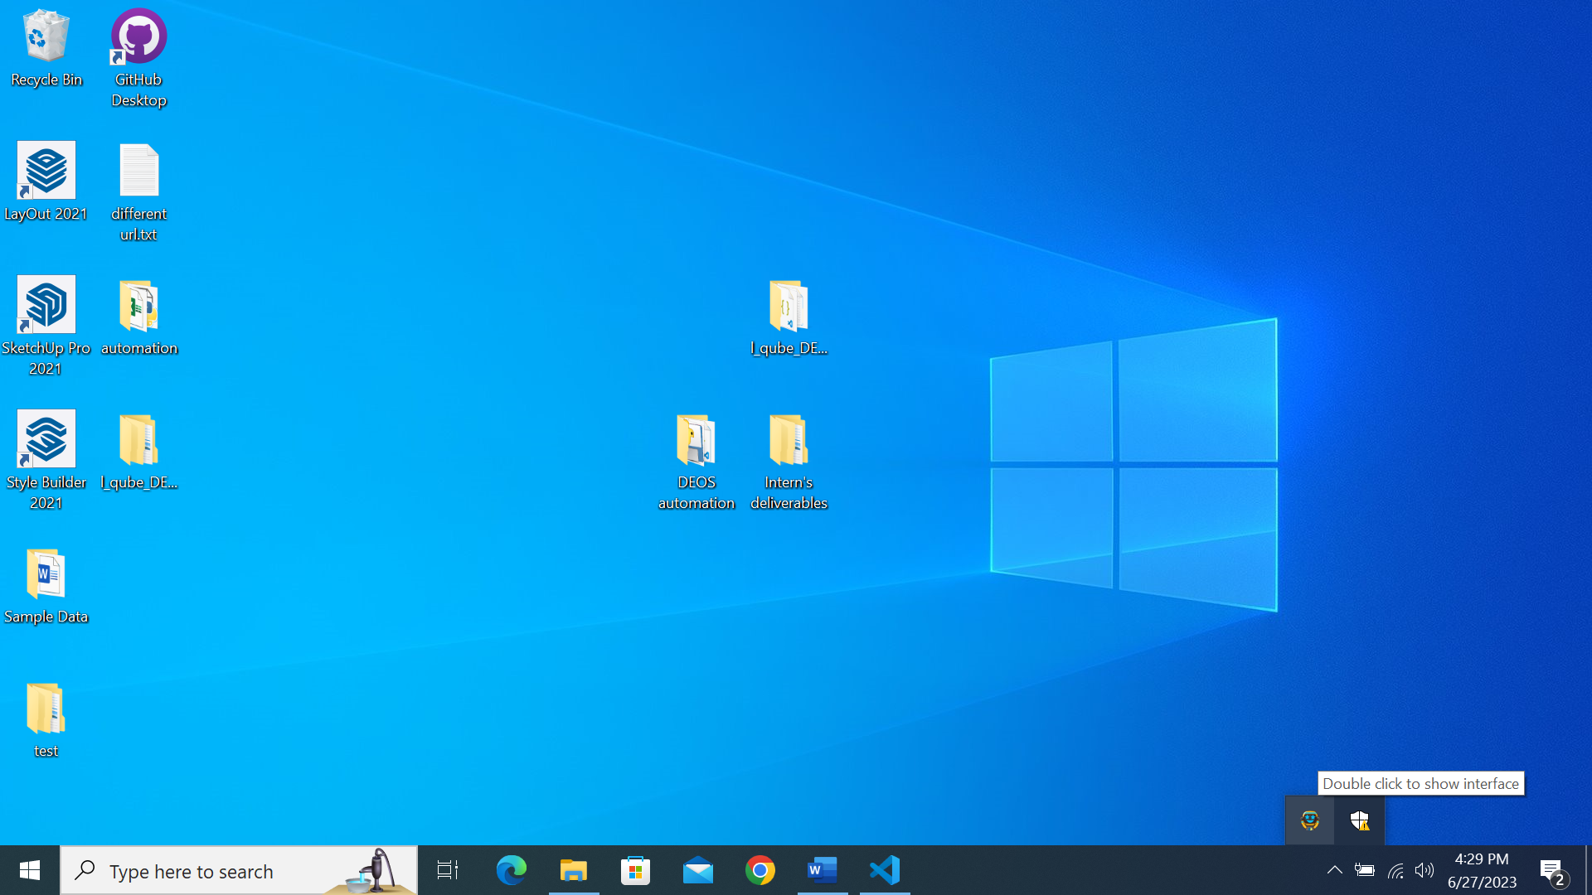

If you wish to relaunch the interface, click the arrow button and double-click the Smiley icon.

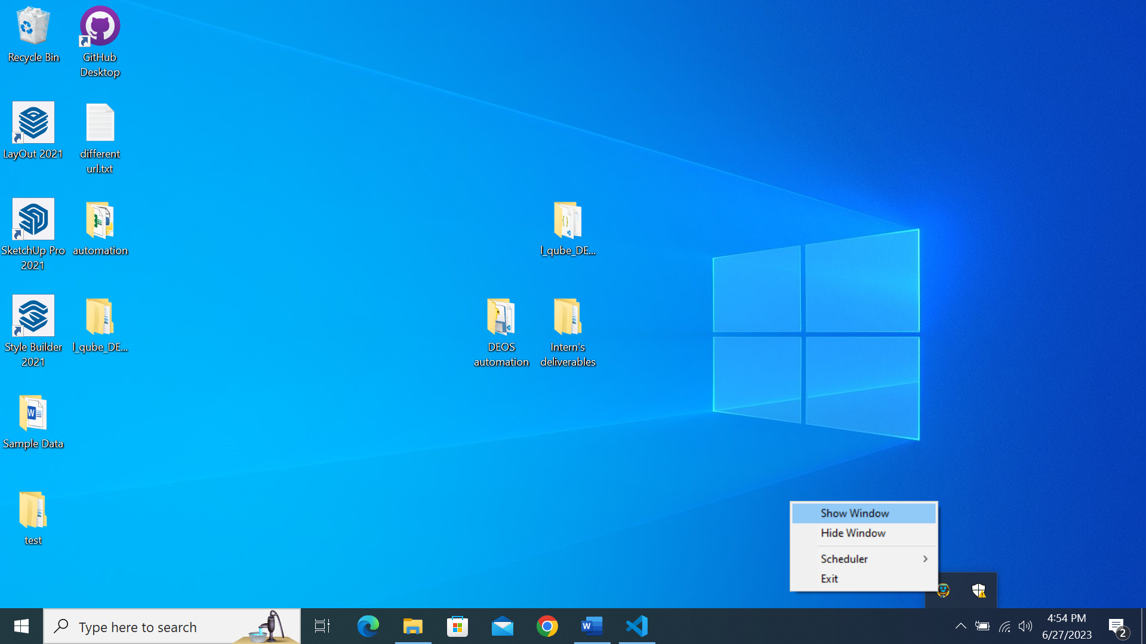

You can also right-click on the icon and press Show Window to relaunch the interface.

### Indication of daily collation running status via System Tray

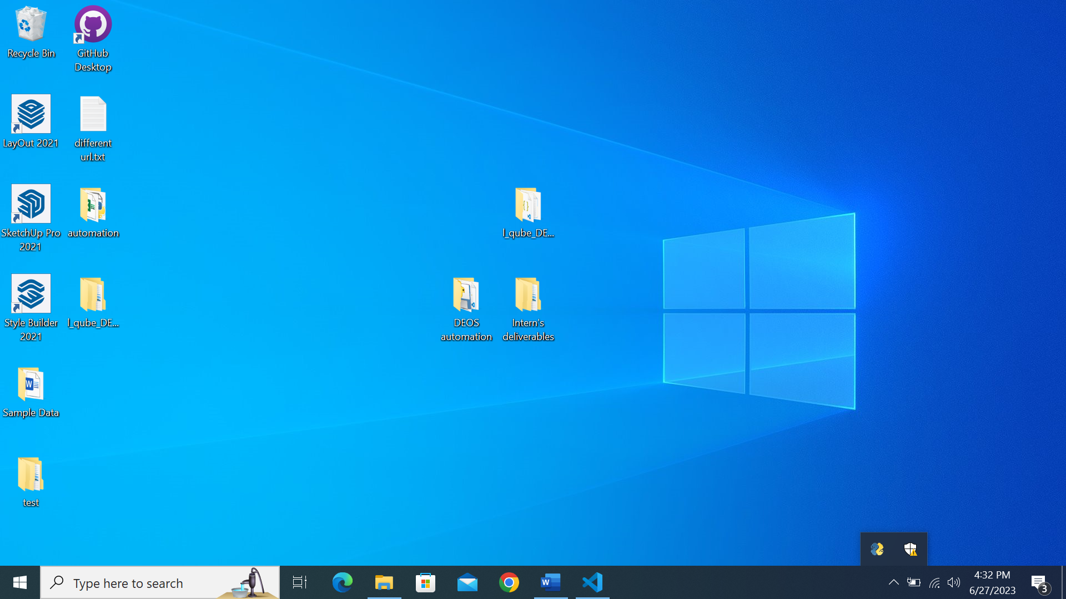

If the daily collation process has not been started, this Python icon will be displayed.

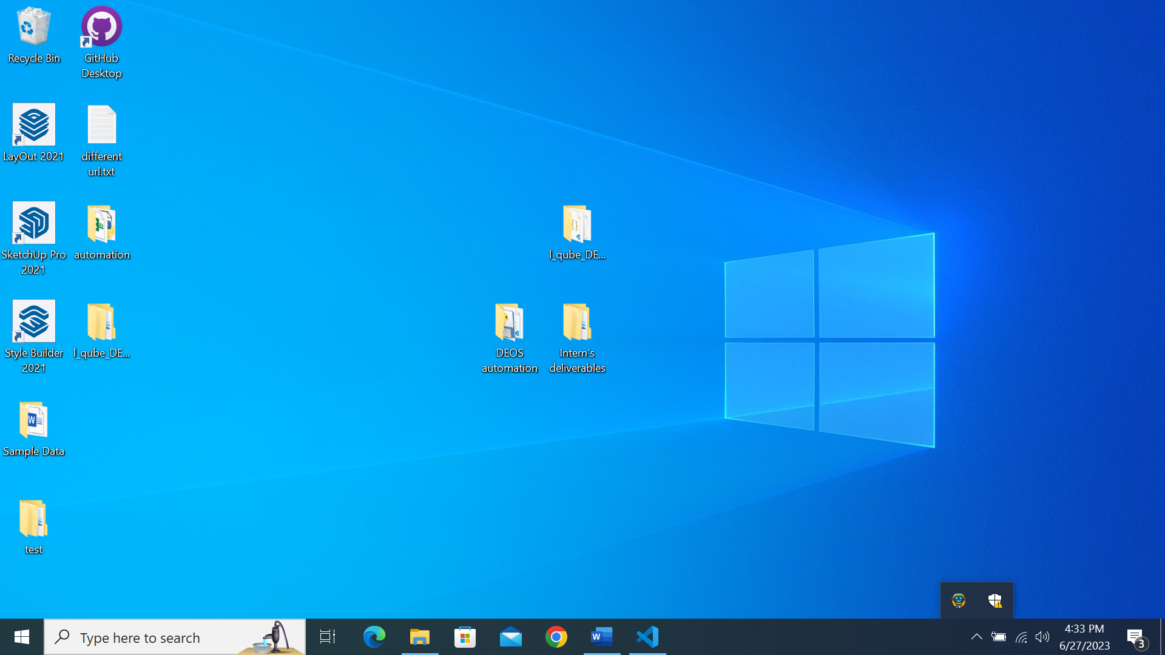

If the daily collation process has been started, this smiley icon will be displayed.

### Starting/Stopping daily collation via System Tray

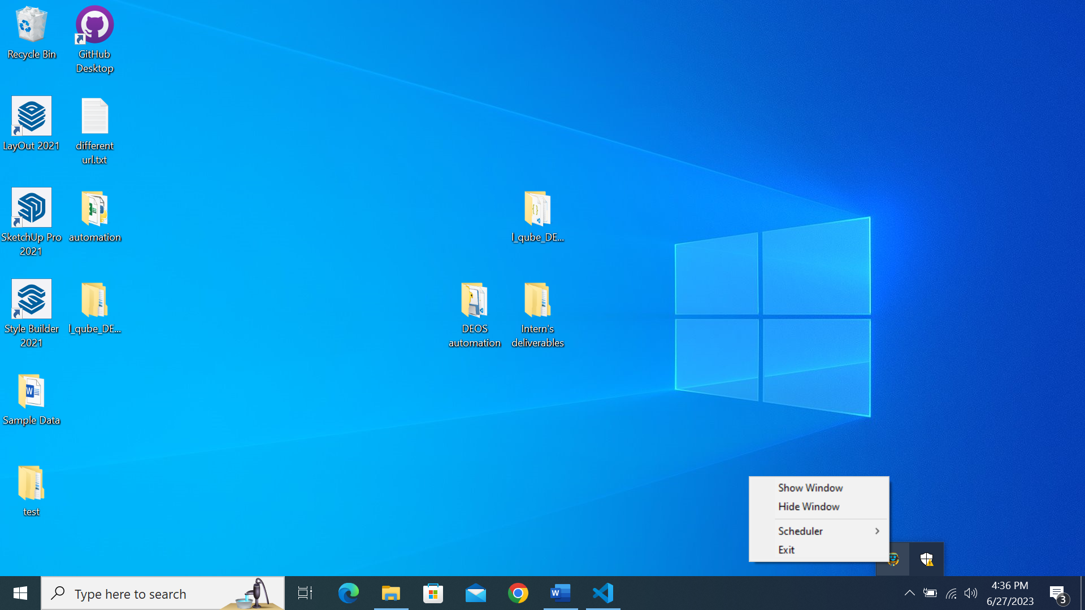

If you wish to start/stop the daily collation process via the System Tray, right click the icon and hover over the ‘Scheduler’ button.

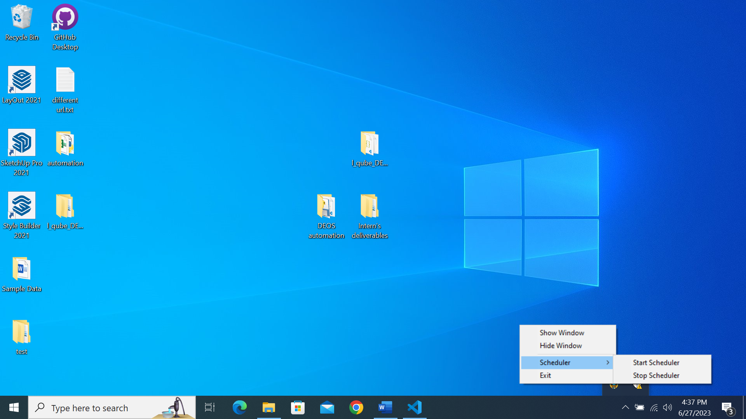

You can then start/stop the daily collation process depending on your needs.

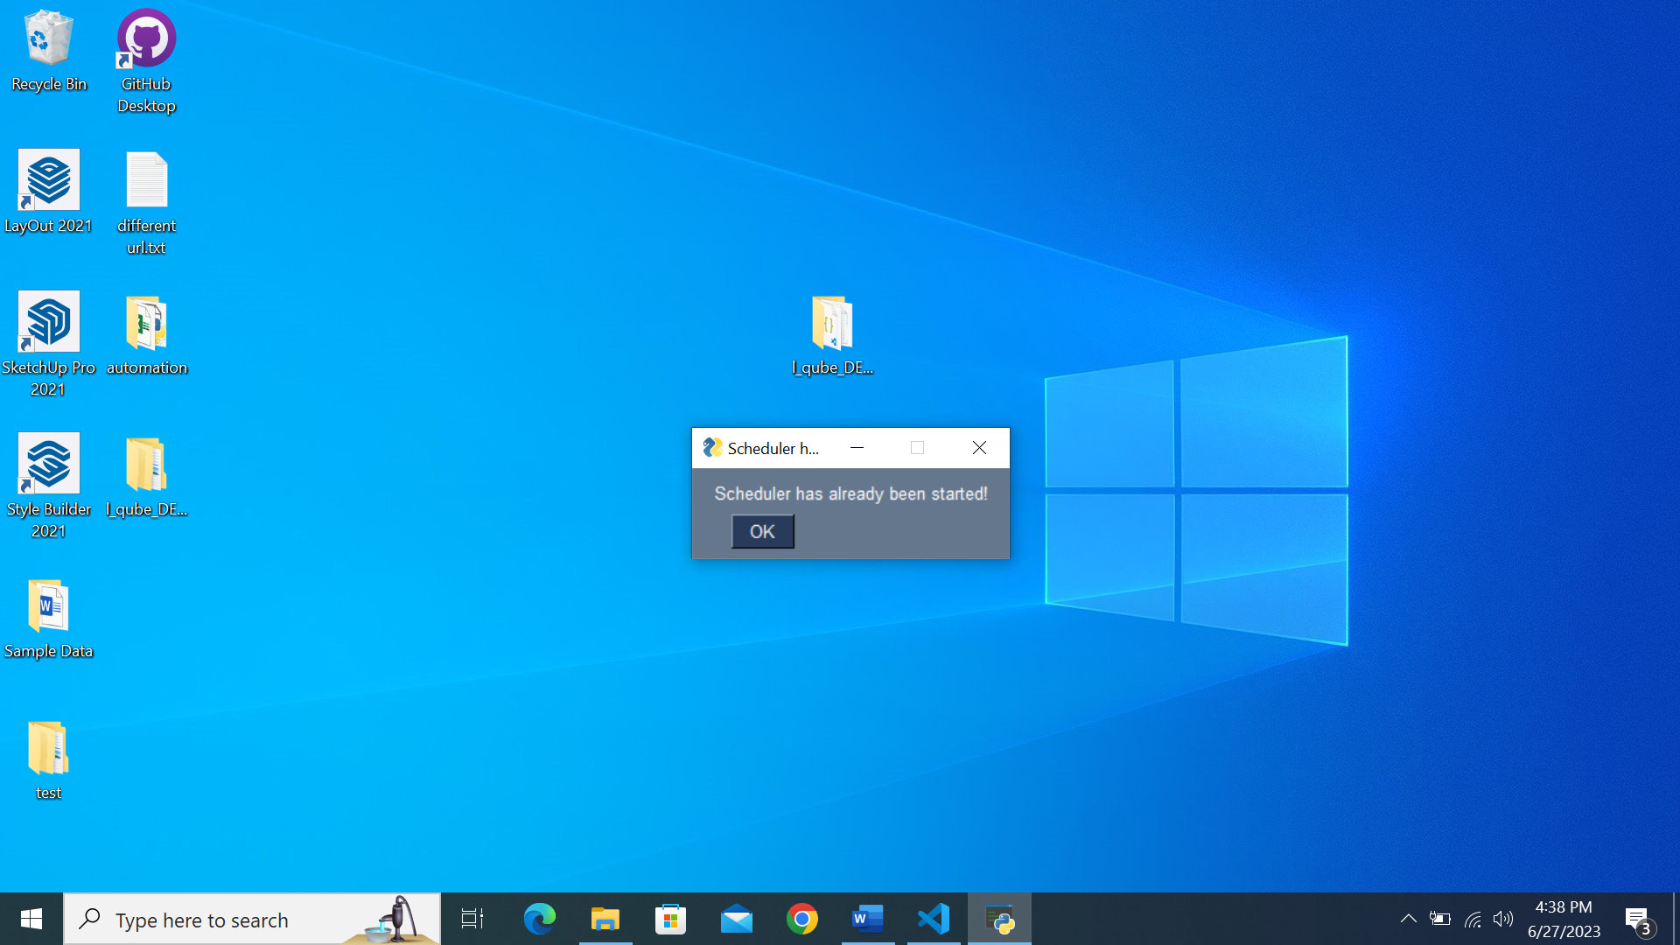

A pop-up will be displayed if the daily collation has already been started but you click ‘Start Scheduler’ again.

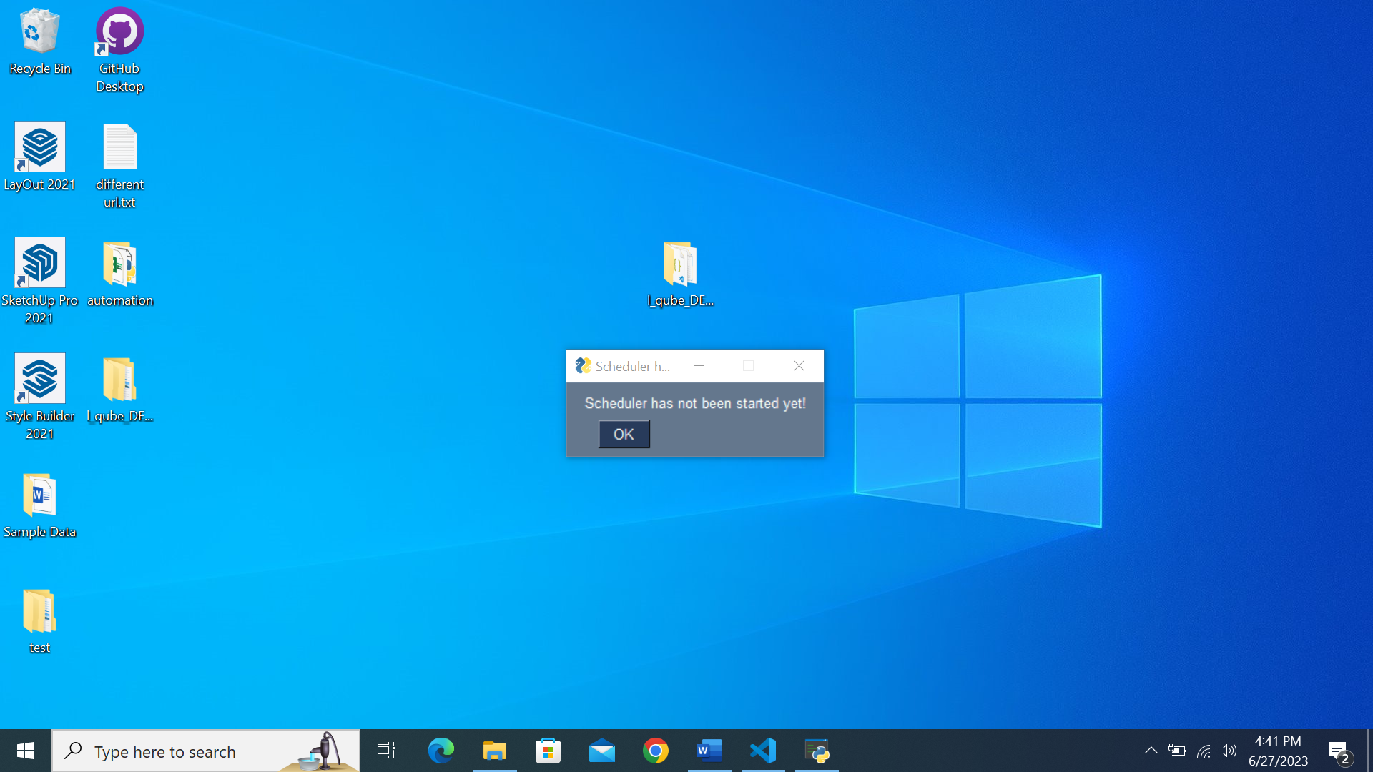

A pop-up will be displayed if the daily collation has already been stopped but you click ‘Stop Scheduler’ again.

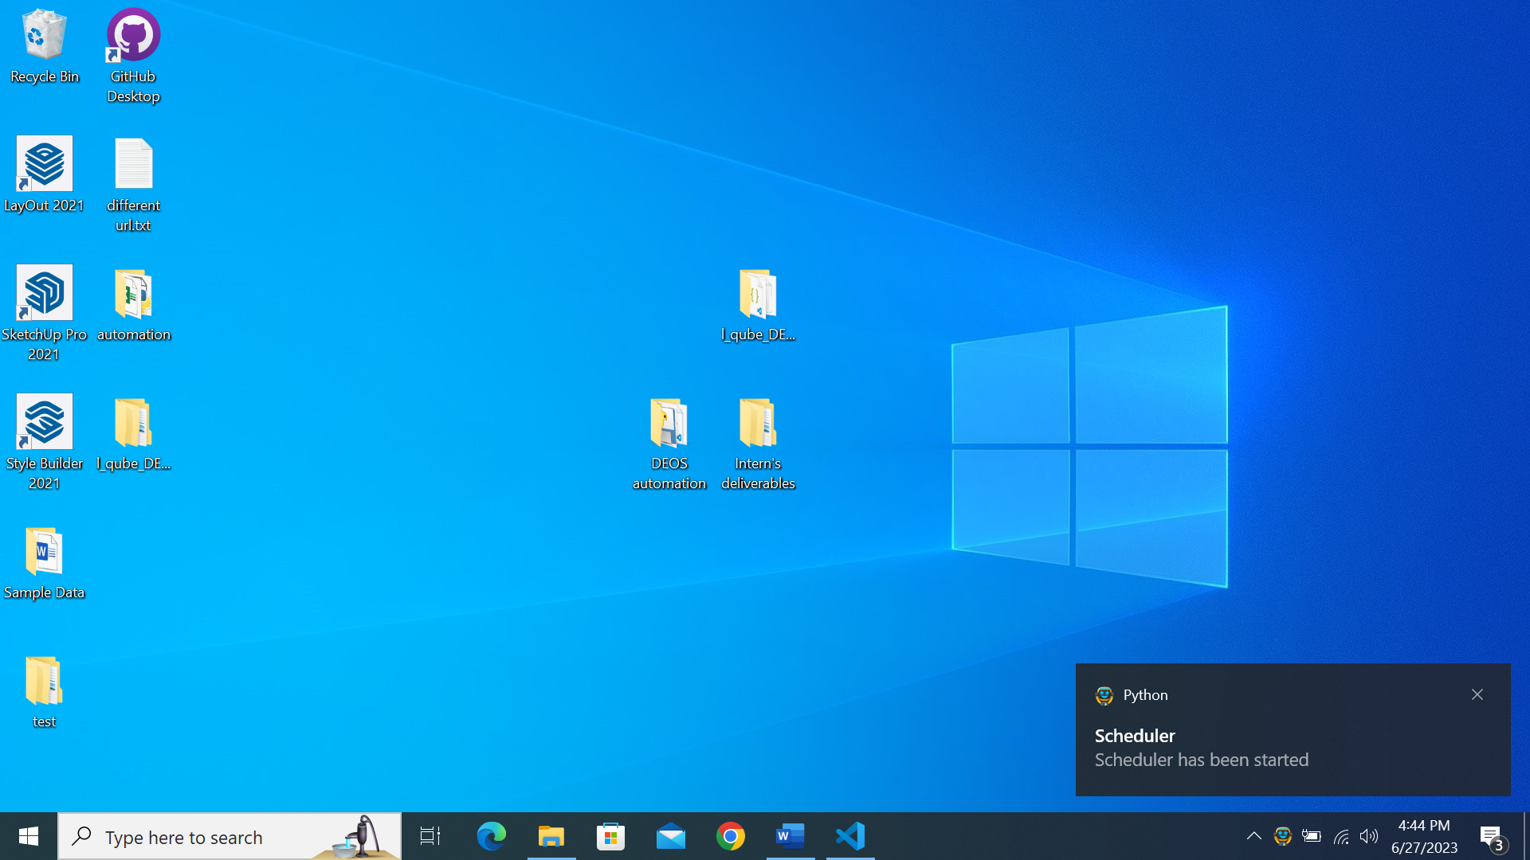

Windows system notification will also be displayed when you start and stop the scheduler successfully.

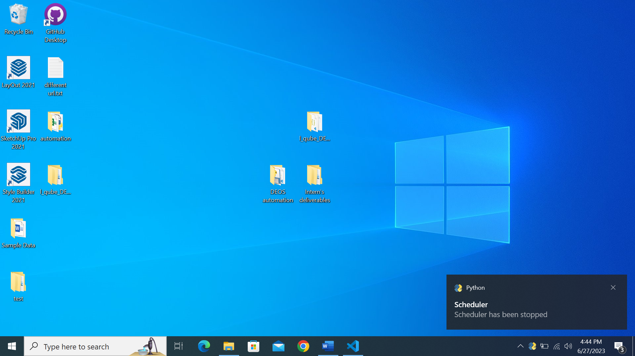

### Killing the program completely

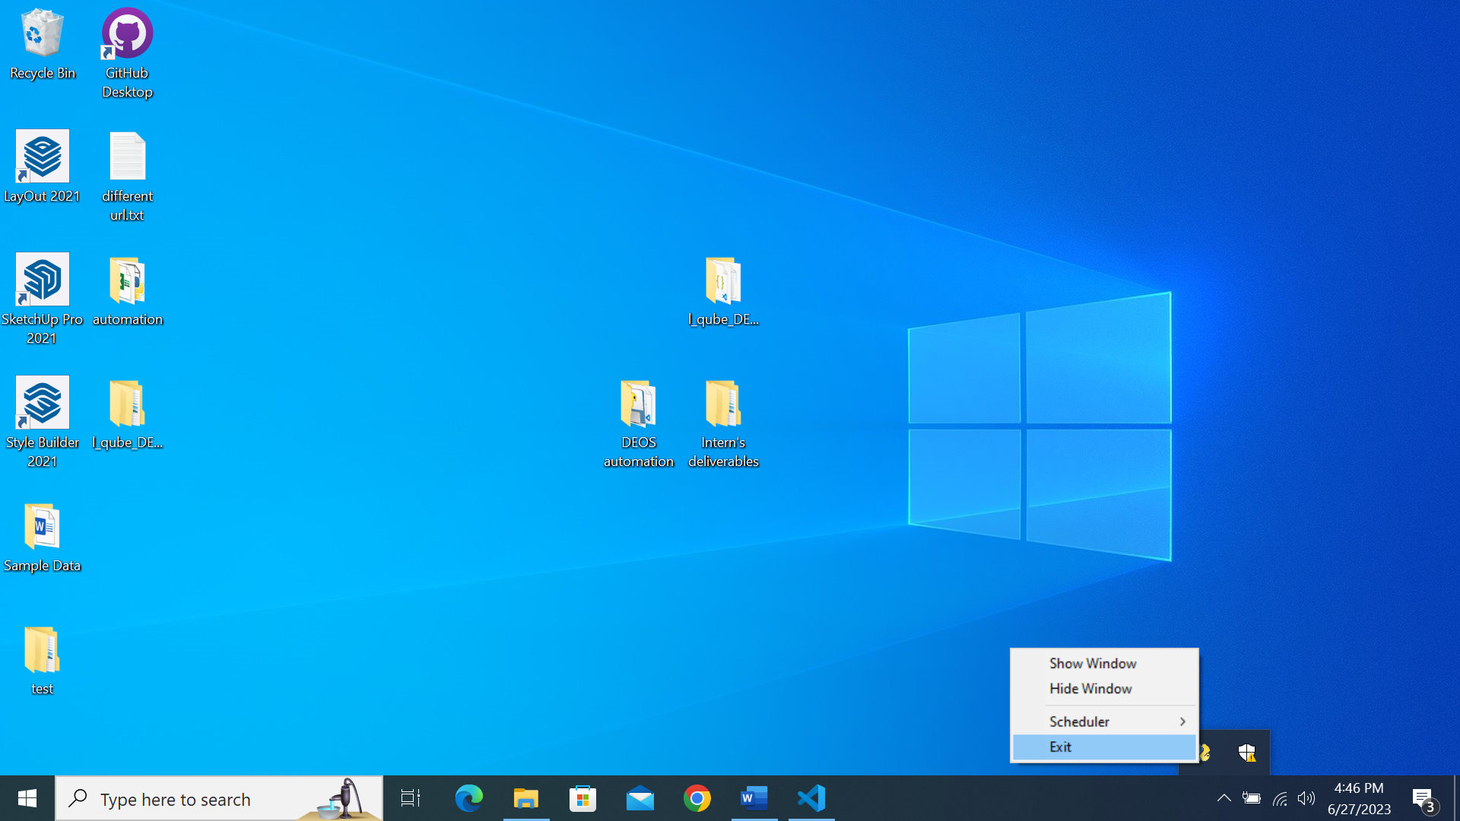

Click on the ‘Exit’ button if you wish to kill the program completely.

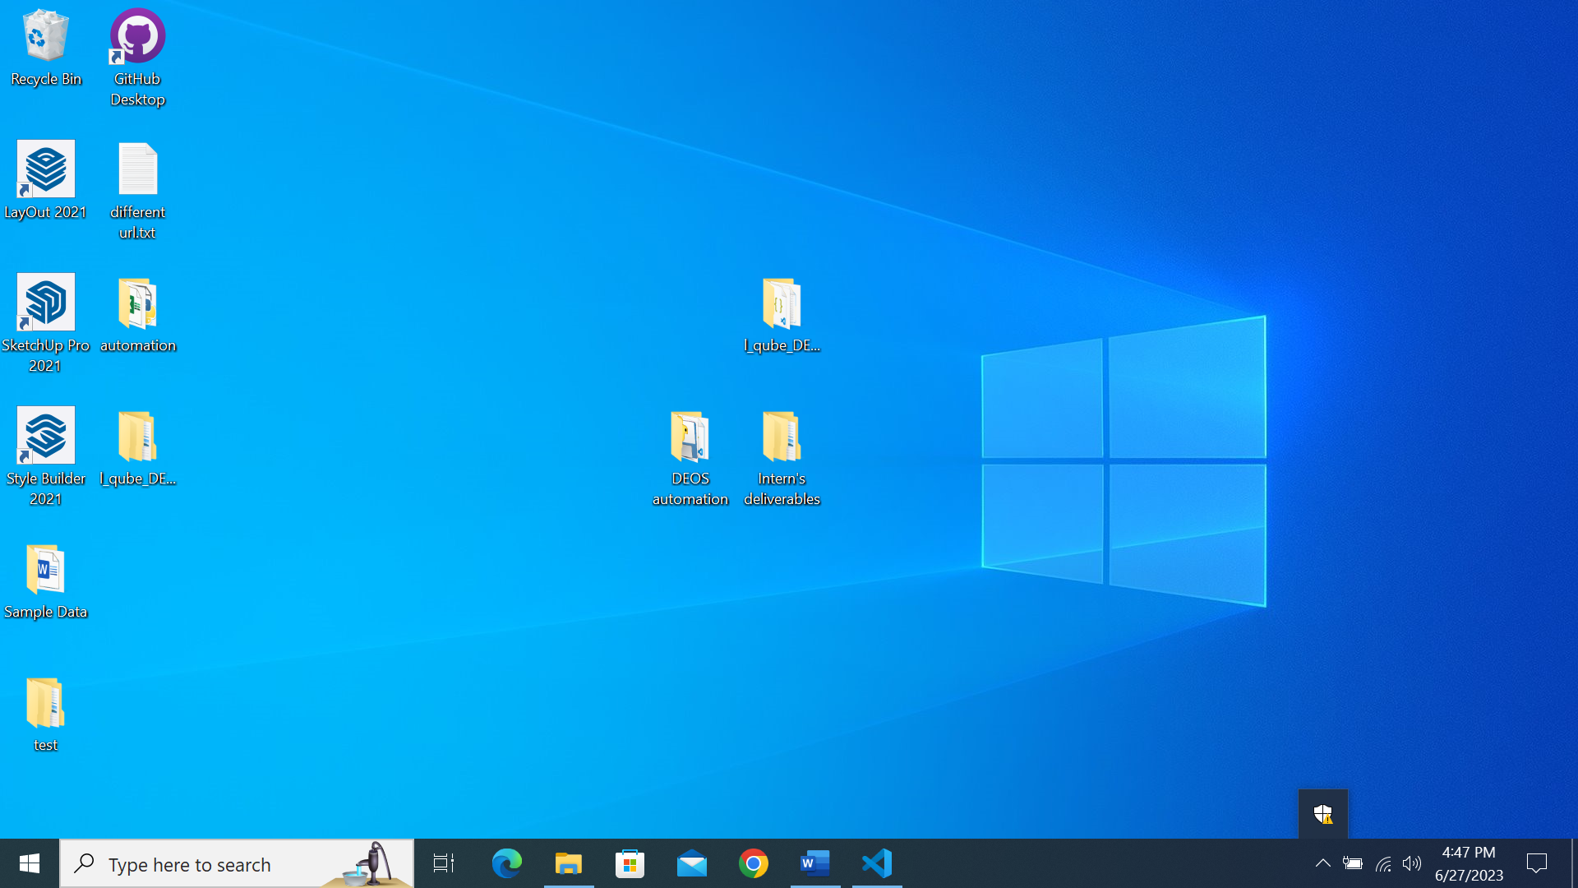

**NOTE: You must stop the daily collation process before killing the program!**

The icon will disappear from the System Tray, indicating that the program has been exited successfully.

## Download all data (Non-repeated)

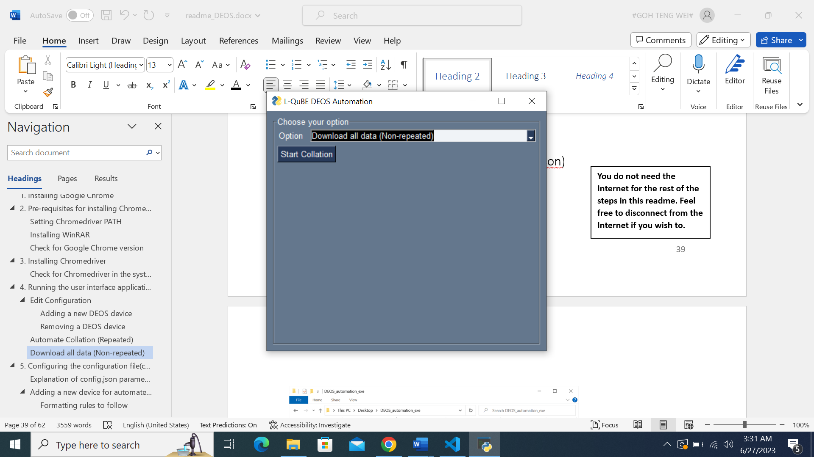

This will be the interface when the ‘Download all data (Non-repeated)’ option is selected.

**Non-repeated indicates that the process will only execute once.**



Click on the ‘Start Collation’ button to download all raw data for all slots on the devices.

Please be reminded this might take quite a while due to the amount of data that needs to be downloaded!

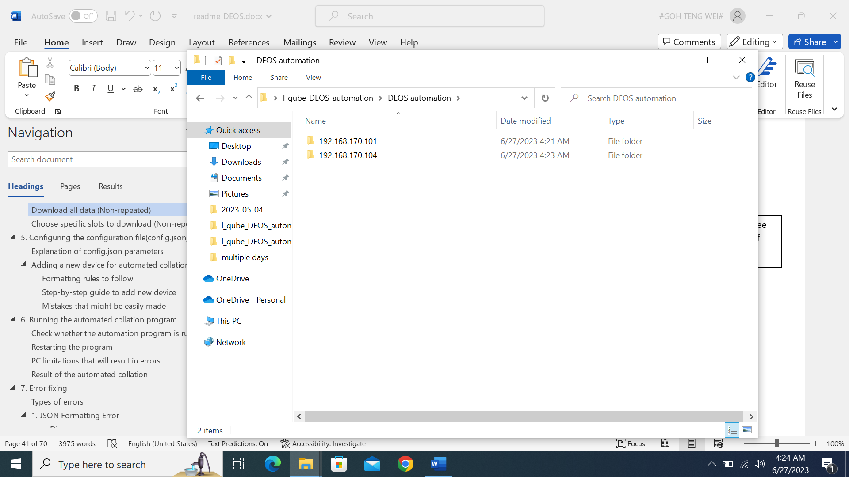

After all collation, you would see these folders named after the IP of the training devices.

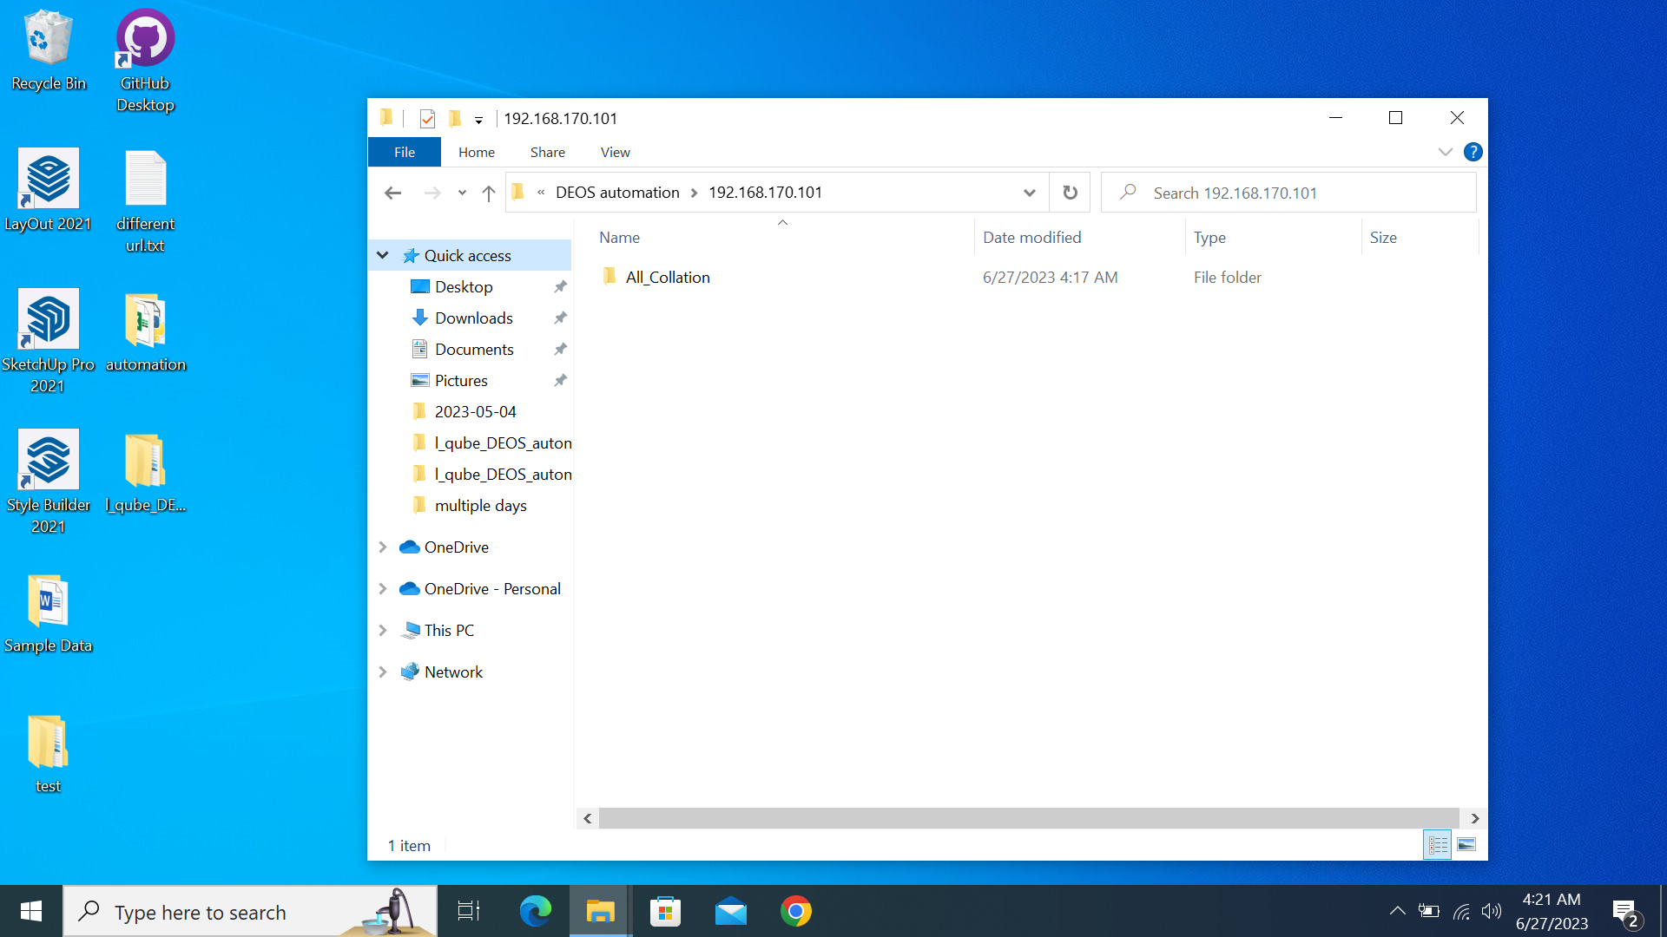

The raw data would be under the folder All_Collation within each IP address.

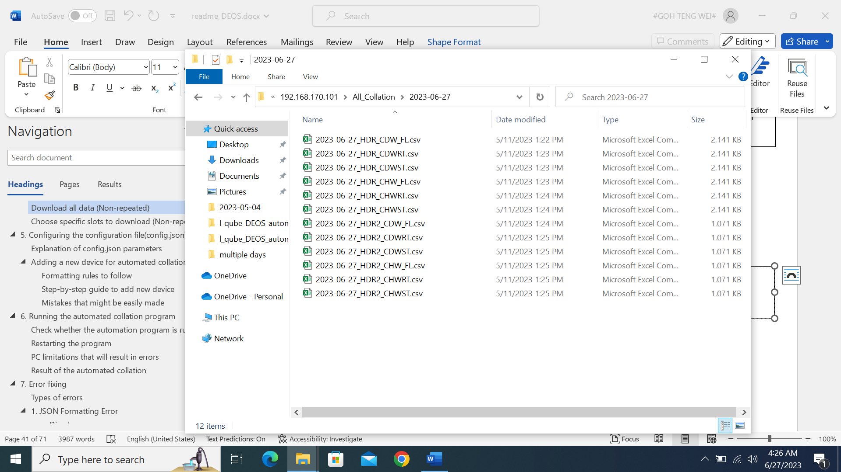

Each raw data will have the following naming format:

{Date}_{Slot name}

## Choose specific slots to download (Non-repeated)

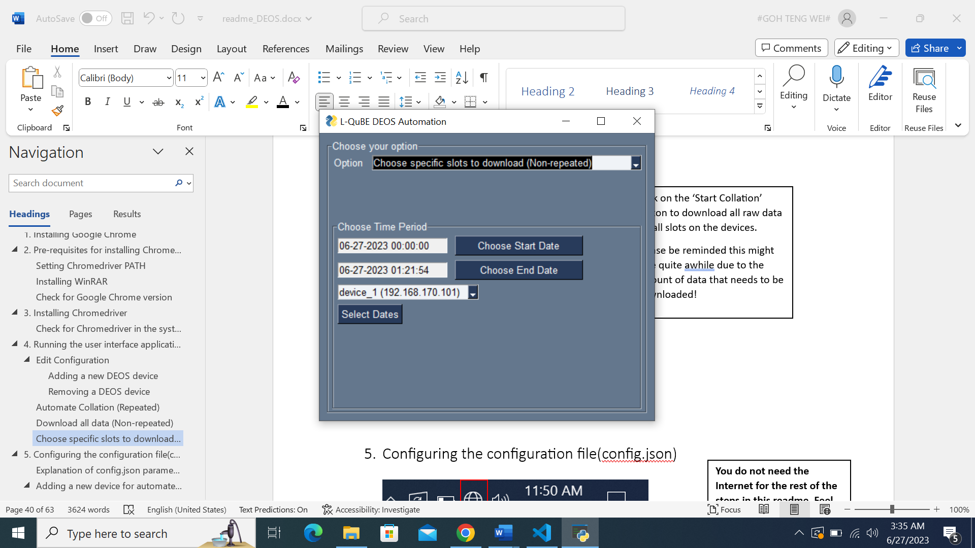

This will be the interface when the ‘Choose specific slots to download (Non-repeated)’ option is selected.

**Non-repeated indicates that the process will only execute once.**



You can select the time period of the raw data that you wish to download.

The default time period is today, from 0000-current time.

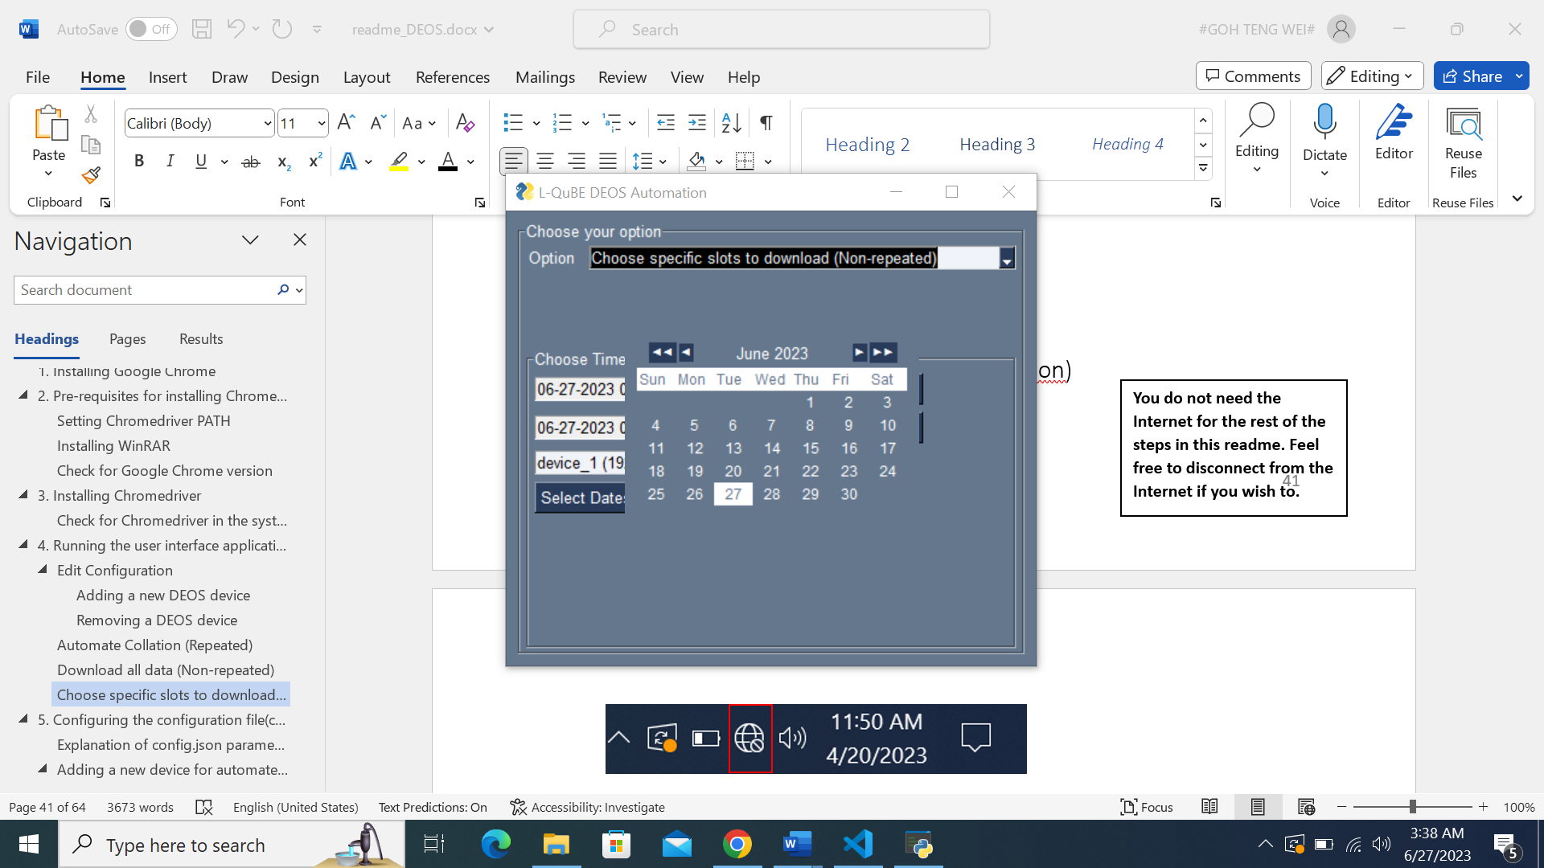

Choose the starting date by clicking on the ‘Choose Start Date Button’ and a calendar will be shown for you to pick the starting date.

You may wish to use the arrows to navigate the calendar by month or year.

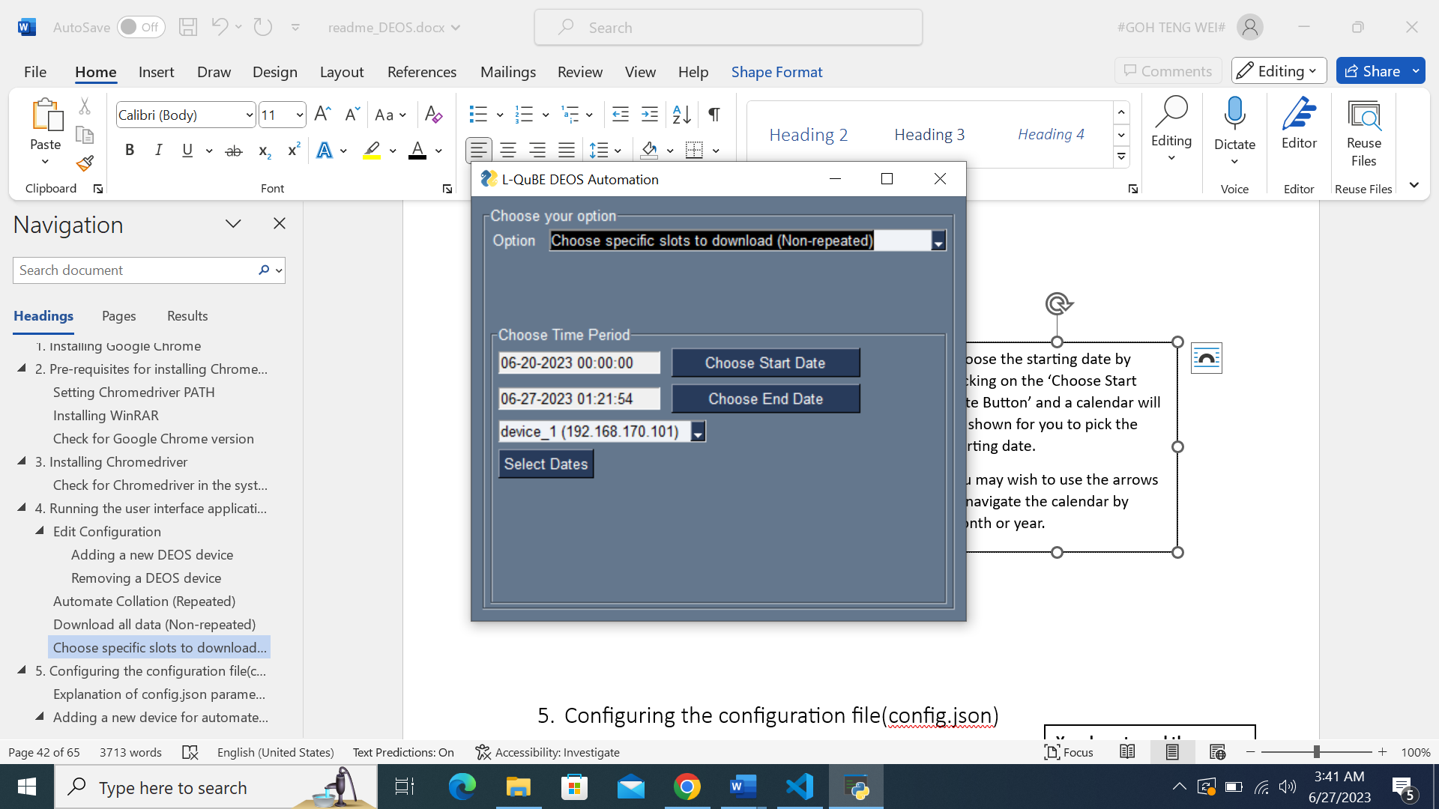

The starting date will then be updated with the date you chose, with the default time being 00:00:00.

You can edit the timing manually if you wish to.

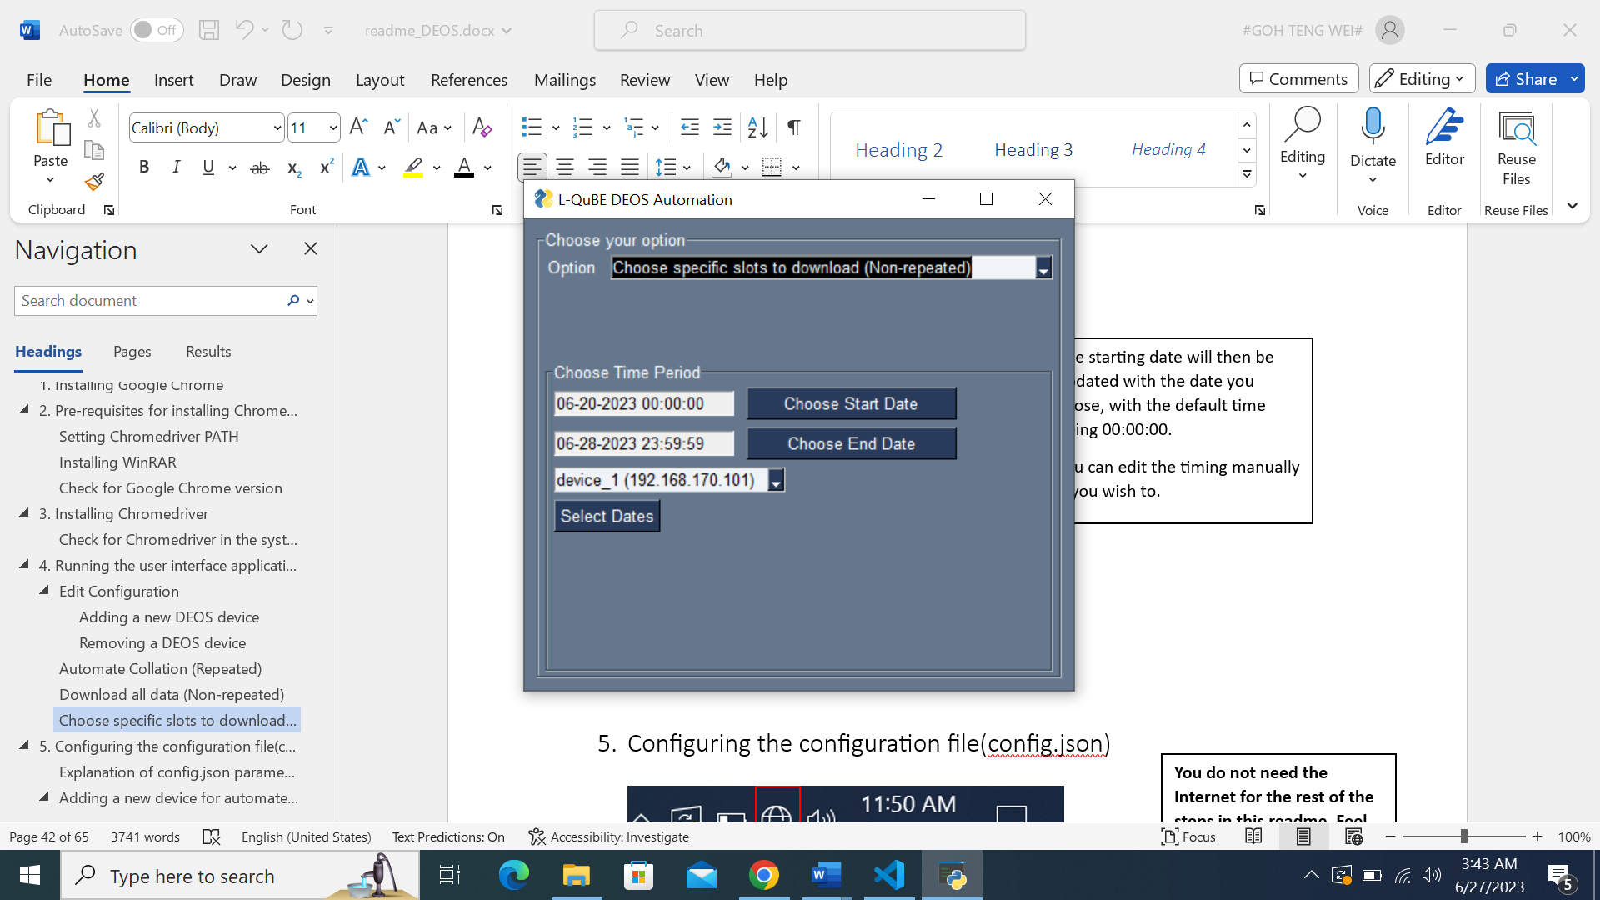

The selection of end date is the same process, with the default time being 23:59:59.

You can also edit the timing manually if you wish to.

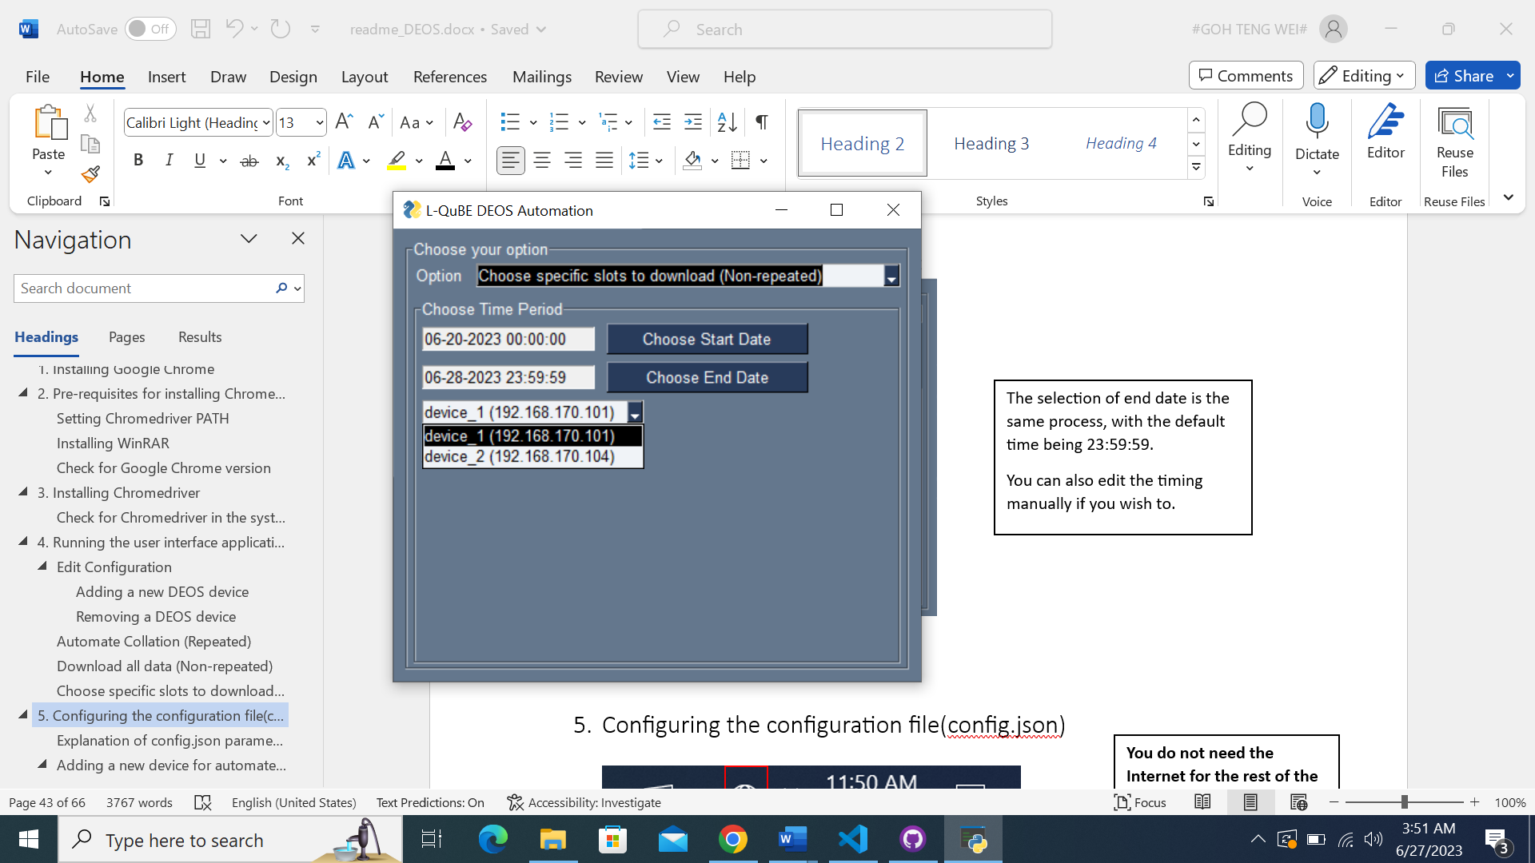

Choose the device which you want to download the specific slots over a specific time period.

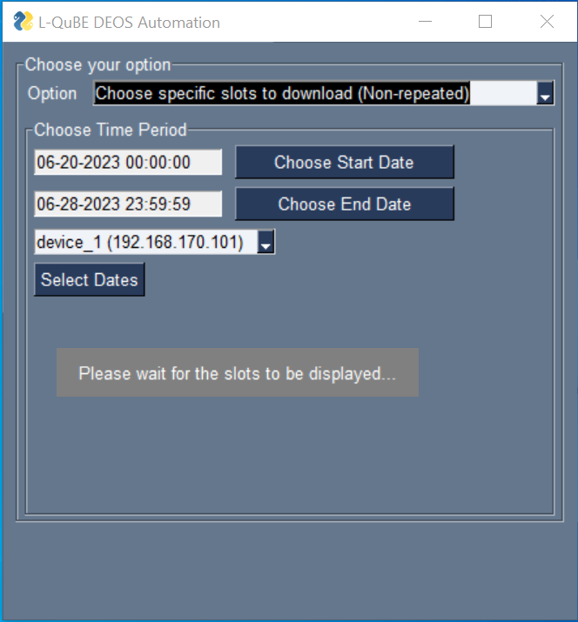

Click on the ‘Select Dates’ button after checking through the time period and device selection.

Please wait for the software to find and display every slot on the device.

It will take ~25 seconds.

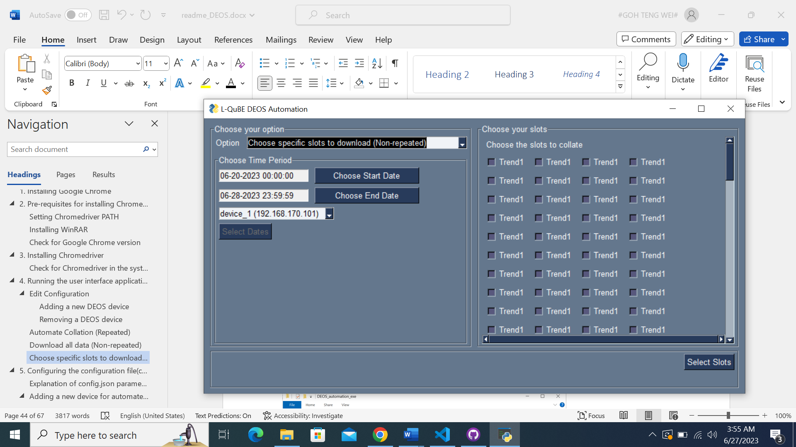

The following interface will be shown, with all the slots displayed.

You can scroll down if there are slots below that you wish to select.

This is the same as the feature for adding slots in new device.

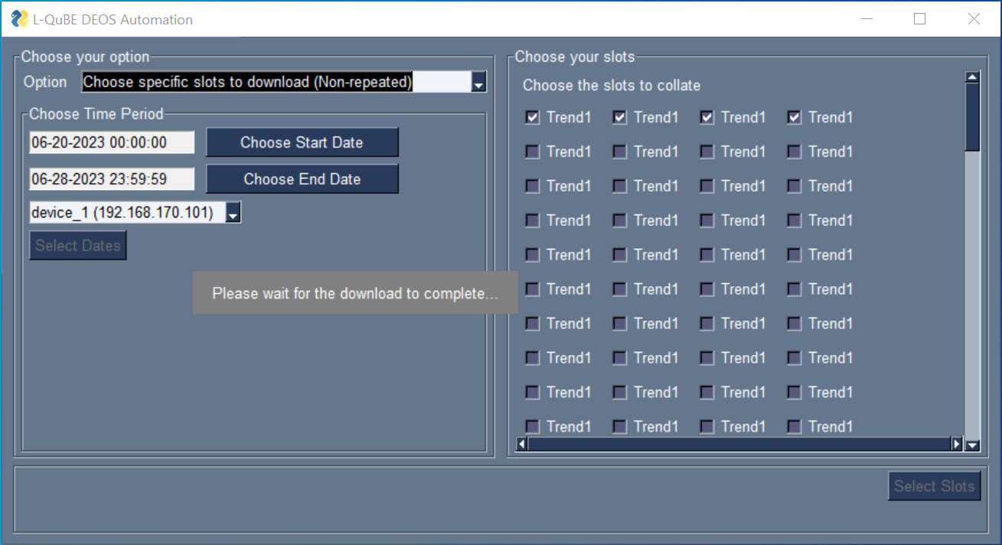

After selecting the slots you want, you can click the ‘Select Slots’ button.

Please wait for the data to be downloaded.

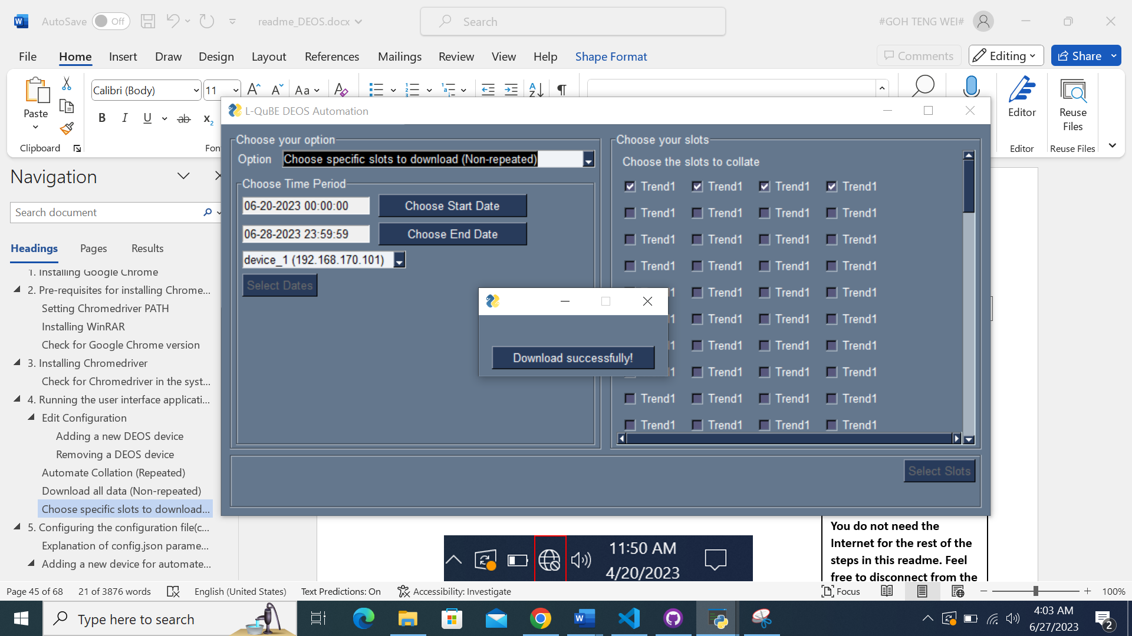

After the download has finished, this popup will appear to indicate the completion of download.

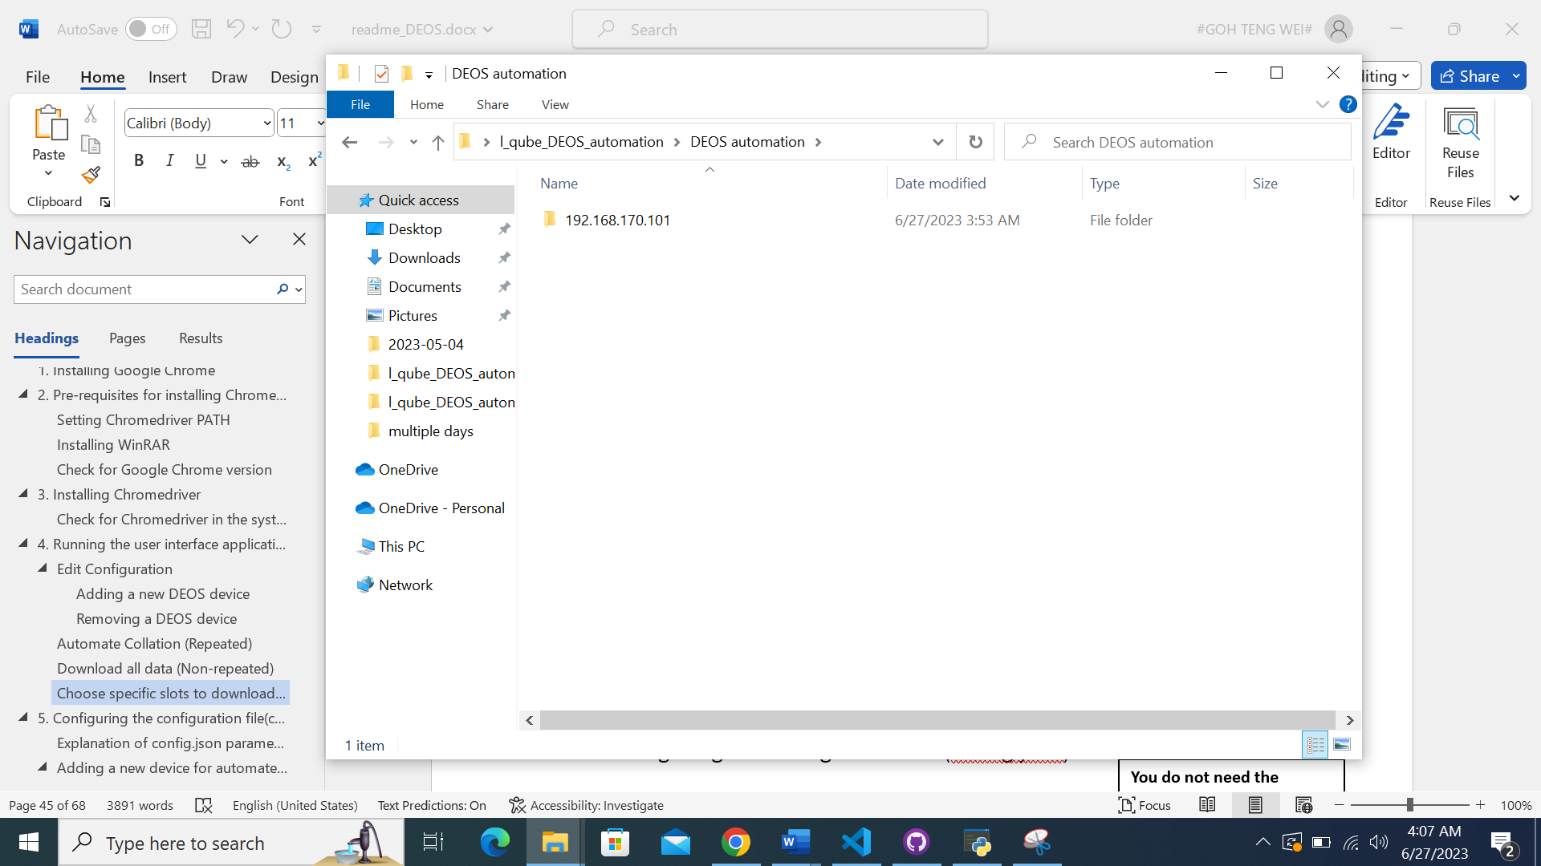

The downloaded raw data will be in the directory that you saved in the configuration, under the IP address of the device.

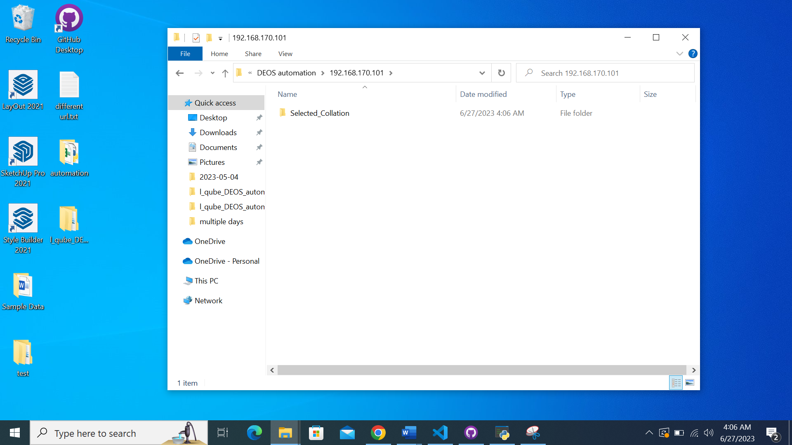

In the folder Selected_Collation

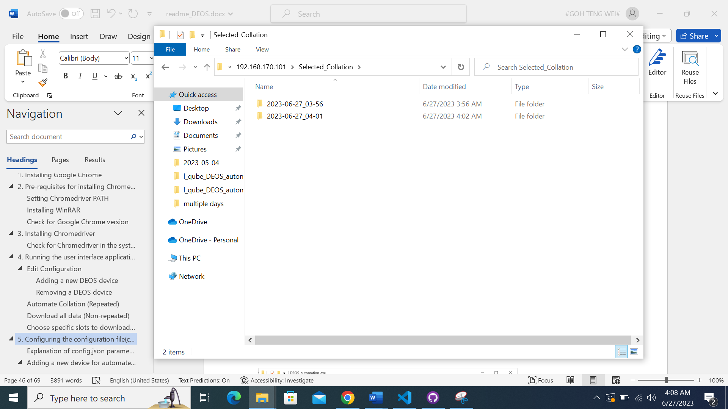

In the folder of the date and time you downloaded the data

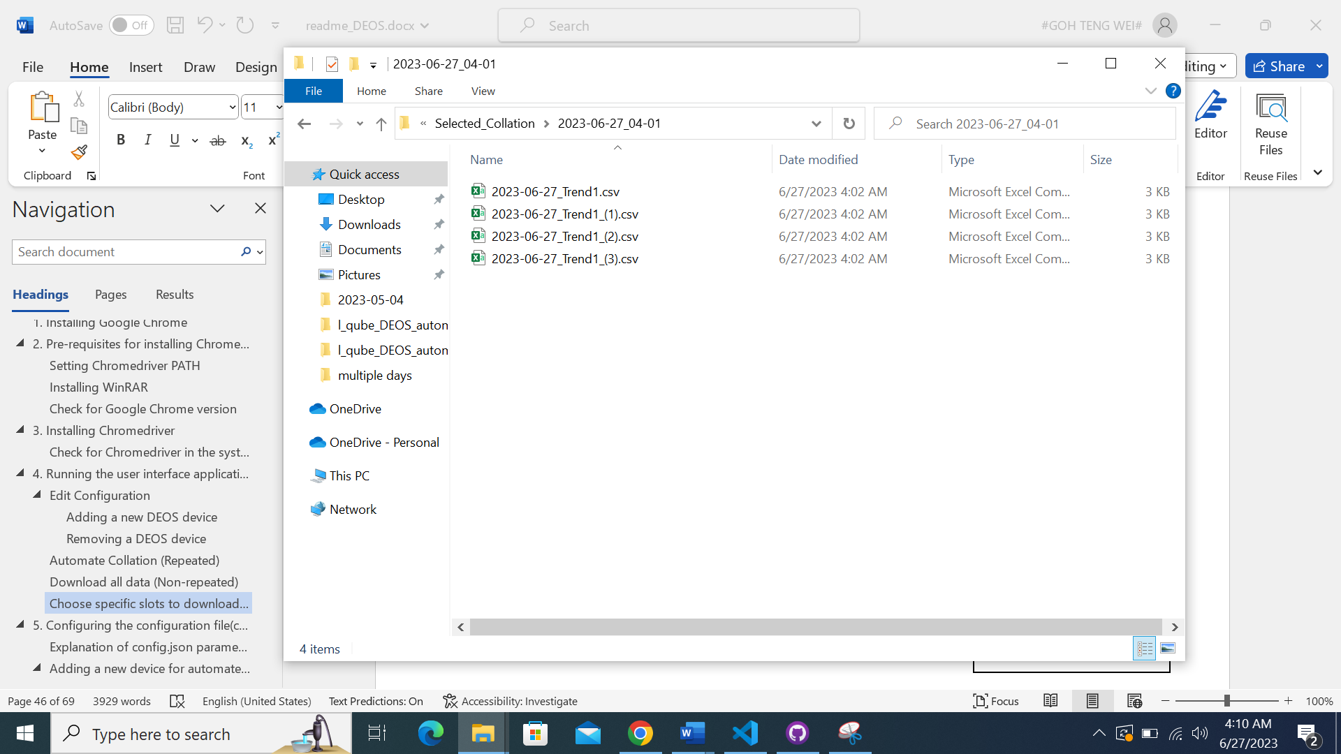

Each raw data will have the following naming format:

{Date}_{Slot name}

Duplicate slot names will be differentiated as shown.

## PC limitations that will result in errors

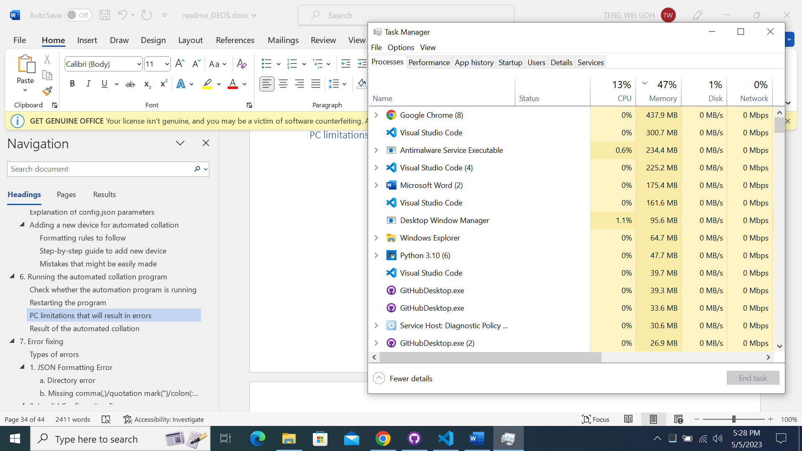

If any of the 3 resources are at 100% capacity, then the program will not be able to run due to the lack of resources. Ensure that there are sufficient resources available for the program.

# Result of the automated collation

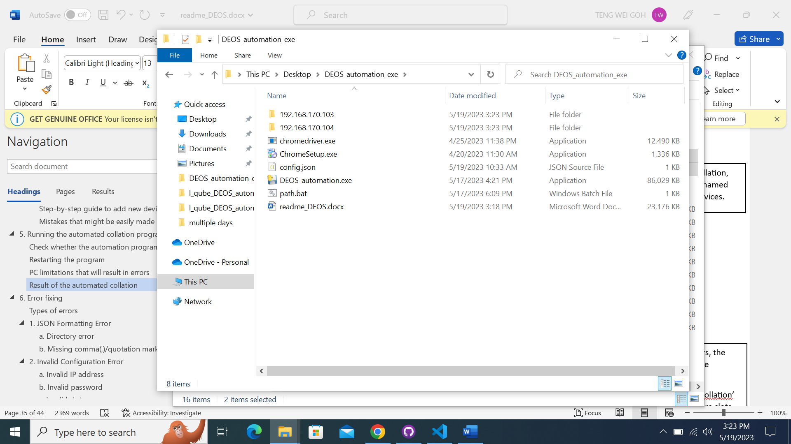

After the daily automated collation, you would see these folders named after the IP of the training devices.

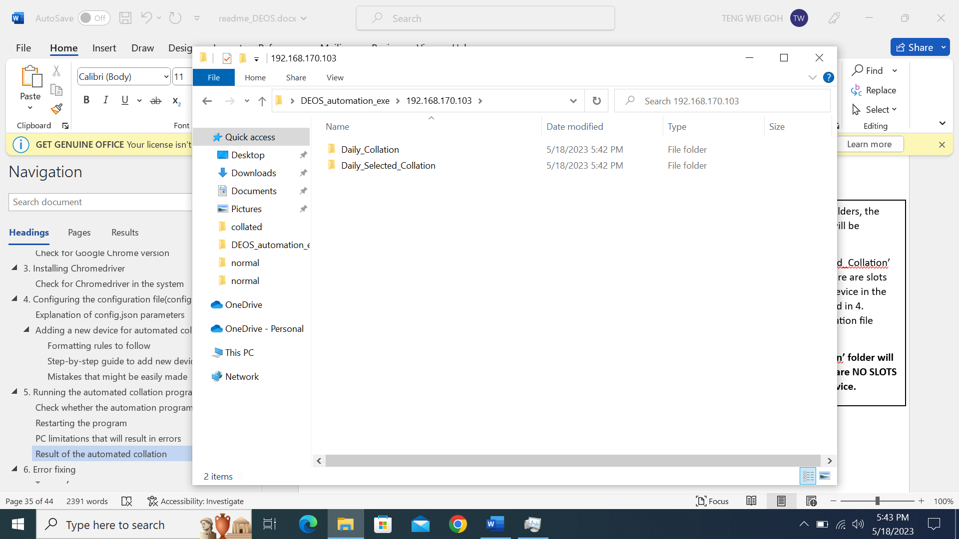

Inside each of these IP folders, the folder ‘Daily_Collation’ will be created.

The folder ‘Daily_Selected_Collation’ will also be created if there are slots that correspond to the device in the saved configuration.

**’Daily_Selected_Collation’ folder will NOT be created if there are NO SLOTS corresponding to the device.**

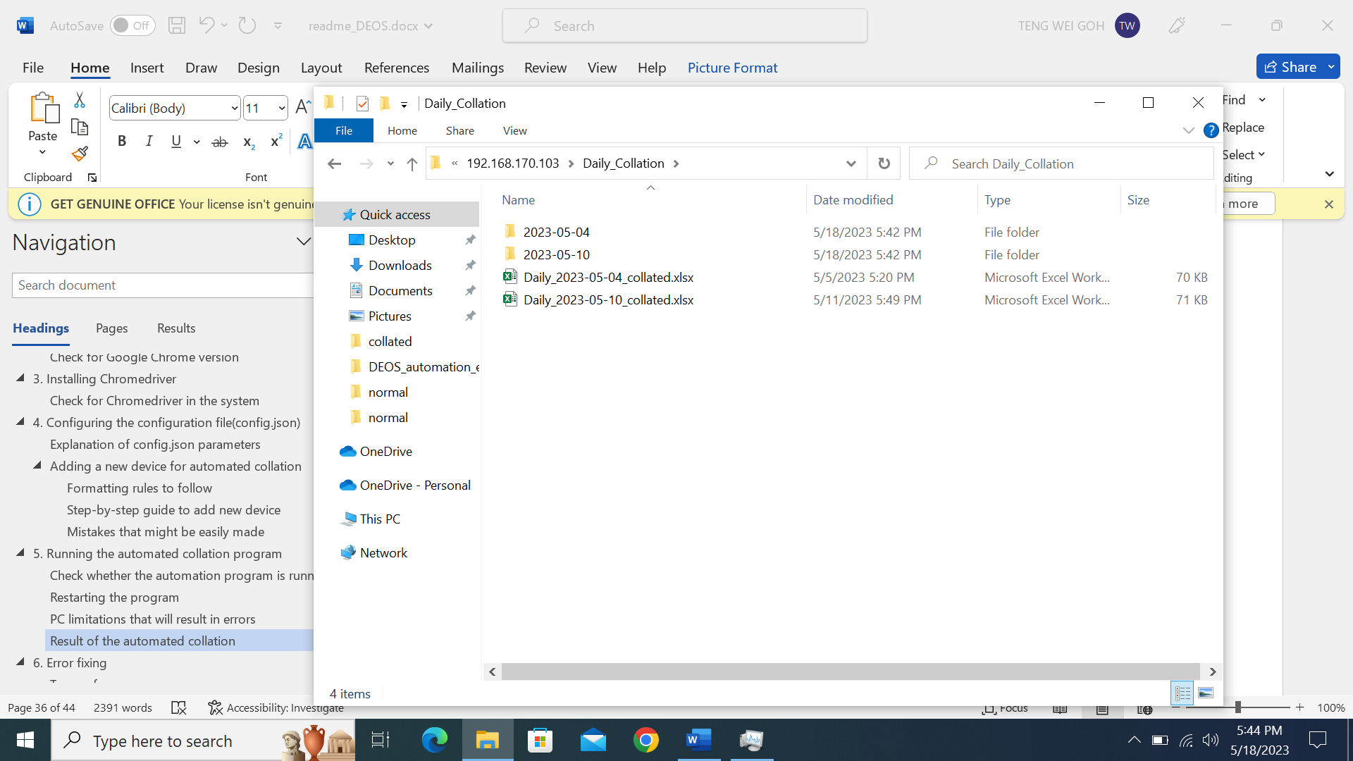

Inside each of the folders, there will be folders named after every day’s date.

Inside each of the folder will be the raw data of each slot.

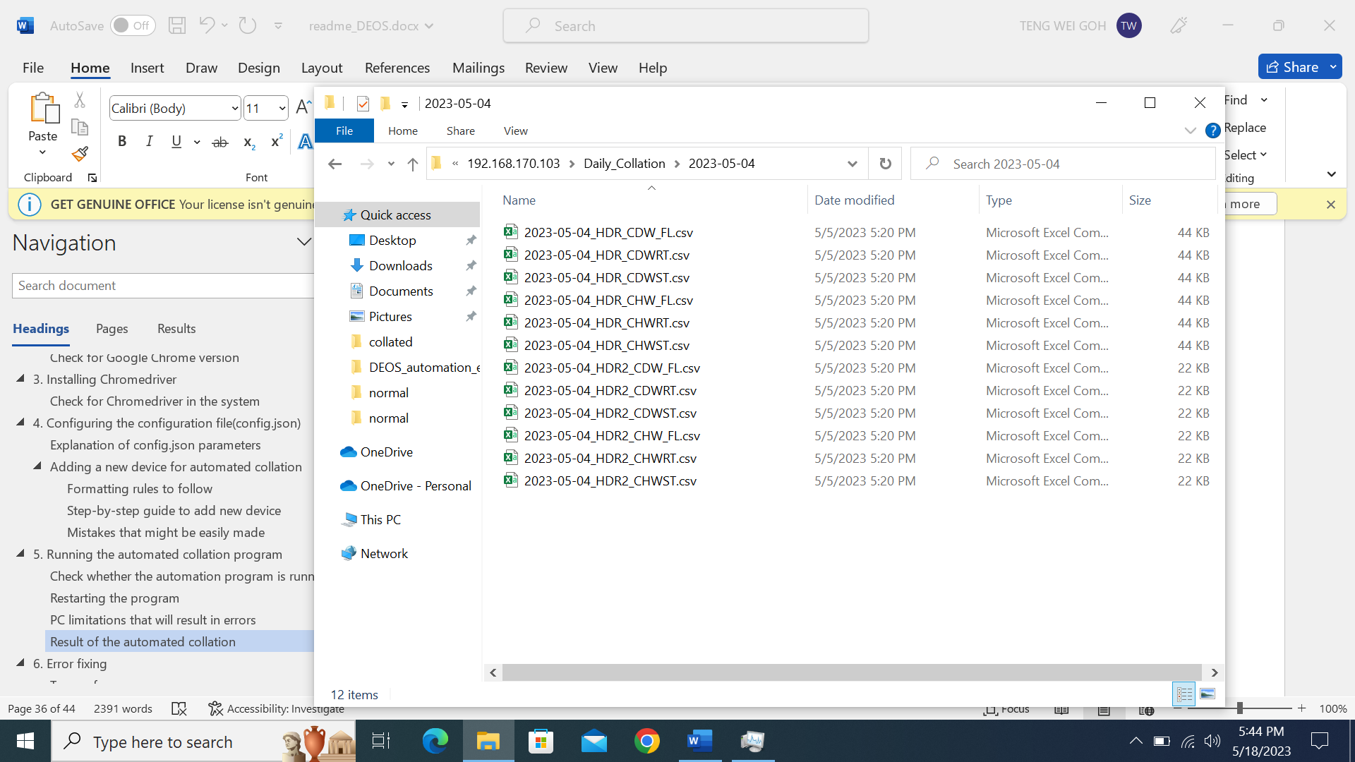



The content inside the collated excel file will be like this, with all the slots matched to their corresponding timestamp.

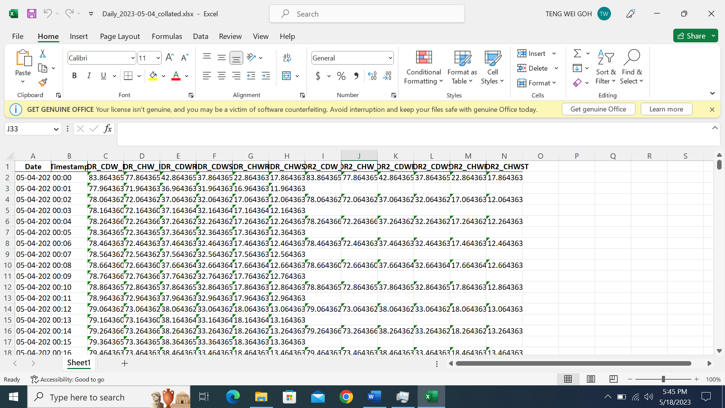

After ensuring the program is running properly, you can lock the windows using Windows Key + L. The program will still run as per usual in the background, downloading and collating the files when the time in the saved configuration is reached.

# Error fixing

## Chromedriver not found

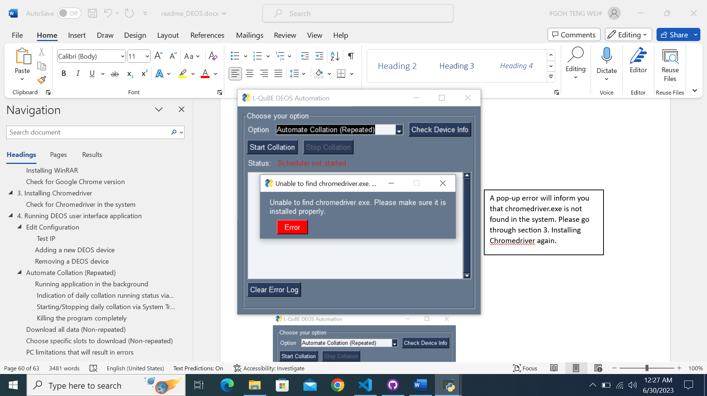

A pop-up error will inform you that chromedriver.exe is not found in the system. Please go through section 3. Installing Chromedriver again.

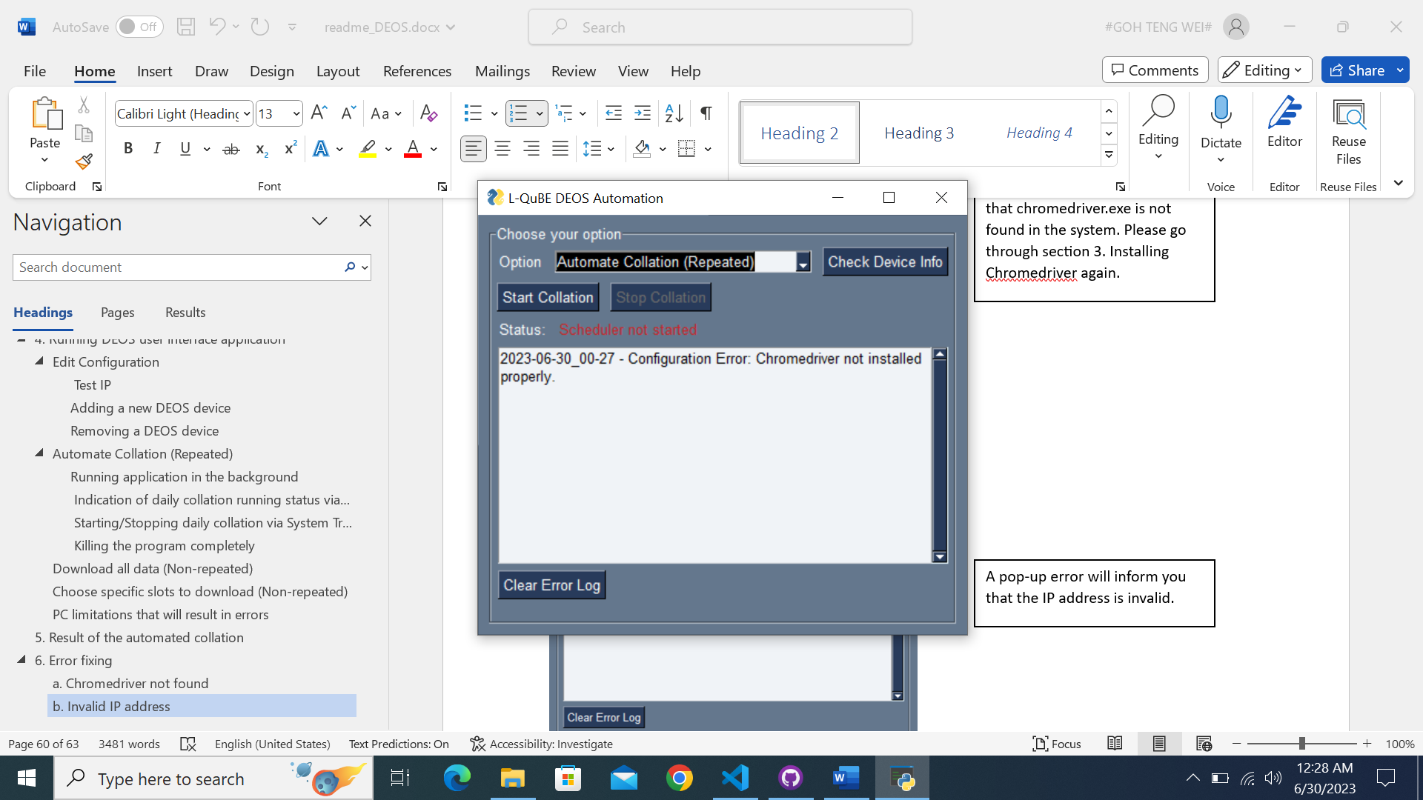

This means that chromedriver.exe cannot be found in the system.

Please go through section 3. Installing Chromedriver and try again.

## Invalid IP address

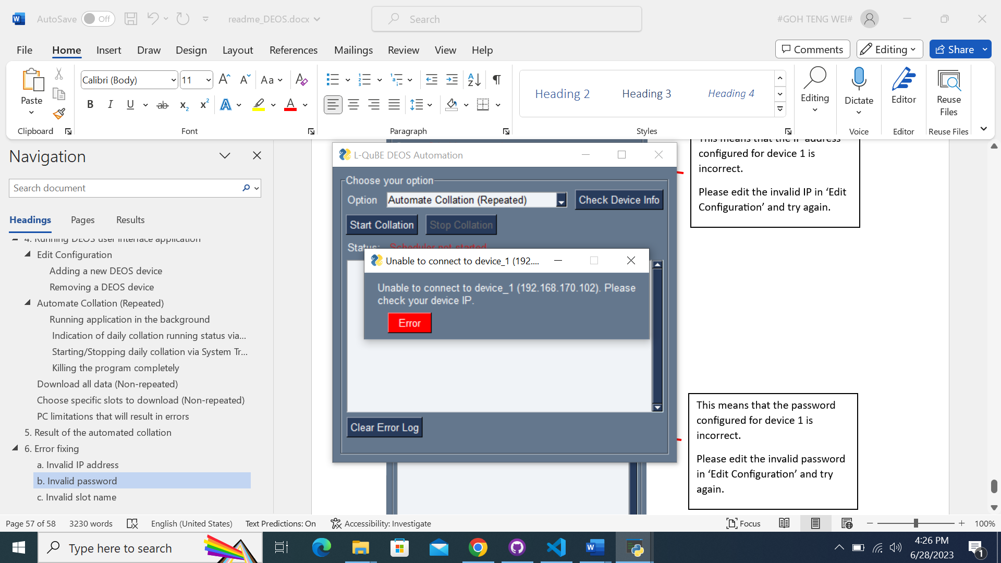

A pop-up error will inform you that the IP address is invalid.

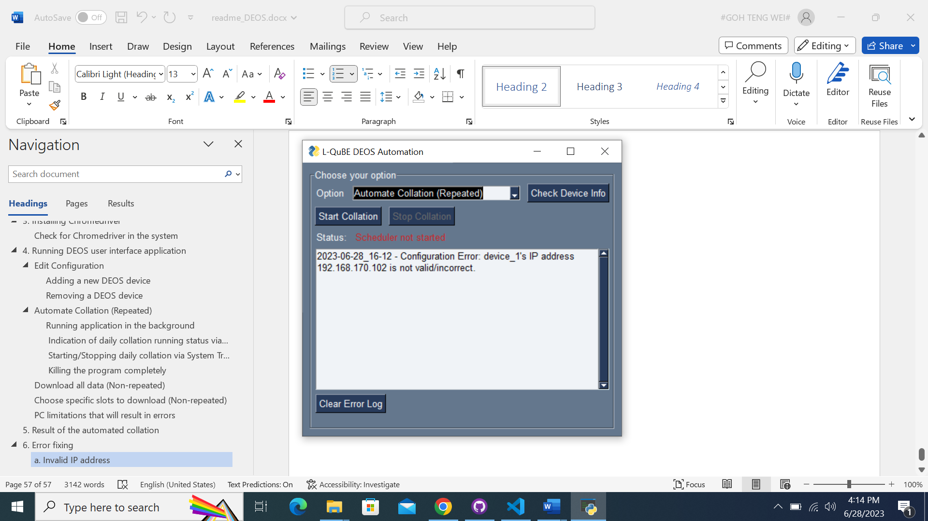

This means that the IP address configured for device 1 is incorrect.

Please edit the invalid IP in ‘Edit Configuration’ and try again.

## Invalid password

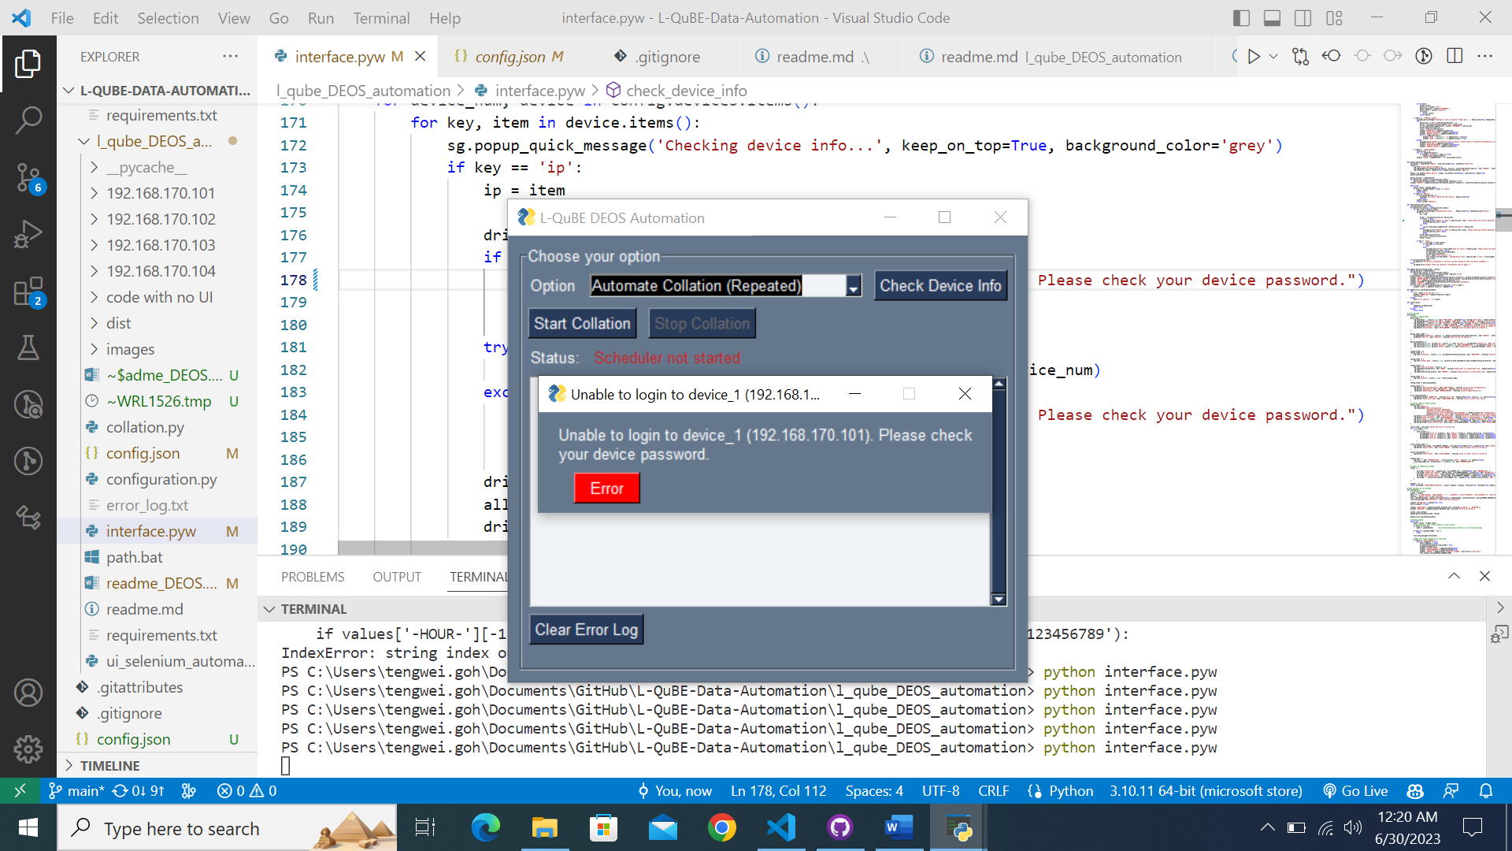

A pop-up error will inform you that the password is invalid.

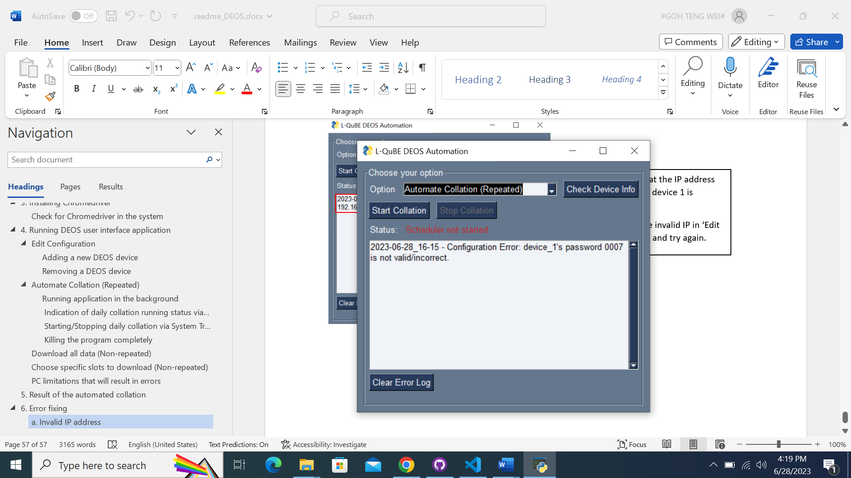

This means that the password configured for device 1 is incorrect.

Please edit the invalid password in ‘Edit Configuration’ and try again.

## Invalid slot name

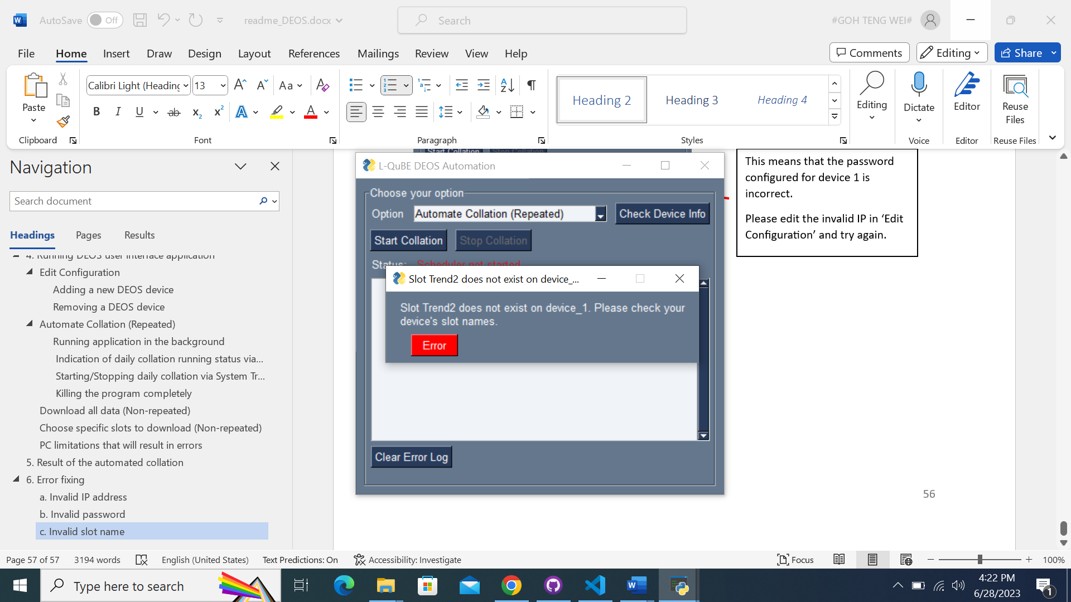

A pop-up error will inform you that the slot name is invalid.

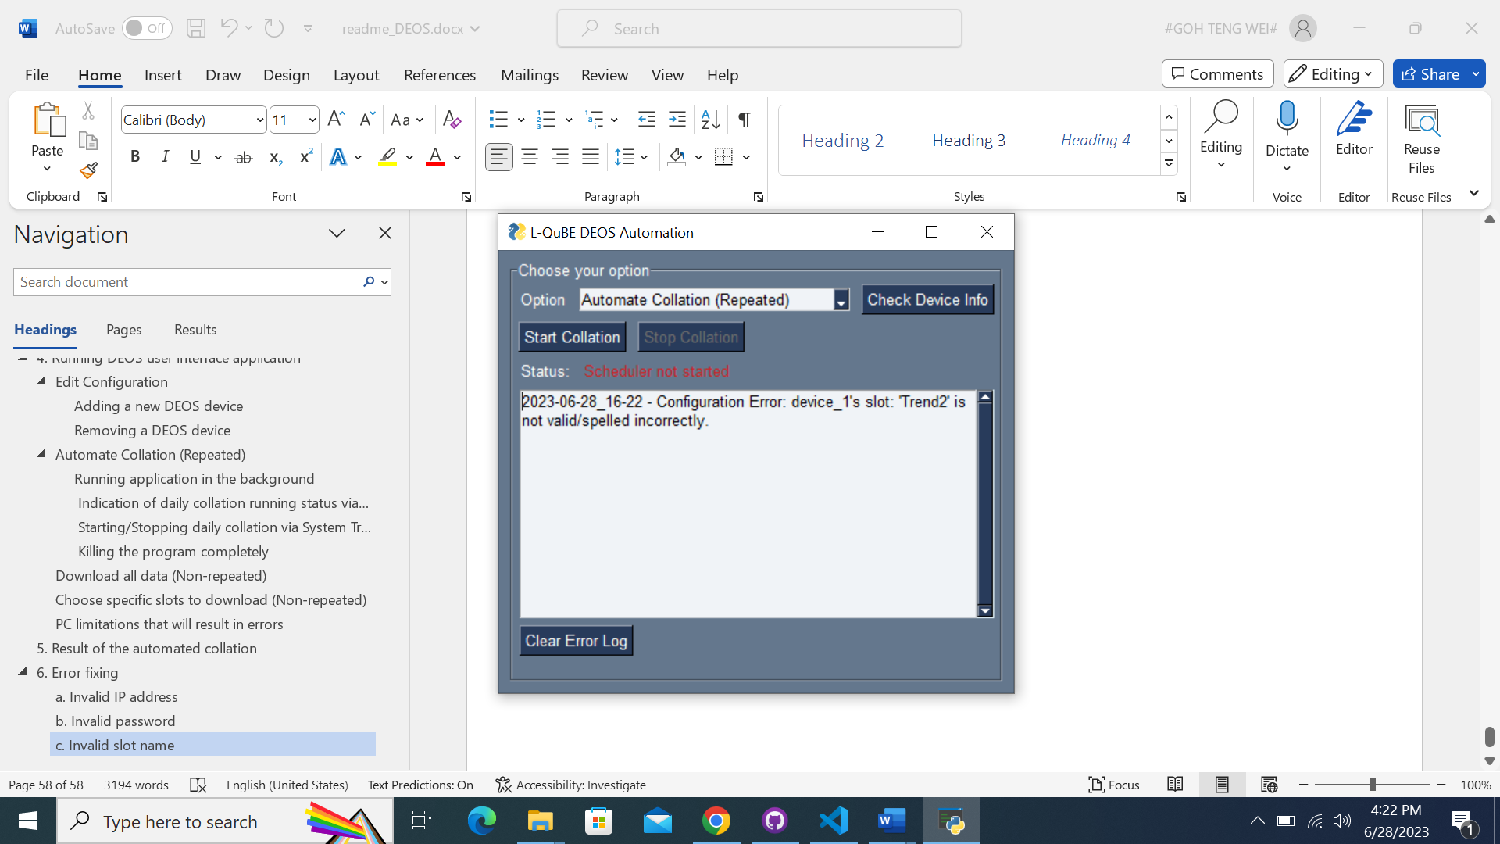

This means that the slot name(s) configured for device 1 is incorrect.

Please edit the invalid slot name in ‘Edit Configuration’ and try again.